United States Patent and Trademark Office
Locarno Task Force Pilot Group |  | Date: February 27, 2009

COMMENTS

We would again like to express our appreciation to the IB and other Task Force participants for their efforts in advancing this important project to improve the search tools for registrations and patents for industrial designs. We expect that further discussion of the merits and limitations of the various proposals to add an indexing scheme as a means to enhance the searchability of industrial design documents will prove instructive and offer the following specific comments to the latest proposal for the inclusion of visual indicators for Locarno Class 06, details for a possible alternative approach to be considered by the Pilot Group, as well as comments to other recently distributed papers and some thoughts for further discussion topics to advance this important effort.

Comments on the joint proposal for Locarno Class 06

After careful review of the joint proposal developed following the recent OHIM Designs Liaison meeting, we noted many of the shortcoming indicated in the prior proposals considered by the Pilot Group. Similar to our comments on the prior proposals, we struggled with the consistent application of the proposed indicators without additional guidance as to, for example, whether one of the “rectilinear” (WA) or “curvilinear” (WB) codes should always be applied in additional to the other shape codes. Definitions, therefore, will be very important as we advance our work, regardless of whether indexing terms or subclasses are the end approach.

Assuming that “universal categories” are intended to apply across all designs, from packaging to chairs, the simulative categories such as plant and animal shapes or celestial bodies could be useful for all products. Both food items and sofa cushions could have the shape of a dog, for example. In this respect, it would be useful to discuss whether items with one or more star, for example, should be given the same indexing code (or classification) as a design with the outer shape that is a star. We believe that a decision on the part of the Experts Group to suggest a “Simulative” class, or “Simulative” subclasses within the Locarno classes could be a beneficial outcome of our work. Such a class or such subclasses should also be broken down further to indicate what is being simulated.

We struggled with a number of the representative images in the latest proposal, for example, the last image for the Heads/Faces indicator (WF) and the first indicator for Celestial bodies/Natural phenomena/Landscapes (WJ) being illustrative of their respective categories. It would furthermore appear to be difficult to consistently apply the indicator for Heraldry/Coins/Emblems (WK) since most classifiers would not be familiar with the breadth of subject matter from diverse cultures, for example, see the following Hindu (Om) and Buddhist (Wheel of Life) symbols:



Likewise, our experts did not understand how the smooth (XA) indicator would apply to the chair having a slotted backrest nor a base having which are used to represent this category. The indicator for buttons/switches/knobs/etc. (XD) similarly presented problems in that we failed to see these features in the first representative image of the latest proposal, nor which portion of the second image was relevant (keyed wheels, drawer handles, or perhaps electrical outlets?).

For the color category, we would reiterate our previous comment that our experts do not think the “not specified” (YA) category is needed, nor do we believe is the category for “one color” (YB). The example given in the note detailing how multiple codes should be applied is also confusing in that the representative image does not seem to be appropriate for category YA.

Furthermore, for many articles, the view would determine the shape. For example, would the following seat be indexed as triangular, rectangular or both?

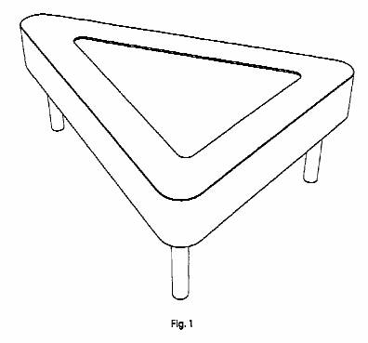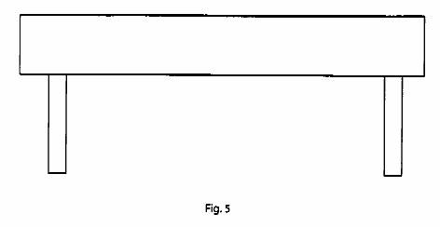

Additionally, reviewing the current indications of goods for Locarno class 06 we note that there are designs appropriate therein for which the proposed indexing codes would be of limited usefulness. For example, we believe the visual indicators of the latest proposal would be of minimal use for many of the goods provided for in the various subclasses of Class 06 such as billiard cue racks, shelving, and coffins which are classified in 06-04, and many of the playpens, radiator covers, and music stands which are classified in 06-06 which according to our experts would appear to have the same visual indicators applied thereto.

Additional “indexing terms” for consideration by the Pilot Group

As explained above, many of the proposed indexing terms would be conducive to use in a traditional classification system. Our attempts to apply some of proposed visual indicators to this specific subject matter in Locarno subclass 06-01 (having almost 5,500 US documents) illustrates the benefits to further elaboration of the Locarno classification itself as opposed to the development of adjunct indexing codes which do not significantly refine the search of this subject matter. We are concerned that the proposed indexing terms will not adequately narrow the body of prior art in industrial designs to enable searching in a reasonable period of time. While the concept of universal indexes is appealing, having a index term of “transparent” for articles such as a bottle will not be useful, and will not narrow down the number of documents for chairs sufficiently either.

As an example of an alternative approach, we offer the following specific example for improving the Locarno classification through the inclusion of additional subclasses for retrieving the prior art such as pertaining to a “glider-type” seating design illustrated below:
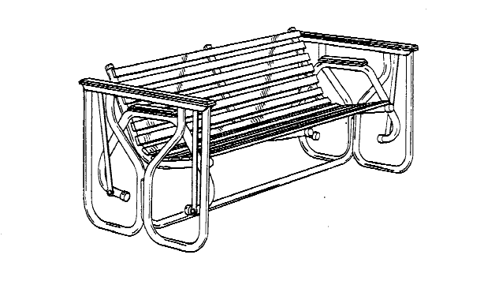
The US classification system provides several specific indexing terms (breakouts) for “glider-type” seating designs (D06/344-348):

Class D06 FURNISHINGS
D06/329 Furniture, Freestanding support, or frame therefor
D06/334 . Seating unit
D06/344 . . Swinging or rocking
D06/345 . . . Simulative
D06/346 . . . Plural facing seats
D06/347 . . . Suspended
D06/348 . . . Curved runner contacts floor

Using the above US classification scheme, it is clear that using the more detailed classification scheme the classifier would quickly locate the relevant prior art classified in D06/347. As this subclass currently contains only 251 US patent documents, locating the prior art is accomplished quickly and with a high degree of certainty that all relevant US design patent documents have been retrieved. It is noted, however, that while the US classification scheme has been used as an example, other classification schemes may be equally useful in narrowing down the number of documents necessary to consider whether a specific design is novel.

As can be seen in the above US classification scheme, the more detailed subclasses may embody visual features, whether of a universal type or a more specific type directed to the subject matter at hand. For example, having plural facing seats is a specific indicator for detailing the alignment of a seating arrangement having multiple seating positions. Alternatively, it would have been possible to incorporate such indicators as “secondary” subclasses in the US classification scheme – an approach that we generally support in situations where the indicators are more universal to the subject matter of a given class.

While we believe that this example provides ample evidence of the benefits to refining the current Locarno classification schemes, we understand that not all Offices may need the level of detail provided if, for example, full examination is not required. In this case, we can foresee a situation analogous to the International Patent Classification (IPC) where Offices may choose to use a “core” level rather than the full “advanced” level. In such a situation, the relevant prior art may still be readily searchable by considering an expanded search to include, where applicable, preceding subgroups, if there is uncertainty that all relevant prior art has been retrieved. An Office electing to use a “core” level would place the document for a chair as above in D06/344, swinging or rocking, the more general category for such a chair, which would require searching through a larger set of documents, or D06/334, seating unit, which would necessitate searching through a still larger set of documents.

One approach which serves to illustrate the alternate display of a “core” level display for a classification scheme also providing more detailed subdivisions is provided below:

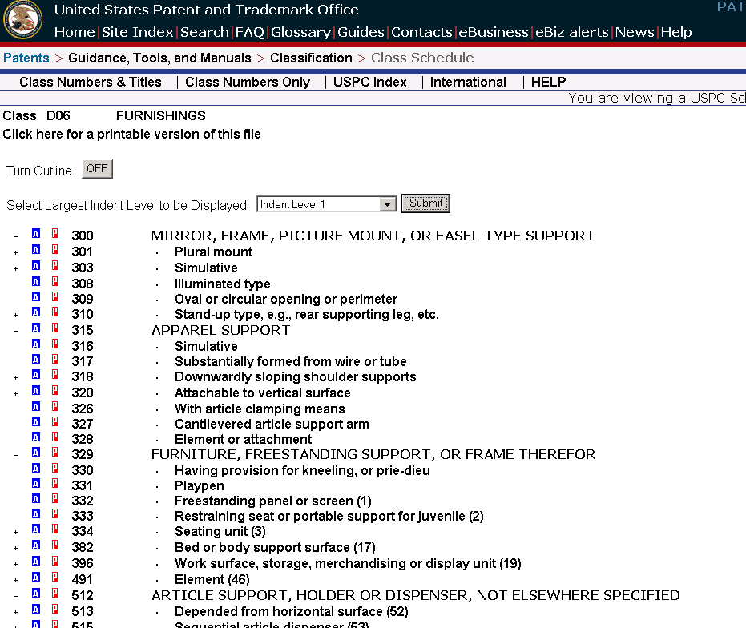

A collapsible/expandable view for such a classification scheme enables ease of use while providing more efficient search when the design is drawn to more targeted group of subdivisions in the detailed classification scheme.

Initial feedback on recently distributed comments and proposals

We view the increasing volume of comments submitted to the Pilot Group as an encouraging signal of the importance of our task in improving the Locarno classification system. We are especially appreciative of the JP comments given their experience with indexing as applied to industrial designs, and share their concern regarding the need to avoid creating an enormous number of indexes as well as the need for the Pilot Group to consider rules to enable consistent application for the subject matter found in different classes.

The comments of both FICPI and RU appear to support using visual indicators in combination with indexing, but in our viewpoint serve to highlight the potential complexity of this approach. While the specific example provided by RU addresses a salient problem associated with visual indicators which we identified in our comments to prior proposals, namely identifying which portion or component of a design a given indicator is to be applied, it further illustrates the complexity of this approach.

We noted that, in the examples provided by OHIM having applied thereto the visual indicators of the joint proposal for Class 06, invariably either “WA” (rectilinear) or “WB” (curvilinear) is applied. This clearly illustrates the limited gains to be affected by the incorporation of these categories of shape visual indicators.

Regarding the latest CZ proposal for Class 06, we feel this proposal is an improvement over prior proposals, but are a bit unclear of the relationship between the two tables upon reading this as we noted that, for example, table #1 shows codes 0647 and 0648 applied to “cribs” and “operating tables”, respectively, while table #2 shows these codes as applying to “compartments” and “drawers”, respectively. It is also unclear how the proposal intends to account for existing Locarno subclasses in Class 06 which are not included, for example, subclass 06-12 (tapestries), but perhaps this will be clarified following the discussion at the upcoming meeting in Prague.

While we have not yet had sufficient time to analyze in detail the recently distributed comments from CA, we believe these comments to be very instructive in aiding the Pilot Group in moving forward with recommendations for improving the Locarno classification. In particular, the CA suggestion to base further subdivisions upon existing breakouts in the various national classification systems is a concept which we wholeheartedly endorse as it additionally provides a solution to the issue of handling the backfile of previously published industrial design documents.

Further discussion topics of the Pilot Group

We believe the Pilot Group will benefit at this point from broadening the discussion to related topics including, but not limited to, the creation of a database providing access to the worldwide collection of industrial design patent documentation, as well as the application of indexing codes to existing registrations and patents for industrial designs, and how the indexing codes will be modified in the future (necessitating the re-indexing of existing registrations and patents for industrial designs). We regret that we will be unable to participate in the meeting, especially for this agenda item.

Additionally, the Pilot Group should consider metrics for quantifying the search benefits to be obtained from the further development of the Locarno classification system. Such metrics should not be limited to improved precision and recall of search, but also metrics for implementation of search systems to support the approach for improving the retrieval of industrial design patent documents.

While we believe it would be exceedingly difficult to develop rules for consistent application of indexing codes, the Pilot Group will also benefit from discussion of this important topic. This discussion should advantageously address the breadth of different goods covered by the Locarno classification and not be limited to a single class, as well as how to apply indexing codes in registrations and patents having multiple embodiments.

We look forward to future discussions of the Pilot Group as well as input from the general public as to best practices for developing an improved classification regime for industrial designs. As per our previous comments, the international community of classification experts collectively provides a valuable source of knowledge and experience to obtain high quality and efficiency while addressing appropriate standards to whatever approach is deemed best for industrial designs. We believe their broadened input will ensure an improved Locarno classification that is expedient in achieving improved usefulness to the user community, both the public and other Offices.

