WIPO |  | E  IPC/CE/30/5 Suppl.1  ORIGINAL: English  DATE: February 15, 2001
WORLD INTELLECTUAL PROPERTY ORGANIZATION
GENEVA
special union for the international patent classification
(IPC union)
committee of experts
Thirtieth Session
Geneva, February 19 to 23, 2001
DETERMINATION OF THE MOST APPROPRIATE
CONTENTS OF THE CORE LEVEL OF THE IPC
Document prepared by the International Bureau

1 At its fourth session, held in October/November 2000, the ad hoc IPC Reform Working Group agreed that, in order to provide a sufficient basis for the IPC Committee of Experts in deciding on the most appropriate contents of the core level, it would be necessary to collect information on the intentions of industrial property offices with regard to the use of the reformed IPC. The Working Group requested the International Bureau to issue a circular inviting members of the Working Group to provide information on whether they intend to use, for classification and searching of patent documentation, the core or advanced level of the IPC and whether they intend to carry out reclassification of their search files following revision changes made to the core or advanced levels (see document IPC/REF/4/4, paragraph 44).

2 Following this request, the International Bureau issued, on December 15, 2000, WIPO Circular No. IPC 54, inviting members and observers of the IPC Union to provide the above information. The Circular is reproduced in Annex 1 to this document.

3 A summary of replies, prepared by the International Bureau, appears as Annex 2 to this document.

[Annexes follow]
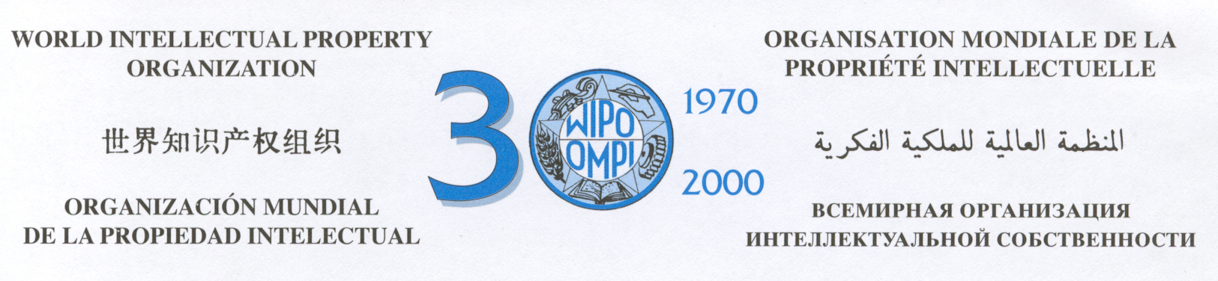
C. IPC 54  01 | December 15, 2000

Re: Use of the reformed IPC
_______________________

Madam,
Sir,

In 1999, the Committee of Experts of the IPC Union decided to launch the reform of the International Patent Classification (IPC) to adapt the Classification to the electronic environment, to increase its efficiency for the retrieval of patent information and to facilitate its use. The next (eighth) edition of the IPC will already contain basic features of the reformed Classification elaborated during a transitional period.

At its twenty-ninth session, held in March 2000, the Committee of Experts decided that the reformed IPC should represent a two-level classification system, which would better satisfy differing needs of small, medium-sized and large industrial property offices and the general public (see Annex III of document IPC/CE/29/11). The two-level system will consist of a core and an advanced level.

Members and observers of the IPC Union will be obliged to use classification symbols of at least the core level for classifying their published patent documents. The core level will be a relatively stable part of the IPC. Amendments to the core level will be made periodically by the Committee of Experts when necessitated by technological progress.

The advanced level will represent a further elaboration of the core level. Any member or observer of the IPC Union can choose its entries for classifying published patent documents. In order to enhance the search efficiency of the advanced level, revisions thereof will be provided continuously through an
accelerated procedure.

/...
./.
C. IPC 54 2.
01

At its third session, held in May 2000, the ad hoc IPC Reform Working Group agreed that, in particular for facilitating the use of the IPC by small industrial property offices and the general public, the core level of the reformed IPC should comprise a restricted version of the seventh edition of the IPC (see document IPC/REF/3/2, paragraph 12).

It is supposed that the core level will include less than half of classification groups of the seventh edition of the IPC containing nearly 70,000 groups. Classification groups not included in the core level will be included in the advanced level. The size of the advanced level will initially correspond to the size of the seventh edition of the IPC but will rapidly increase in the future, in view of the accelerated revision of the advanced level.

One of the objectives of IPC reform is to provide possibilities for performing patent searches with the use of the current edition of the IPC only and to eliminate the need to rely on superseded IPC editions. This objective could be achieved by reclassification of national patent collections according to periodical revision changes of the core level or, depending on the choice of an industrial property office, according to continuous revision changes of the advanced level.

In order to provide a sufficient basis for the Committee of Experts in deciding on the most appropriate contents of the core level, the ad hoc IPC Reform Working Group at its fourth session, held in October/November 2000, requested the International Bureau to obtain information from the members of the Working Group on whether they intend to use, for classification of their published patent documents, the core or advanced level of the reformed IPC and whether they intend to carry out reclassification of their search files following revision changes made to the core or advanced level (see document IPC/REF/4/4, paragraph 44).

You are kindly invited to complete the attached questionnaire relating to the use of the reformed IPC, in the light of the information provided above. It would be appreciated if the questionnaire could be returned to the International Bureau by January 15, 2001, preferably by e-mail to the following address “mikhail.makarov@wipo.int”.

Sincerely yours,
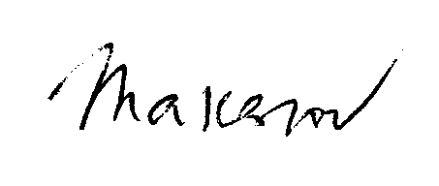
Mikhail Makarov
Head
International Patent Classification Section

Annex to WIPO Circular No. IPC 54

QUESTIONNAIRE RELATING TO THE USE OF THE REFORMED IPC

To be returned to: World Intellectual Property Organization (WIPO)
34, chemin des Colombettes
1211 Geneva 20
Switzerland

Reply submitted by:

1. Does your Office intend to use the core or advanced level of the reformed IPC for classification of your published patent documents?

core level |  | advanced level

2. Does your Office intend to carry out reclassification of your published patent documents following revision changes made to the core or advanced level of the reformed IPC?

Yes |  | No

3. Remarks

[Annex 2 follows]

IPC/CE/30/5 Suppl.1

ANNEX 2

SUMMARY OF REPLIES

1. On December 15, 2000, the International Bureau issued WIPO Circular No. IPC 54 inviting members and observers of the IPC Union to provide information on their intentions to use the core or advanced level of the IPC and to carry out reclassification of their published patent documents.

2. Replies were received from the following members and observers of the IPC Union: Austria, Belarus, Belgium, Bulgaria, Canada, Croatia, Czech Republic, Egypt, Estonia, Germany, Ireland, Israel, Japan, Kyrgyzstan, Monaco, Netherlands, Portugal, Republic of Korea, Republic of Moldova, Romania, Russian Federation, Slovak Republic, Slovenia, Spain, Sweden, Switzerland, United Kingdom, Eurasian Patent Office (EAPO), European Patent Office (EPO) (29).

3. With regard to the intentions to use the core or advanced level of the reformed IPC for classification of their published patent documents:

– the following industrial property offices intend to use the core level: Belarus, Croatia, Estonia, Ireland, Kyrgyzstan, Monaco (6);

– the following industrial property offices intend to use the advanced level: Austria, Belgium (classification is done by the EPO), Bulgaria (first level publication documents could be classified at the core level), Canada, Czech Republic, Egypt, Germany, Israel, Japan, Portugal, Republic of Korea, Republic of Moldova, Romania, Russian Federation, Slovak Republic, Slovenia, Spain, Sweden, Switzerland, United Kingdom, EAPO, EPO (22).

4. With regard to the intentions to carry out reclassification of their published patent documents, the following industrial property offices intend to carry out reclassification: Belarus, Egypt, Ireland, Germany, Japan (according to FI System based on the IPC), Portugal (depending on the workload), Republic of Korea, Republic of Moldova, Romania, Russian Federation, Sweden (documents published after 1970 at the most), EAPO, EPO (13).

5. Some remarks made by industrial property offices in their replies appear in the Appendix to this summary.

[Appendix follows]

APPENDIX

SOME REMARKS MADE BY INDUSTRIAL PROPERTY OFFICES

BULGARIA

“We could reclassify our published patent documents only after elaboration of automated reclassification tool.”

GERMANY

“We are willing to apply the advanced level for classifying our published patent documents as well as for the search file. During the last IPC Reform meeting it arises that the advanced level should be updated monthly. If that will be the case, our office would run into problems, regarding in particular: managing the scopes of duty—since the distribution of work is organized according to the IPC (German Patent Law)—, transaction of internal data-base update, reclassification, preparation of the publication of patent documents, in particular the applications, translation into German, etc. We could go along with an annual update of the advanced level.”

IRELAND

“As a small IPO we welcome the introduction of the core level in the IPC as a major step in facilitating its use by offices such as ourselves. We would wish the core level to be highly stable so as to minimise the amount of reclassification work which would have to be performed on a regular basis.”

SLOVAK REPUBLIC

“If there is some proper technical tool that will enable to carry out reclassification in the near future, we are prepared to do it.”

SLOVENIA

“Slovenian Intellectual Property Office intends to use advanced level of the reformed IPC for classification of its published patent documents. However, since we do not have a search procedure and therefore no search files, we do not intend to carry out reclassification.
I have to admit that the decision on the type of level to be used in our Office was not an easy one. From one point of view, the core level can be very secure and simple way, since we have only six examiners. But we believe that the question of the patent classification within IPC is not only the question of organising search files, but mostly the question of document
visibility. And since one of the main tasks of patent offices is making the teaching from patent documents available to the public as a part of state of the art, the role of patent classification is even more significant. Small offices that are not a part of PCT minimum documentation list can be very easily left on the margin. Only through exact classification codes allotted to offices' documents, documents from these countries can become accessible during searches and can form a real part of the state of the art. That is why we decided for harder way and select advanced level.”

UNITED KINGDOM

“We envisage that we would use the advanced level for our published documents although we may have difficulty coping with a very high frequency of revision, e.g. monthly.”

[End of Annex 2 and of document]

