WIPO |  | E  CLIM/GTP/26/2  English only  DATE: September 3, 2007
WORLD INTELLECTUAL PROPERTY ORGANIZATION
GENEVA
special union for the international classification of goods and
services for the purposes of the registration of marks
(NICE UNION)
preparatory working group
Twenty-Sixth Session
Geneva, November 26 to 30, 2007
PROPOSALS FOR CHANGES TO THE NINTH EDITION
OF THE NICE CLASSIFICATION
Document prepared by the International Bureau

1 The Annexes to this document contain proposals for amendments and other changes to the ninth edition of the Nice Classification, received in response to WIPO Circular NCL 72, dated September 19, 2006.

2 These proposals were submitted by China (Annex I), Finland (Annex II), Germany (Annex III), Japan (Annex IV), Latvia (Annex V), Mexico (Annex VI), Russian Federation (Annex VII), The former Yugoslav Republic of Macedonia (Annex VIII), United Kingdom (Annex IX) and the United States of America (Annex X).

3 The Preparatory Working Group is invited to consider the above-mentioned proposals and to express its views thereon.

[Annexes follow]

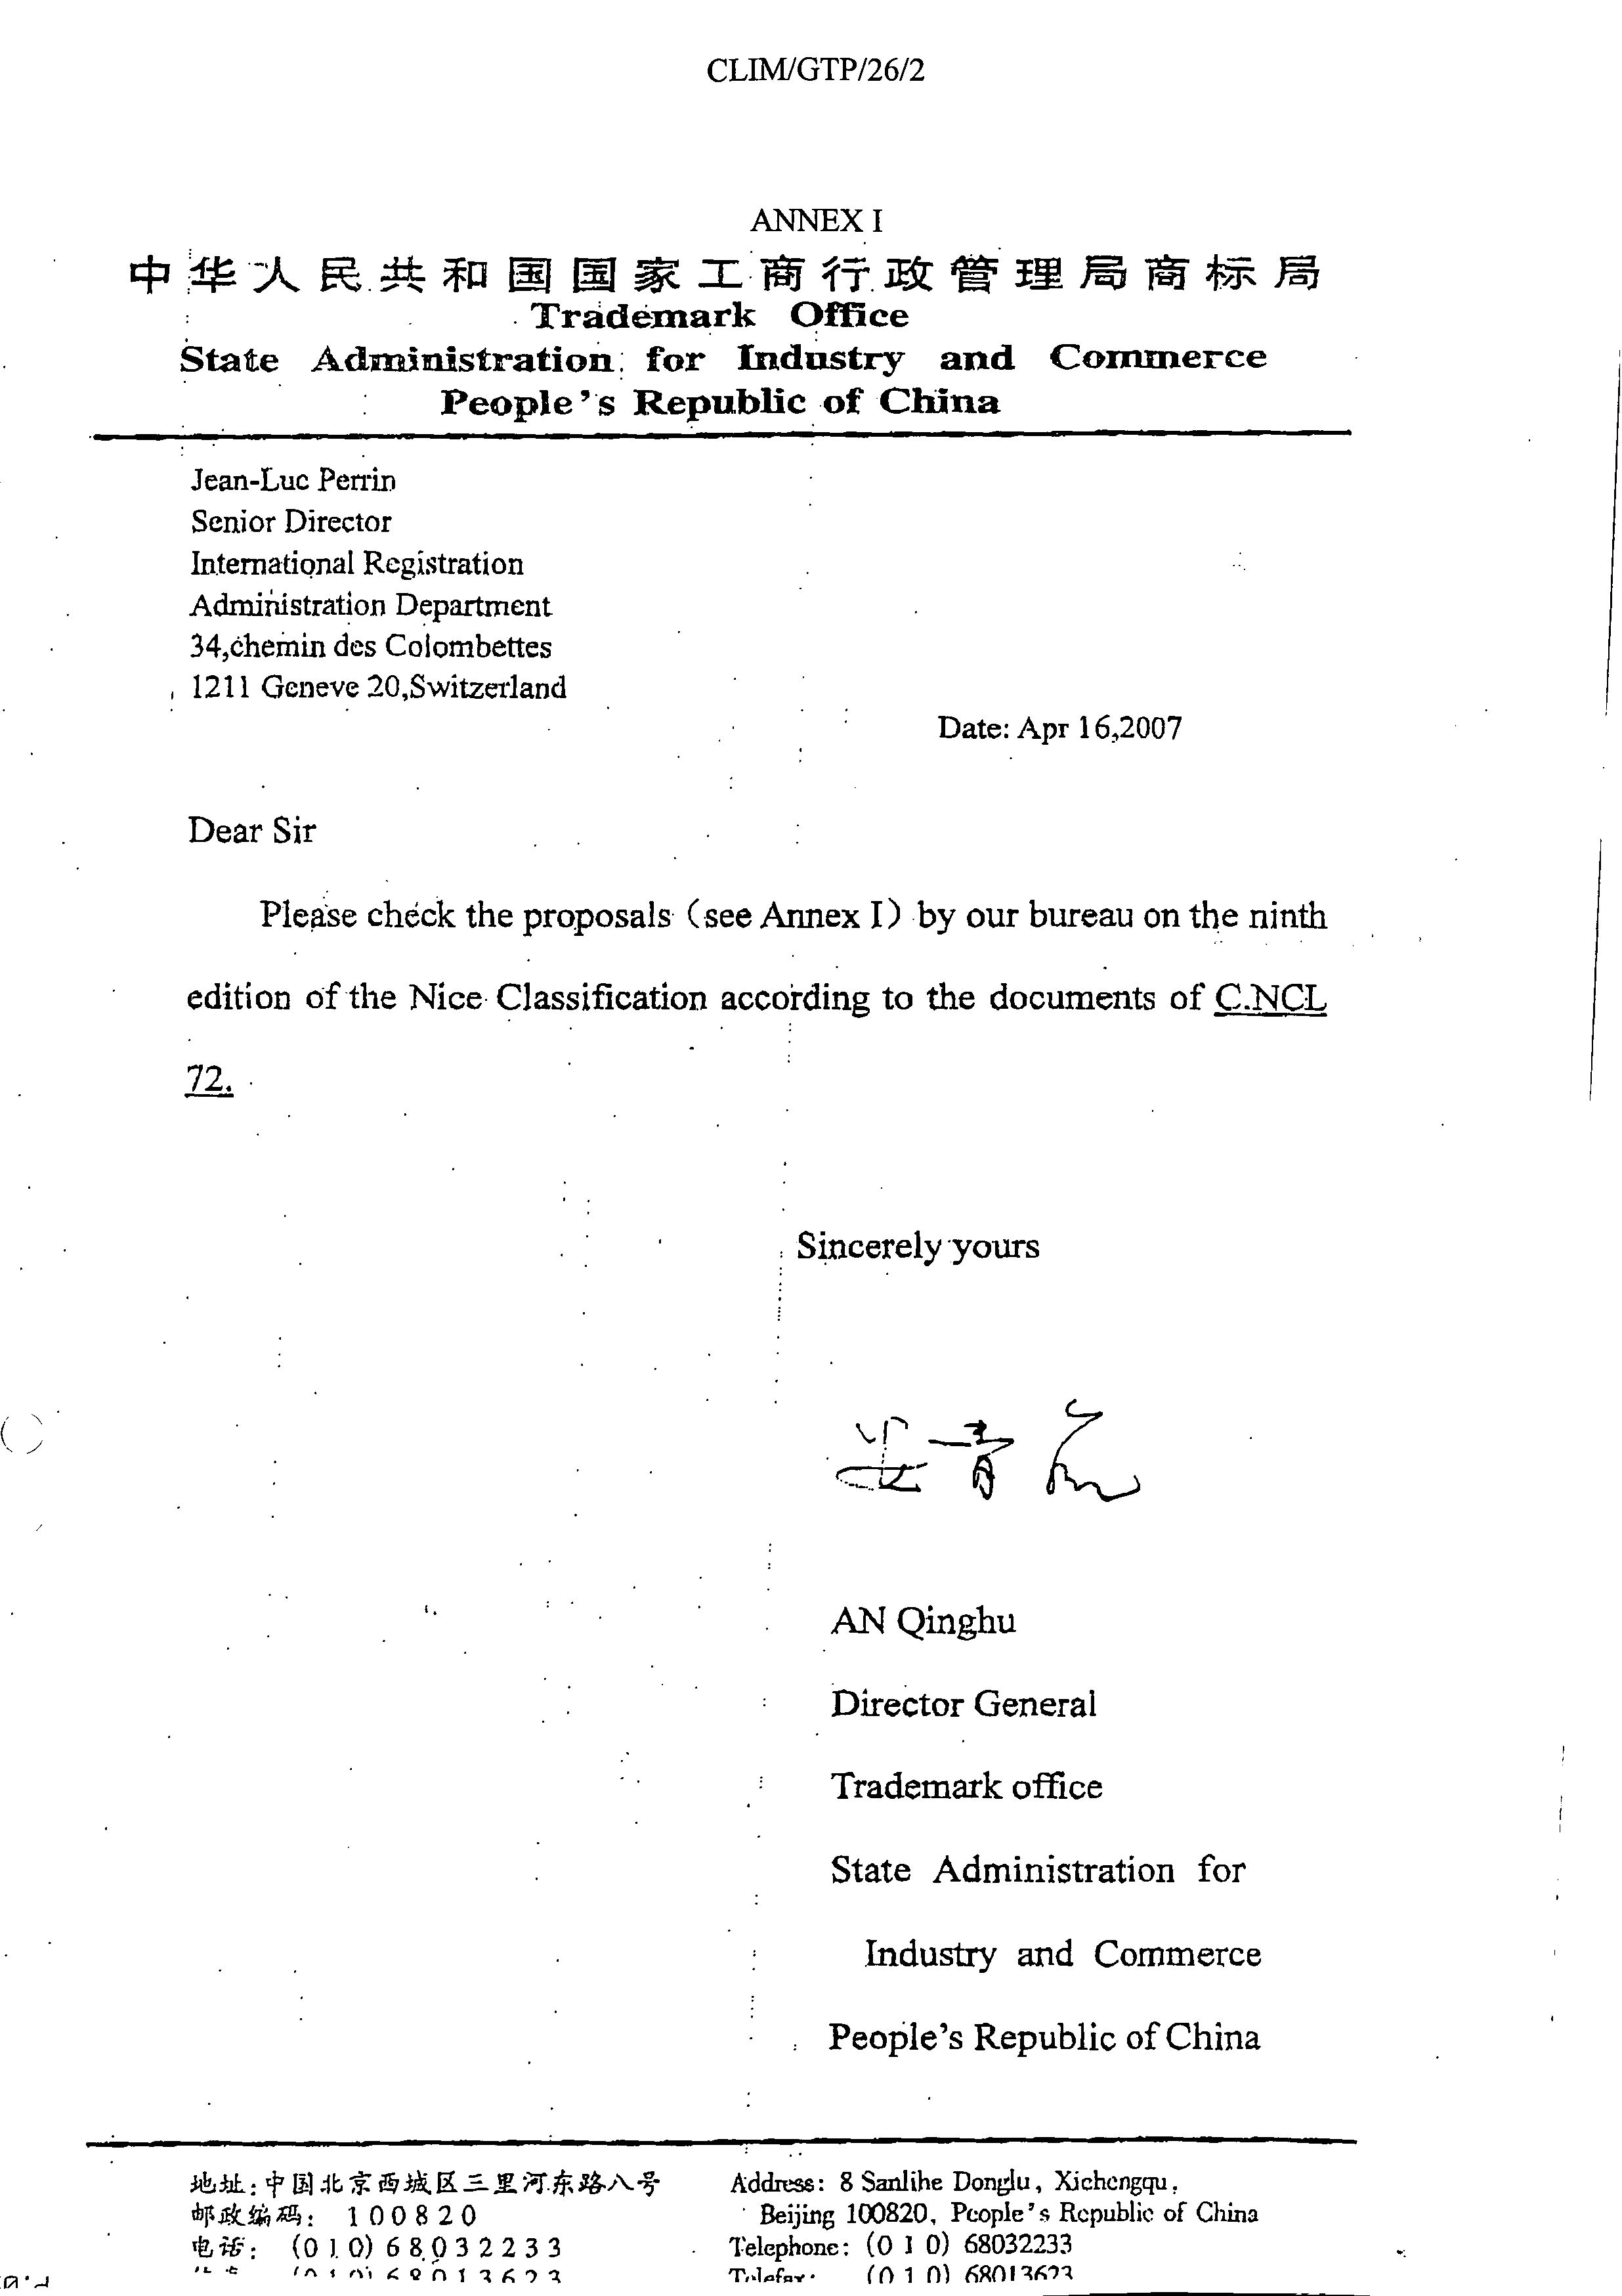

Category 1-New indications

Class | Basic No. | Proposal
1 |  | Genes of seeds for agricultural production
3 |  | Automatic washing-up mashing drier
20 |  | Knobs, not of metal
29 |  | Milk shake
39 |  | Funicular transport

Category 2-Exisiting indications to be deleted

Class | Basic No. | Proposal
21 | 210249 | Delete K0063 “Knobs of porcelain”
42 | 420159 | Delete R0044 “Rental of computer software” and S0055 “Software (Rental of computer-)

Category 3-Exisiting indications to be changed or transferred

Class | Basic No. | Proposal
8 | 080059 | Transfer T0002 “Table cutlery (knives, forks and spoons)” and T0026 “Tableware (knives, forks and spoons)” to Class 21
8 | 080070 | Transfer T0003 “Table forks” to Class 21
8 | 080078 | Transfer C1105 “Cutlery*” to Class 21
8 | 080080 | Transfer S0755 “Spoons*” and W0281 “Wine (Ladles for-) to Class 21
8 | 080081 | Transfer L0030 “Ladles (hand tools)” to Class 21
8 | 080203 | Transfer S0468 “Silver plate (knives, forks and spoons)” to Class 21
9 | 090428 | Transfer E0070 “Electric welding apparatus” to Class 7
9 | 090456 | Transfer S0643 “Soldering apparatus, electric” and W0185 “Welding apparatus, electric” to Class 7

[Annex II follows]
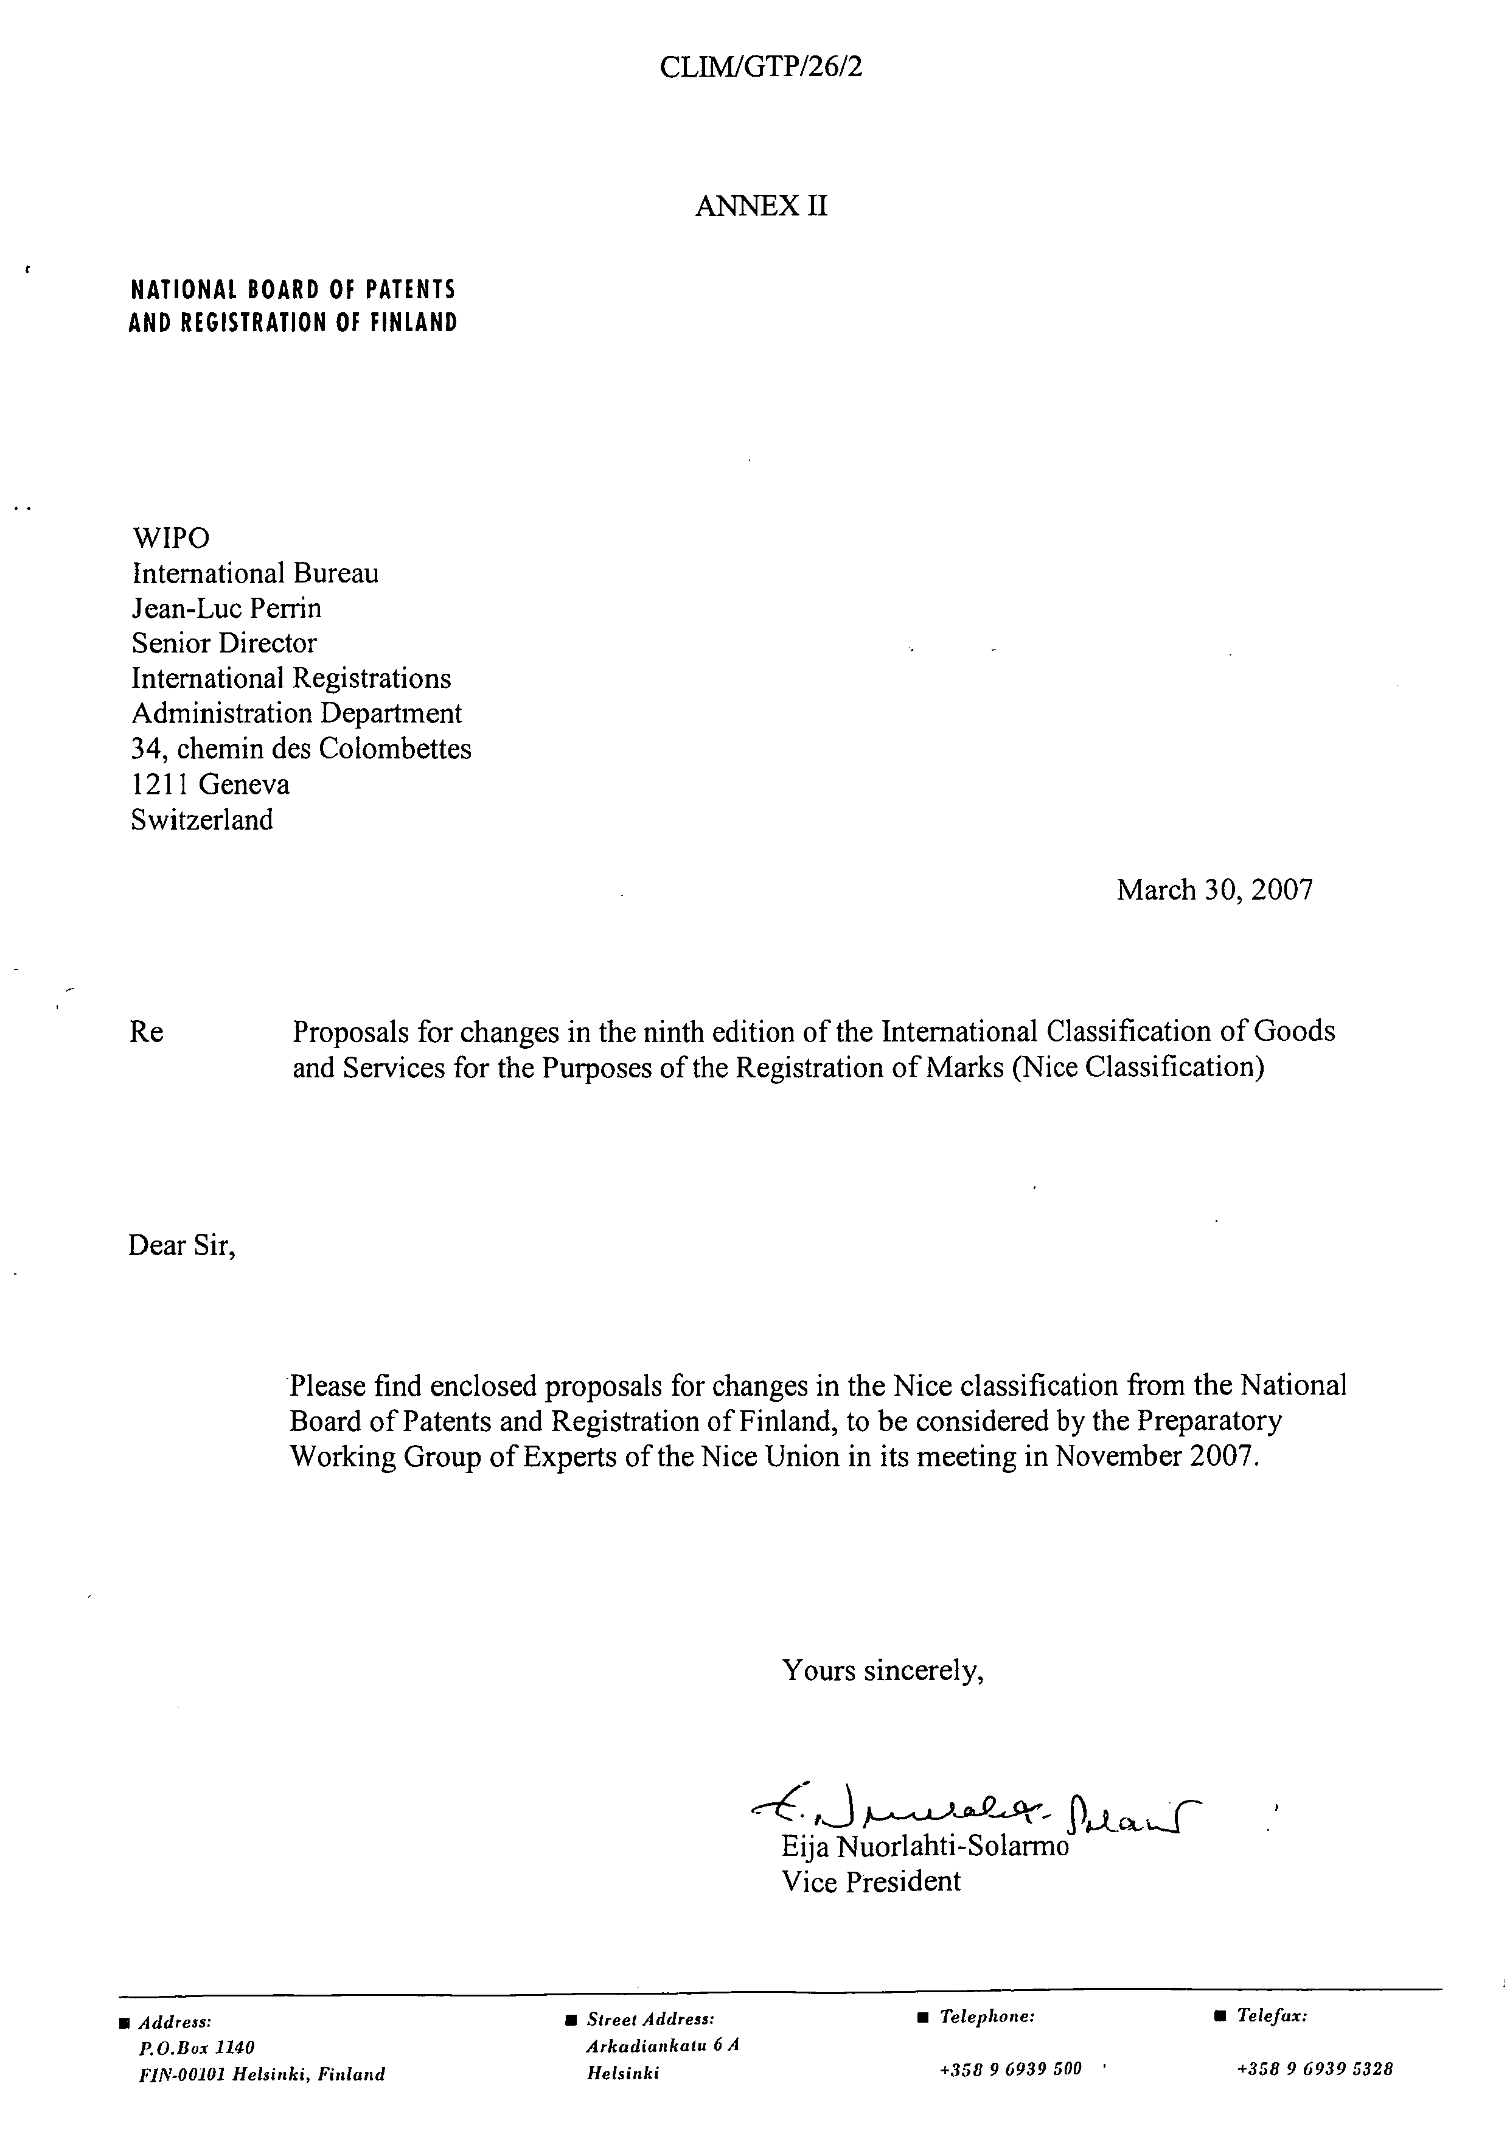
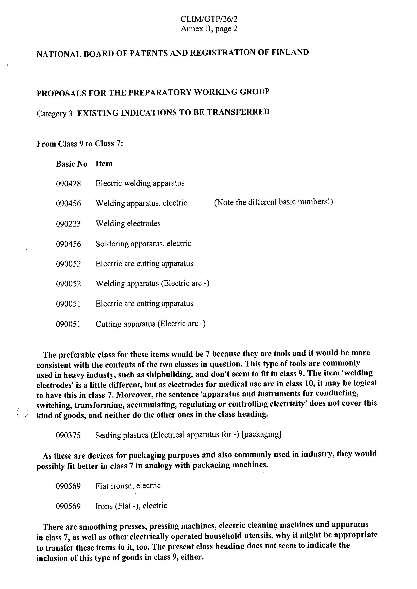
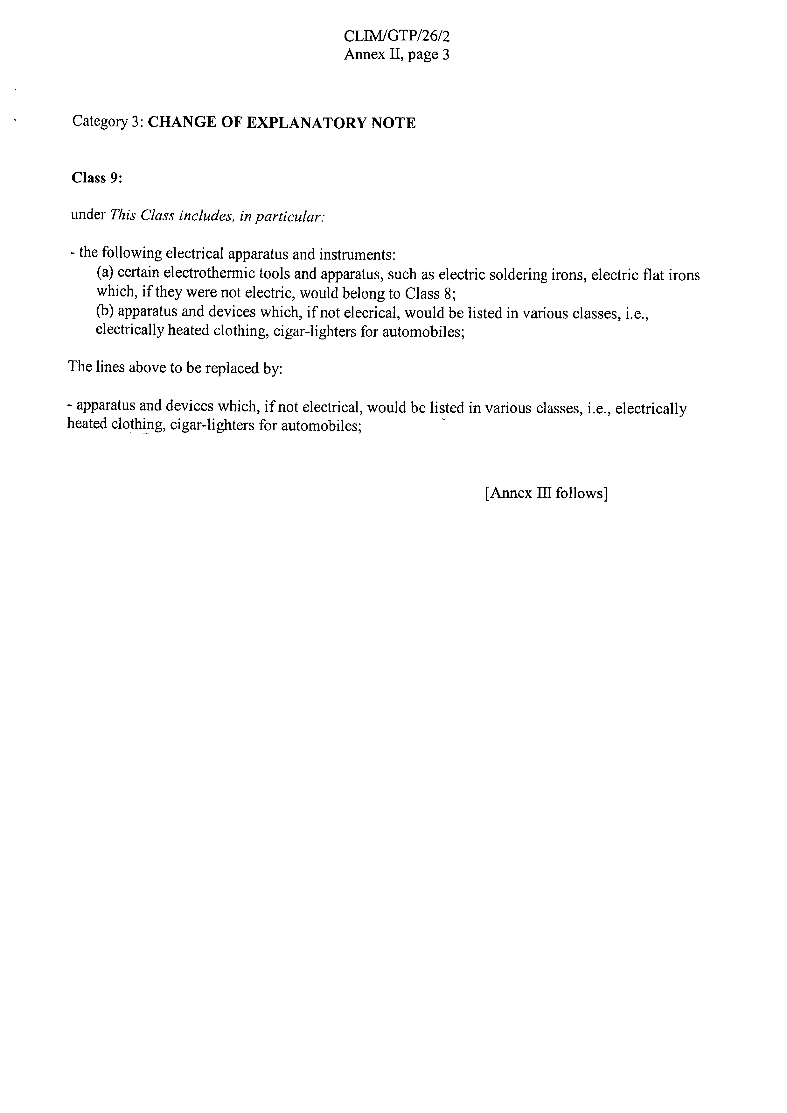

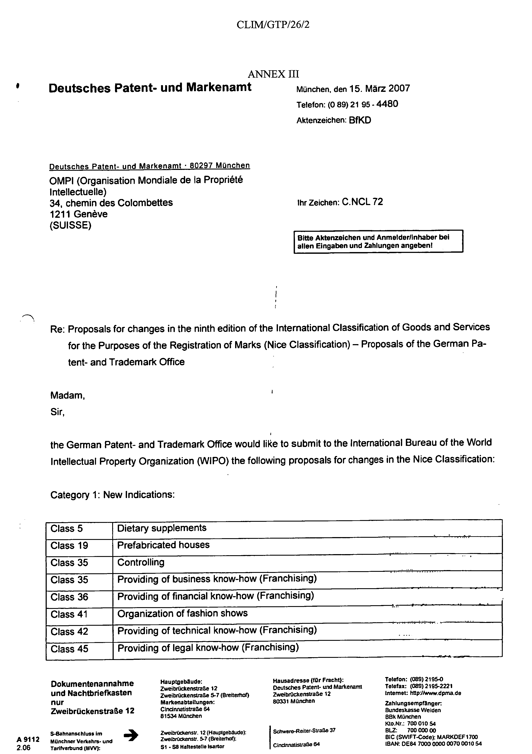

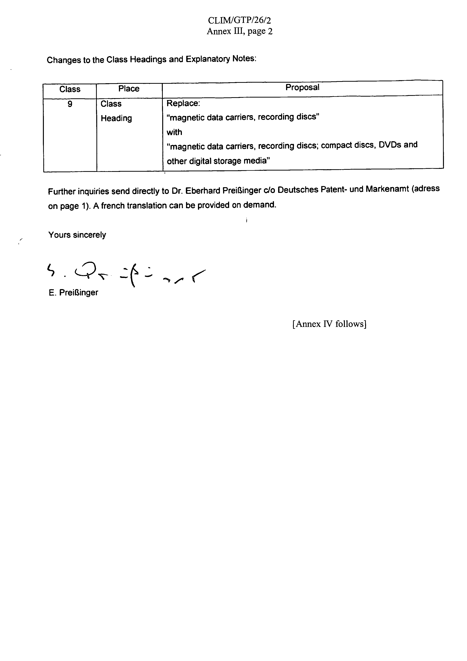

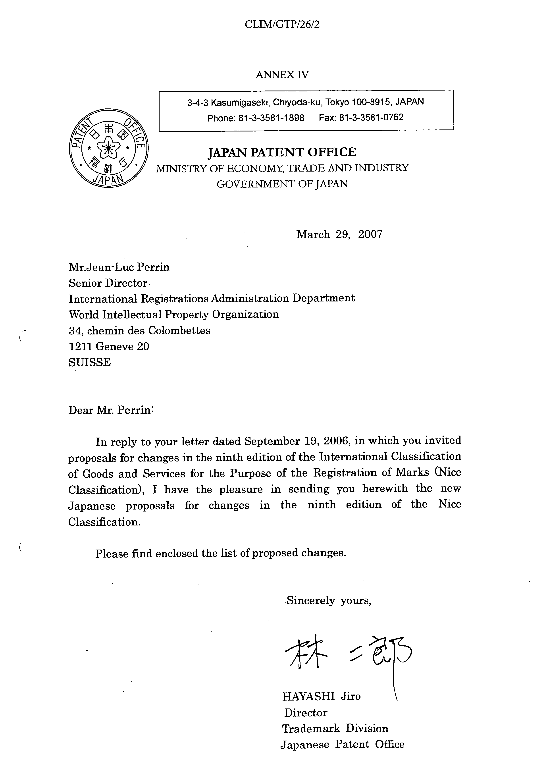

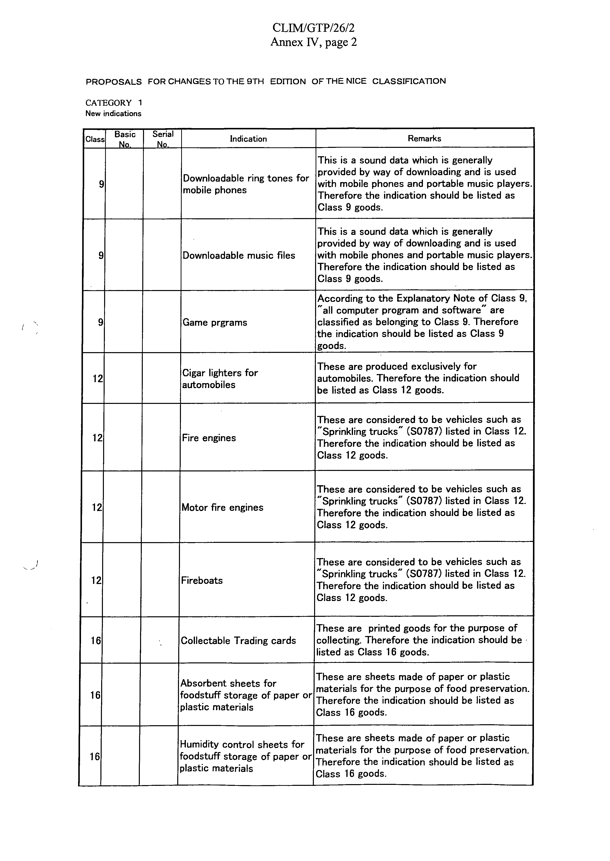

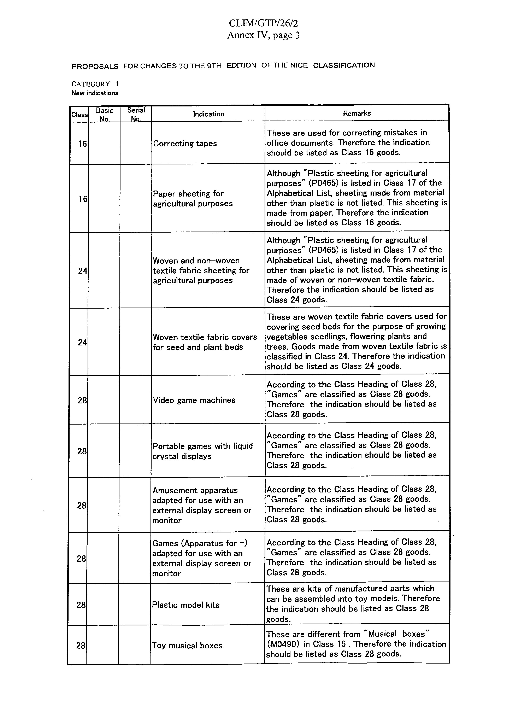

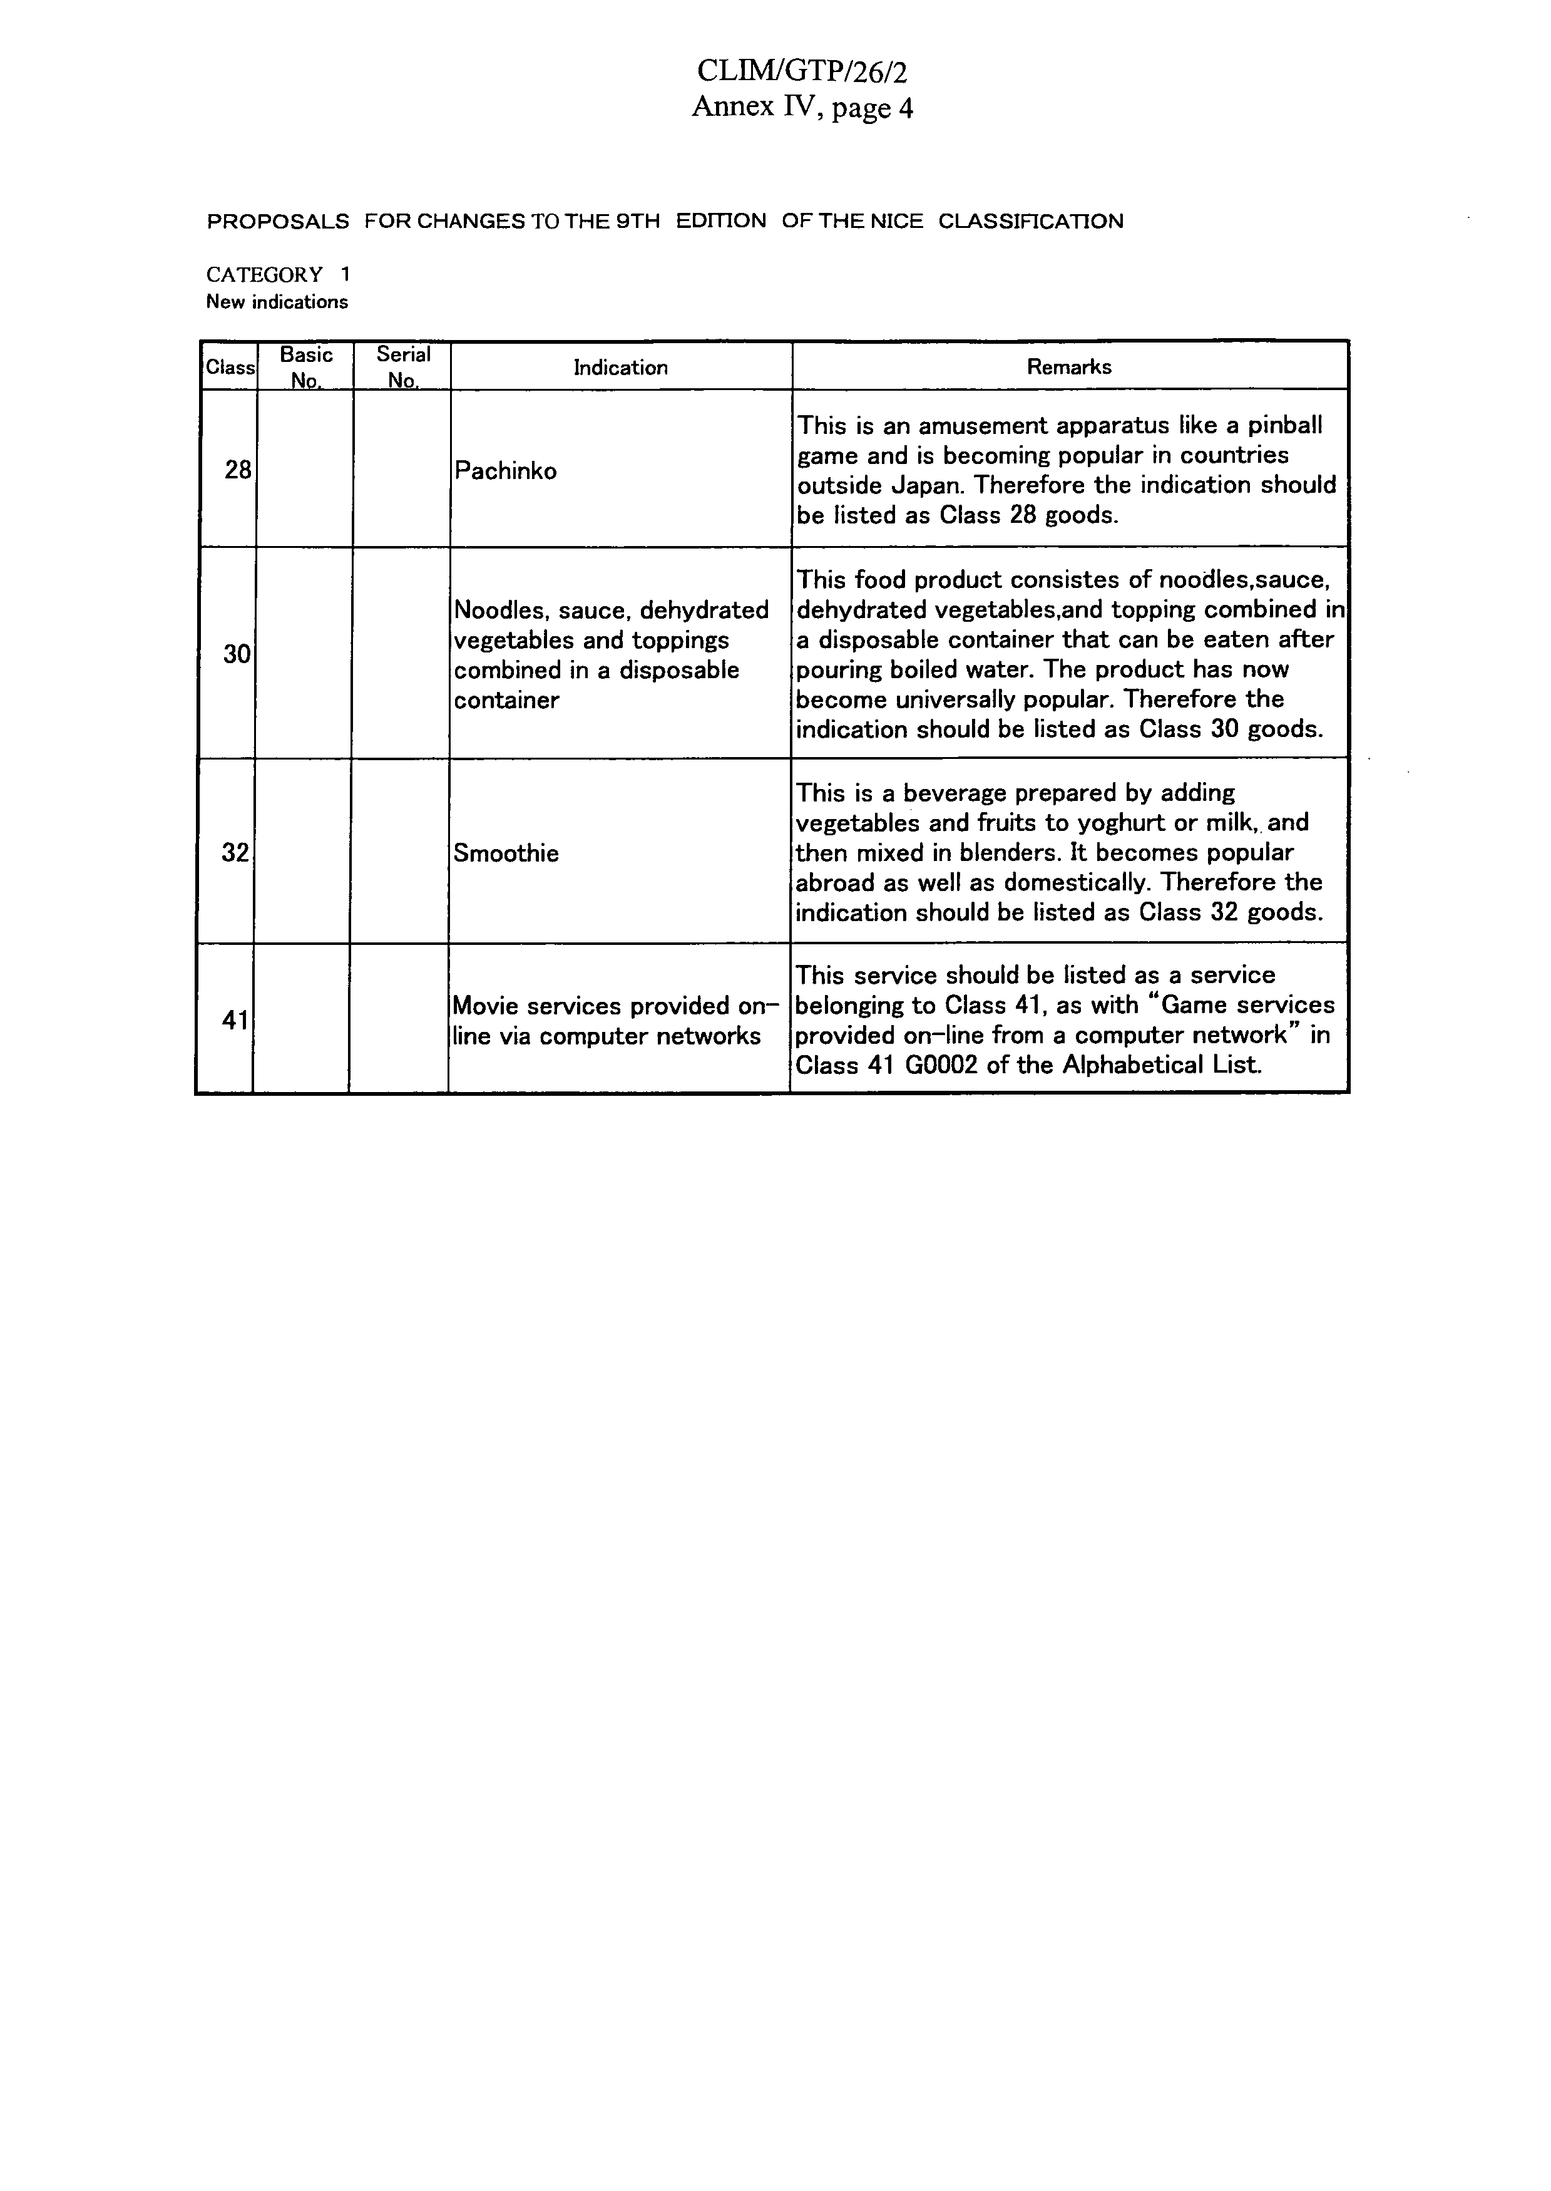
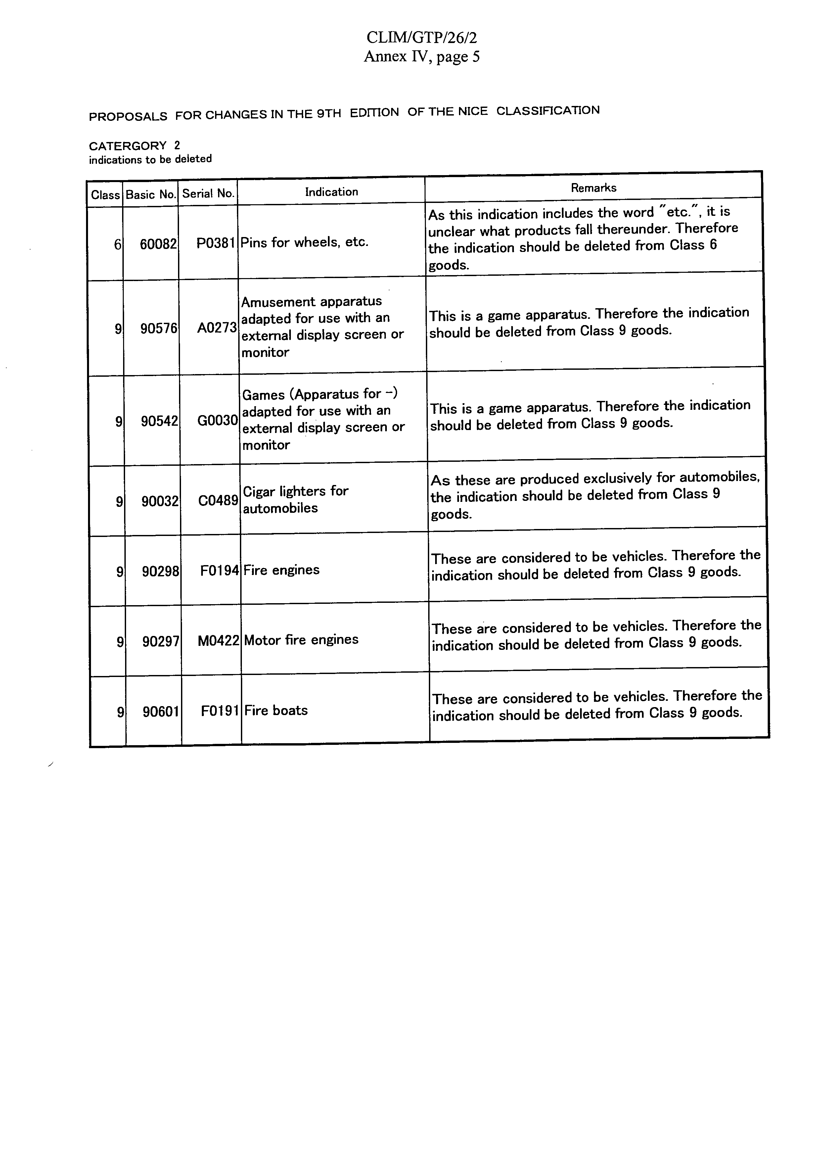
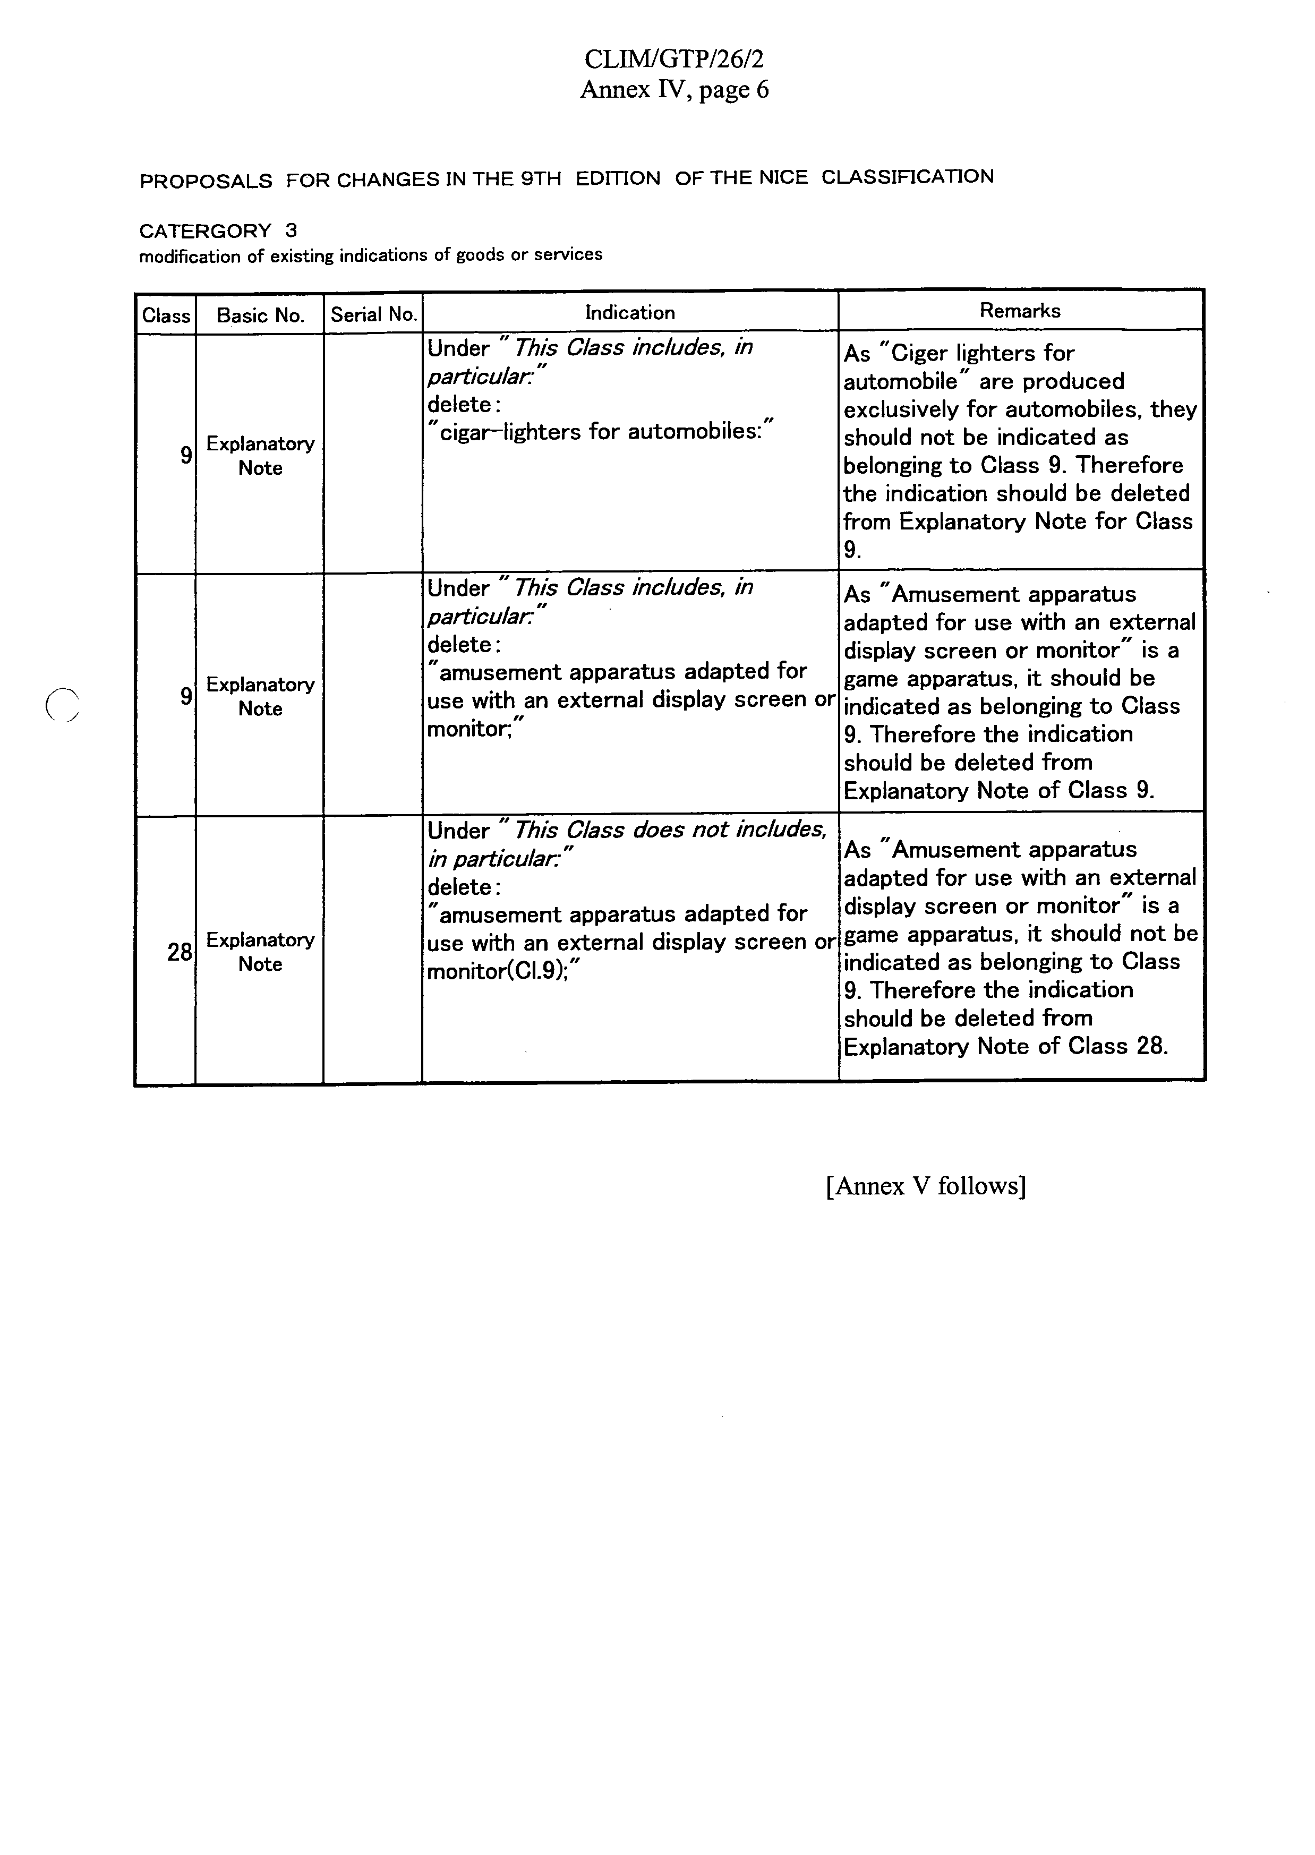

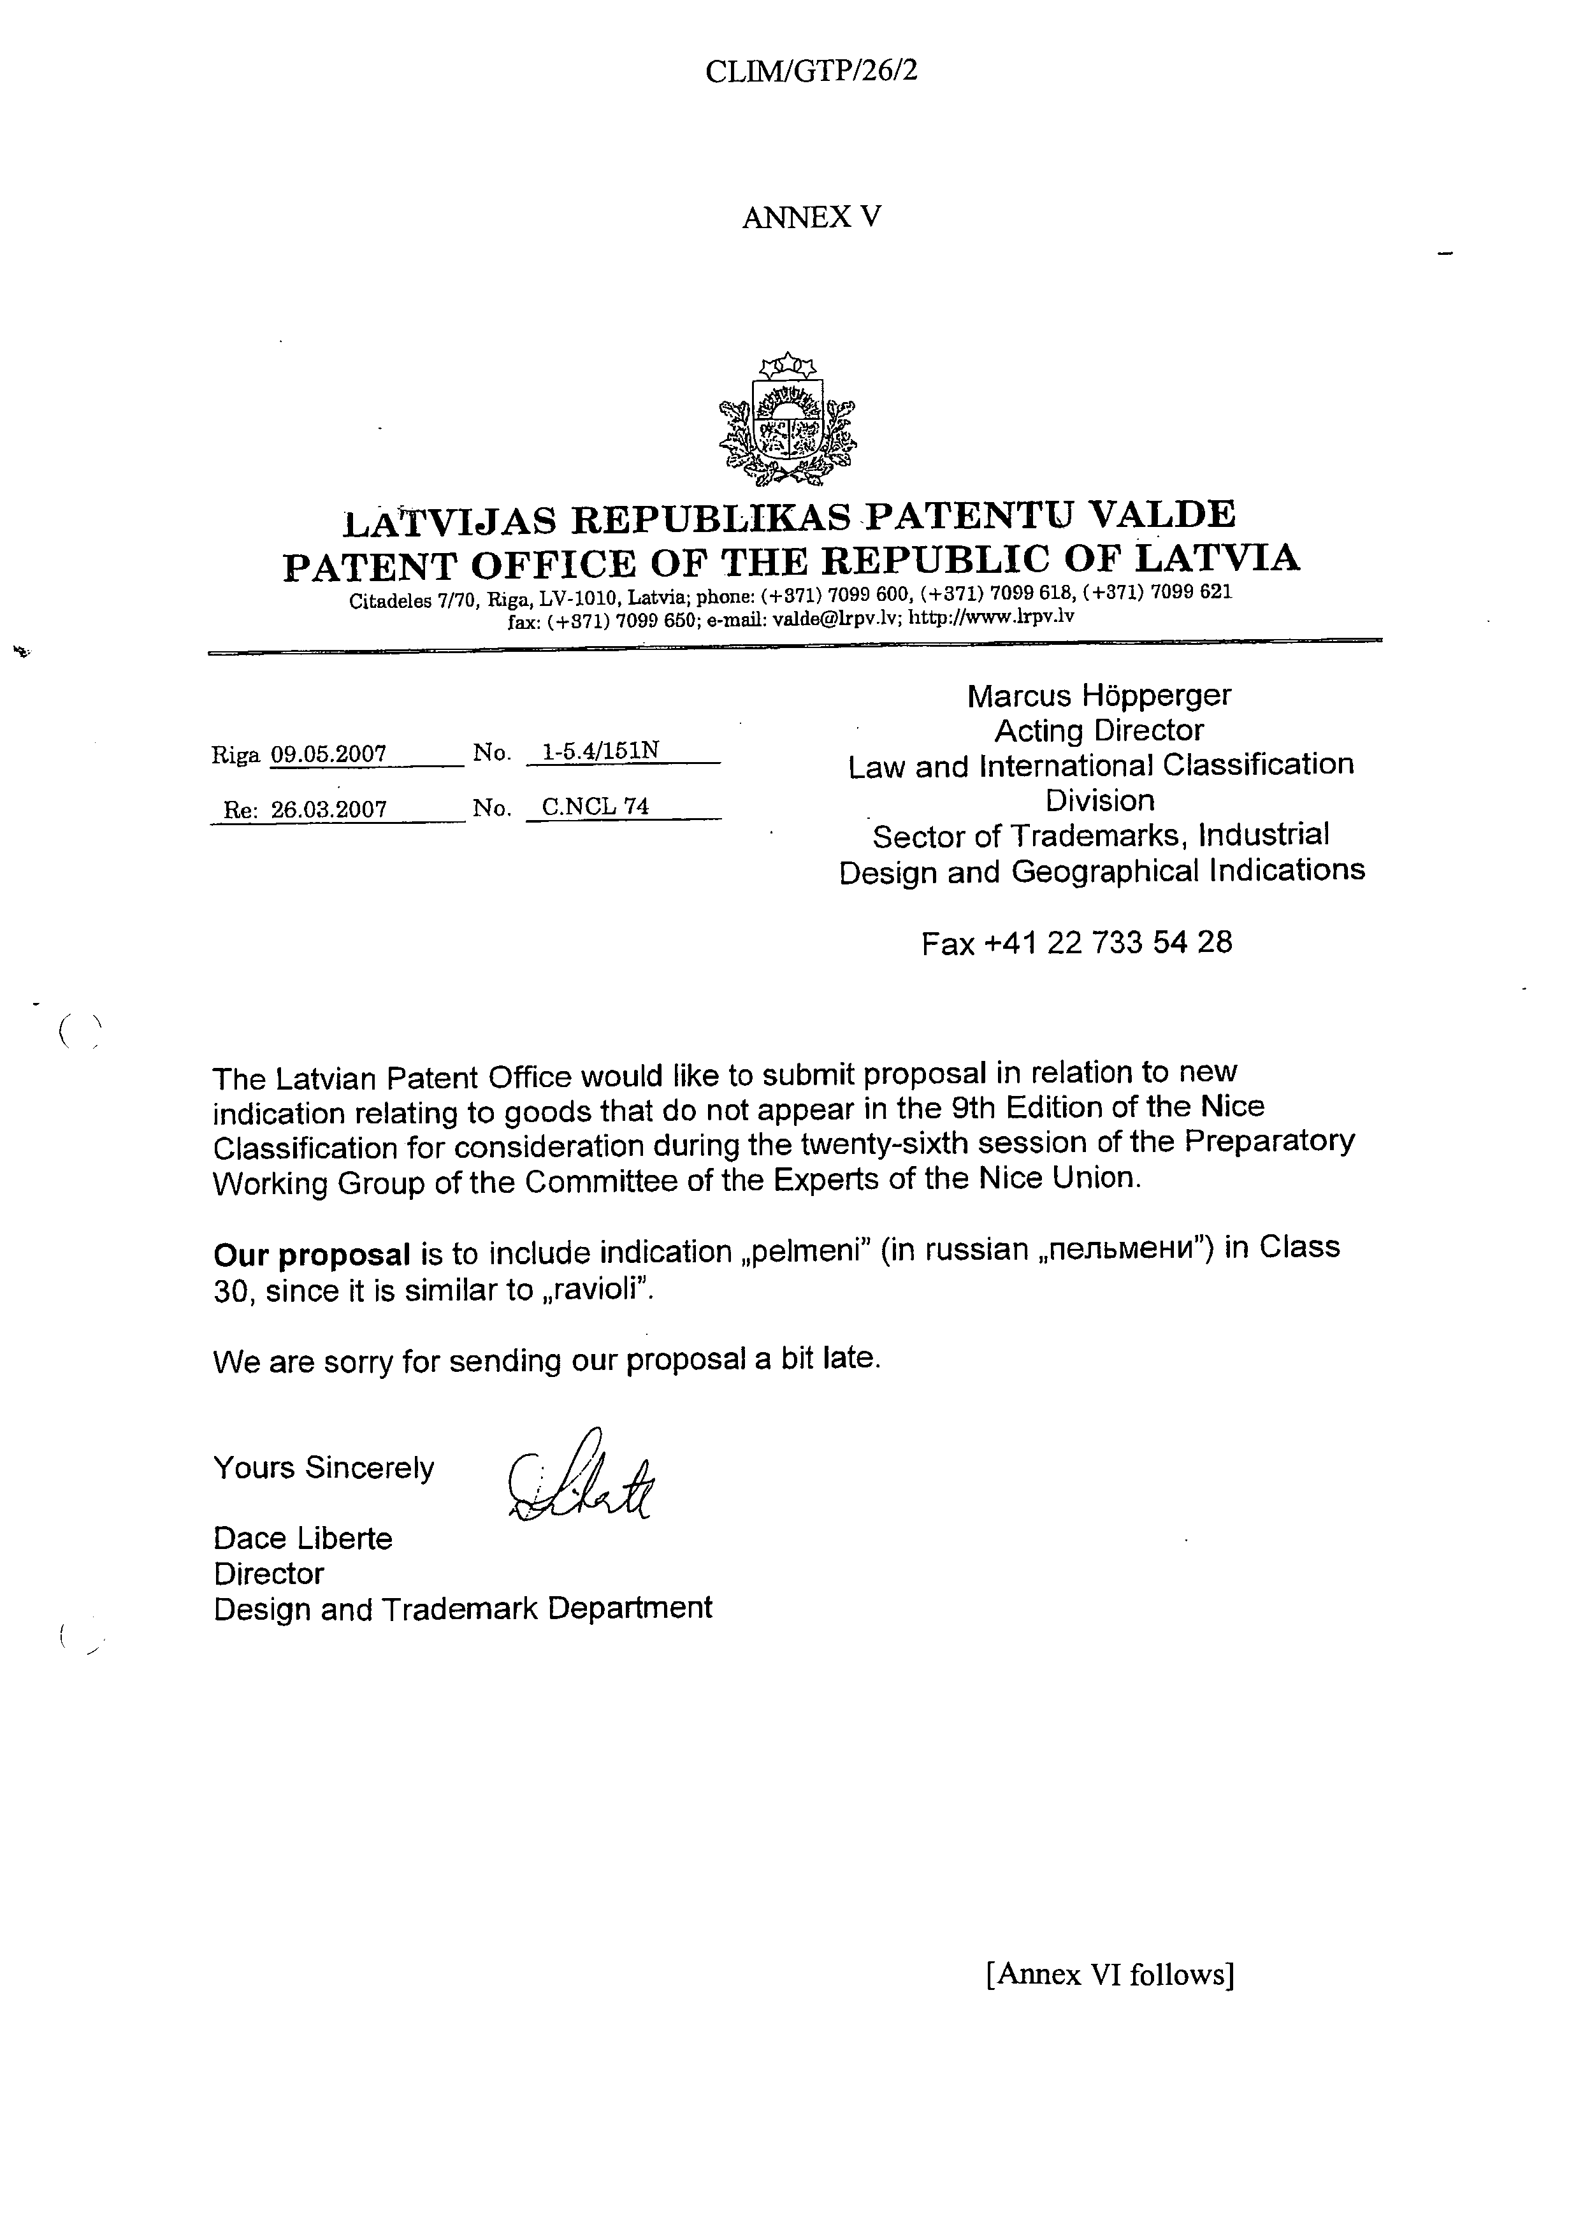

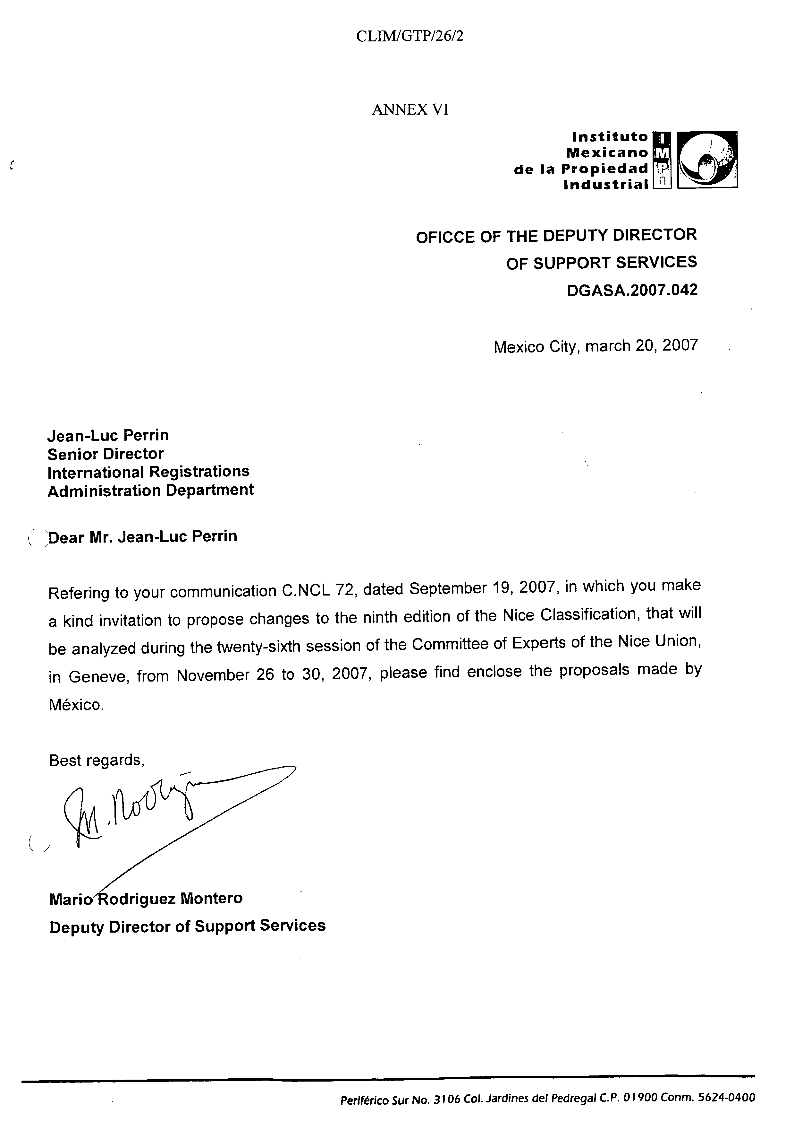
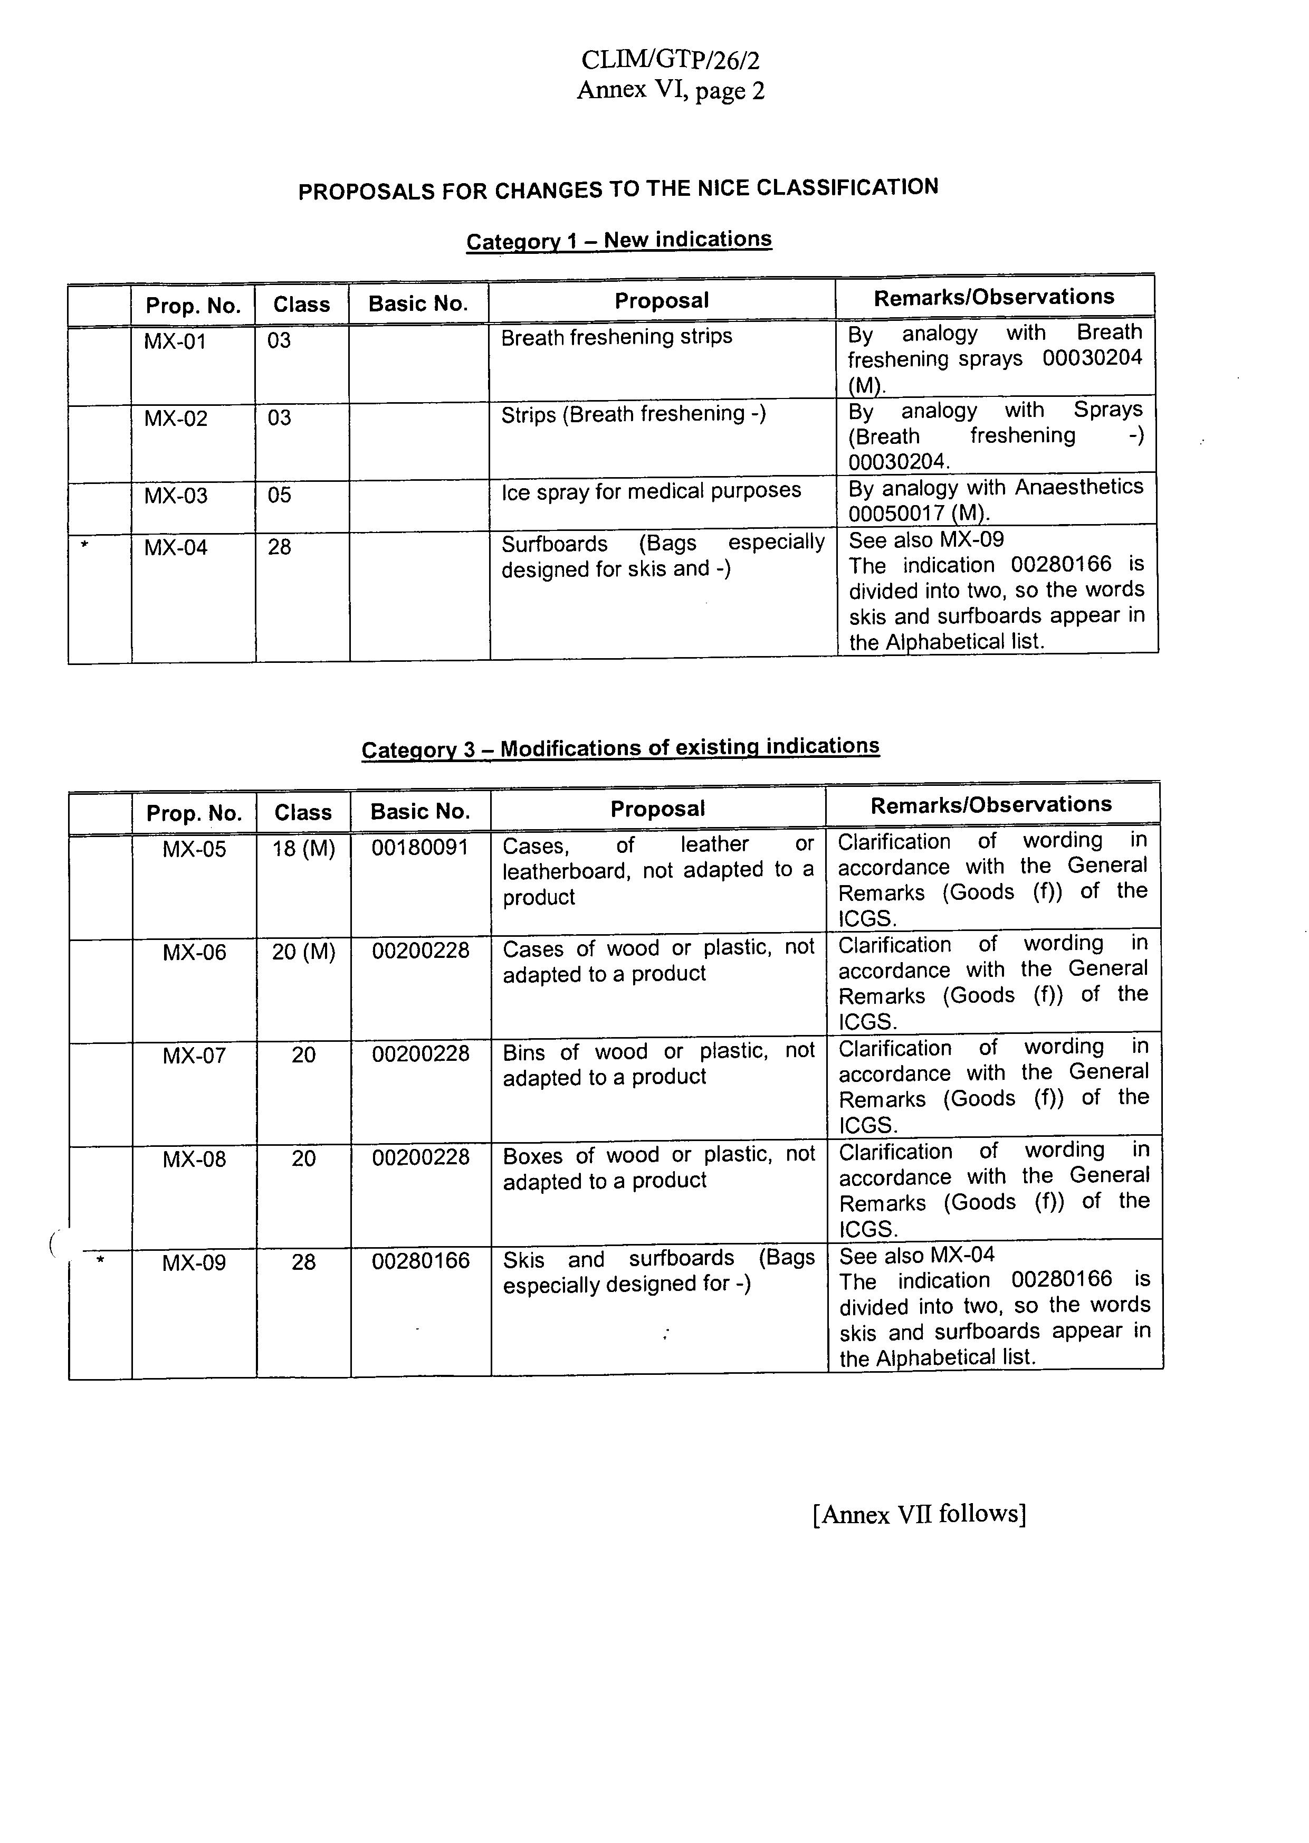
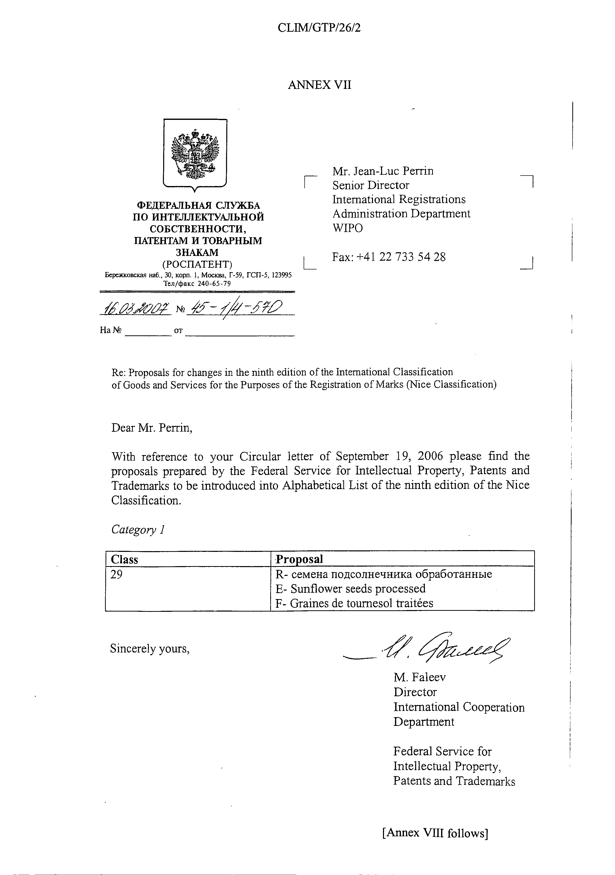

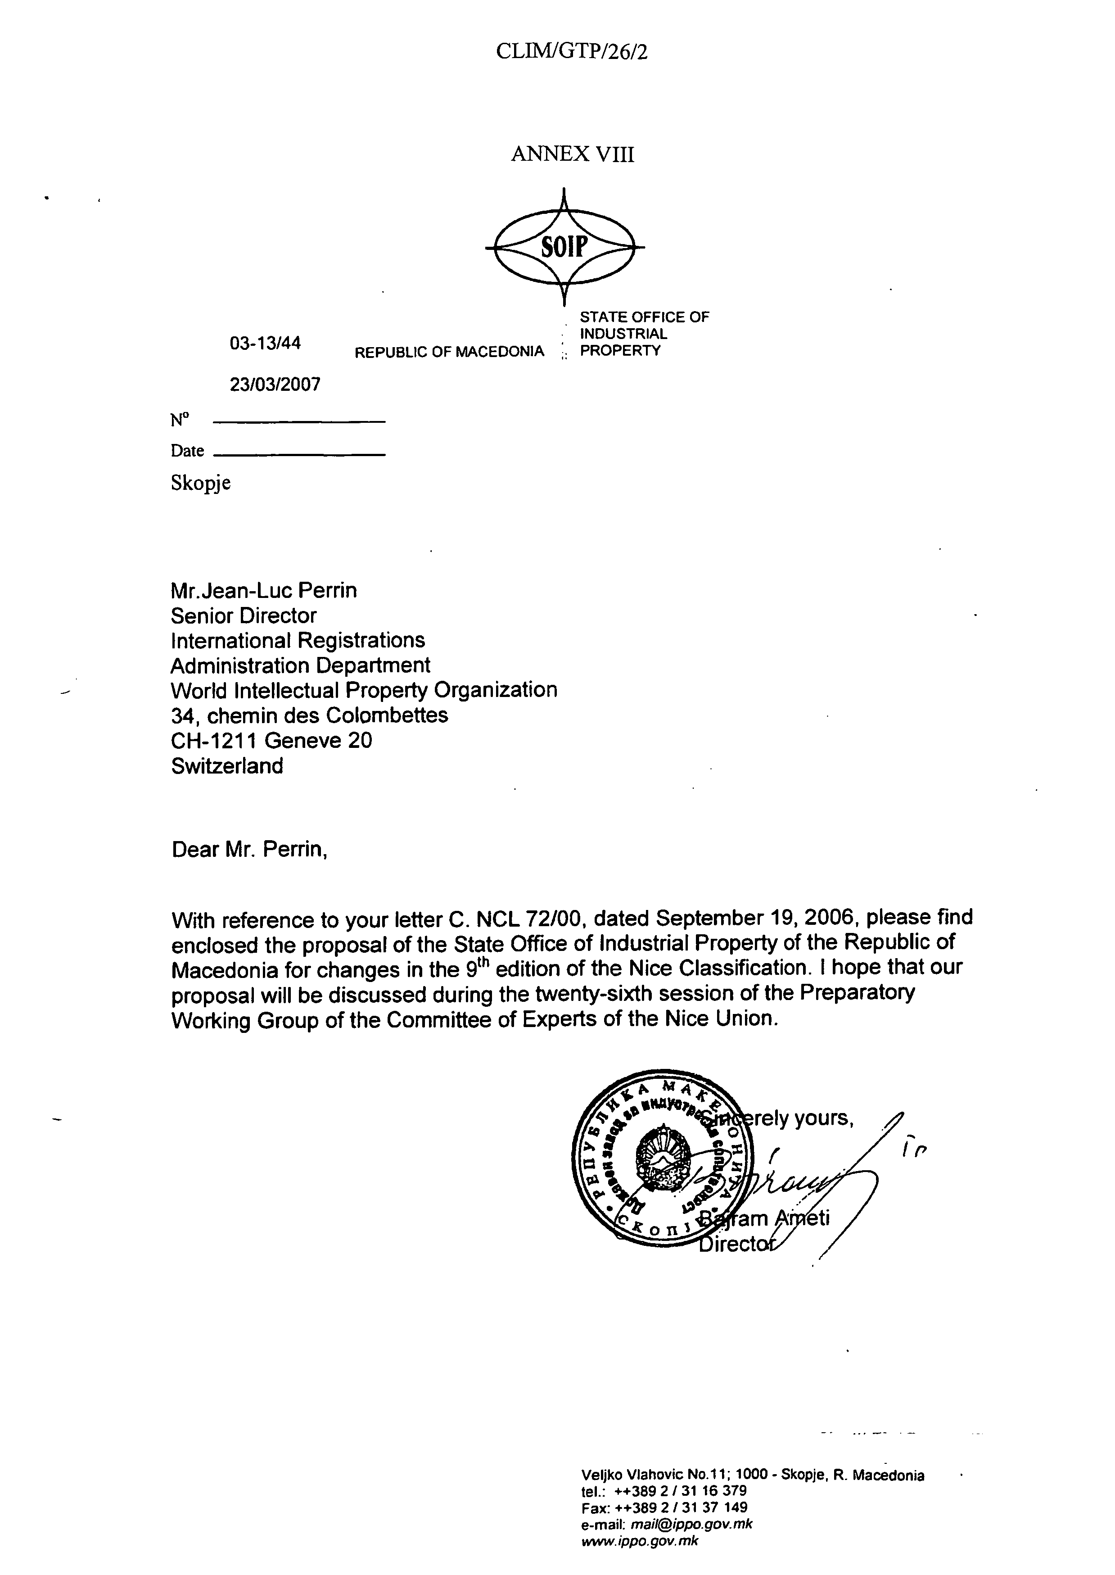
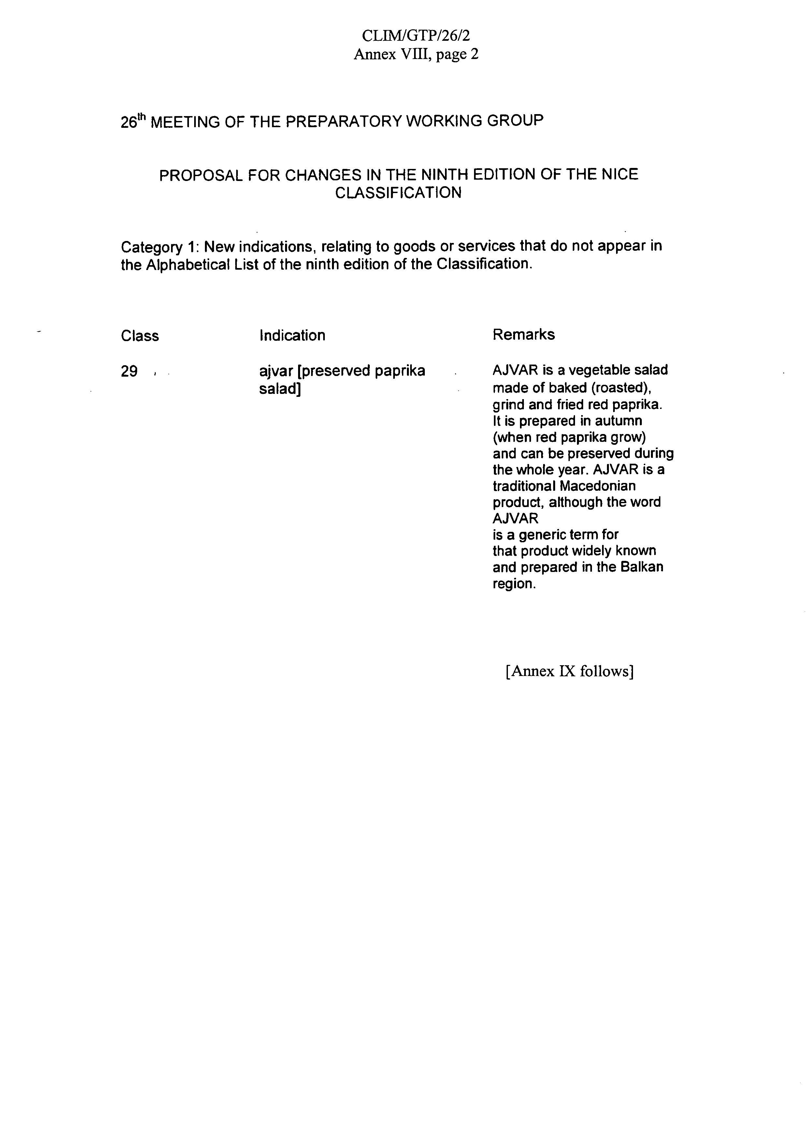

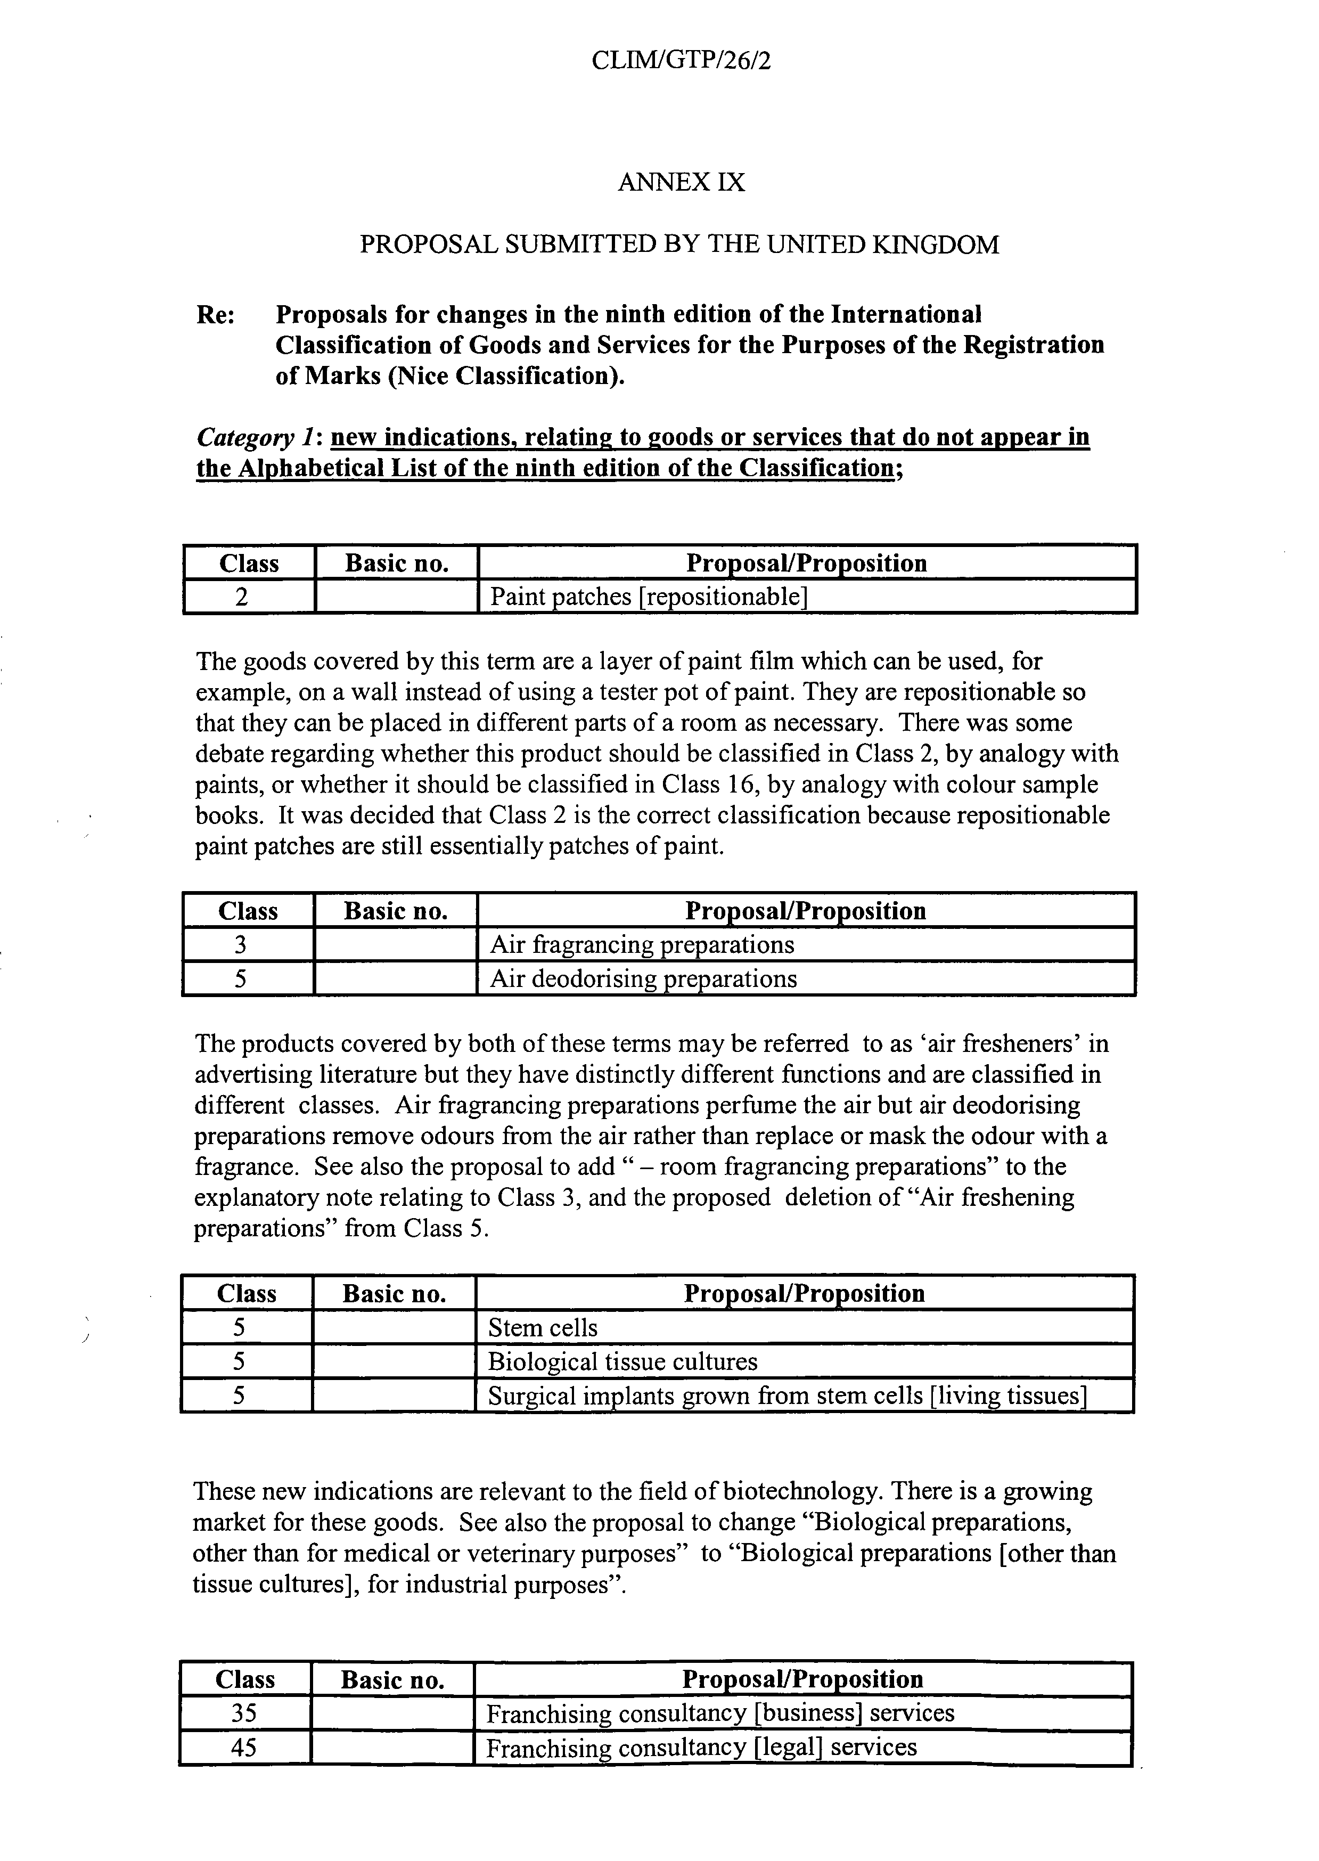
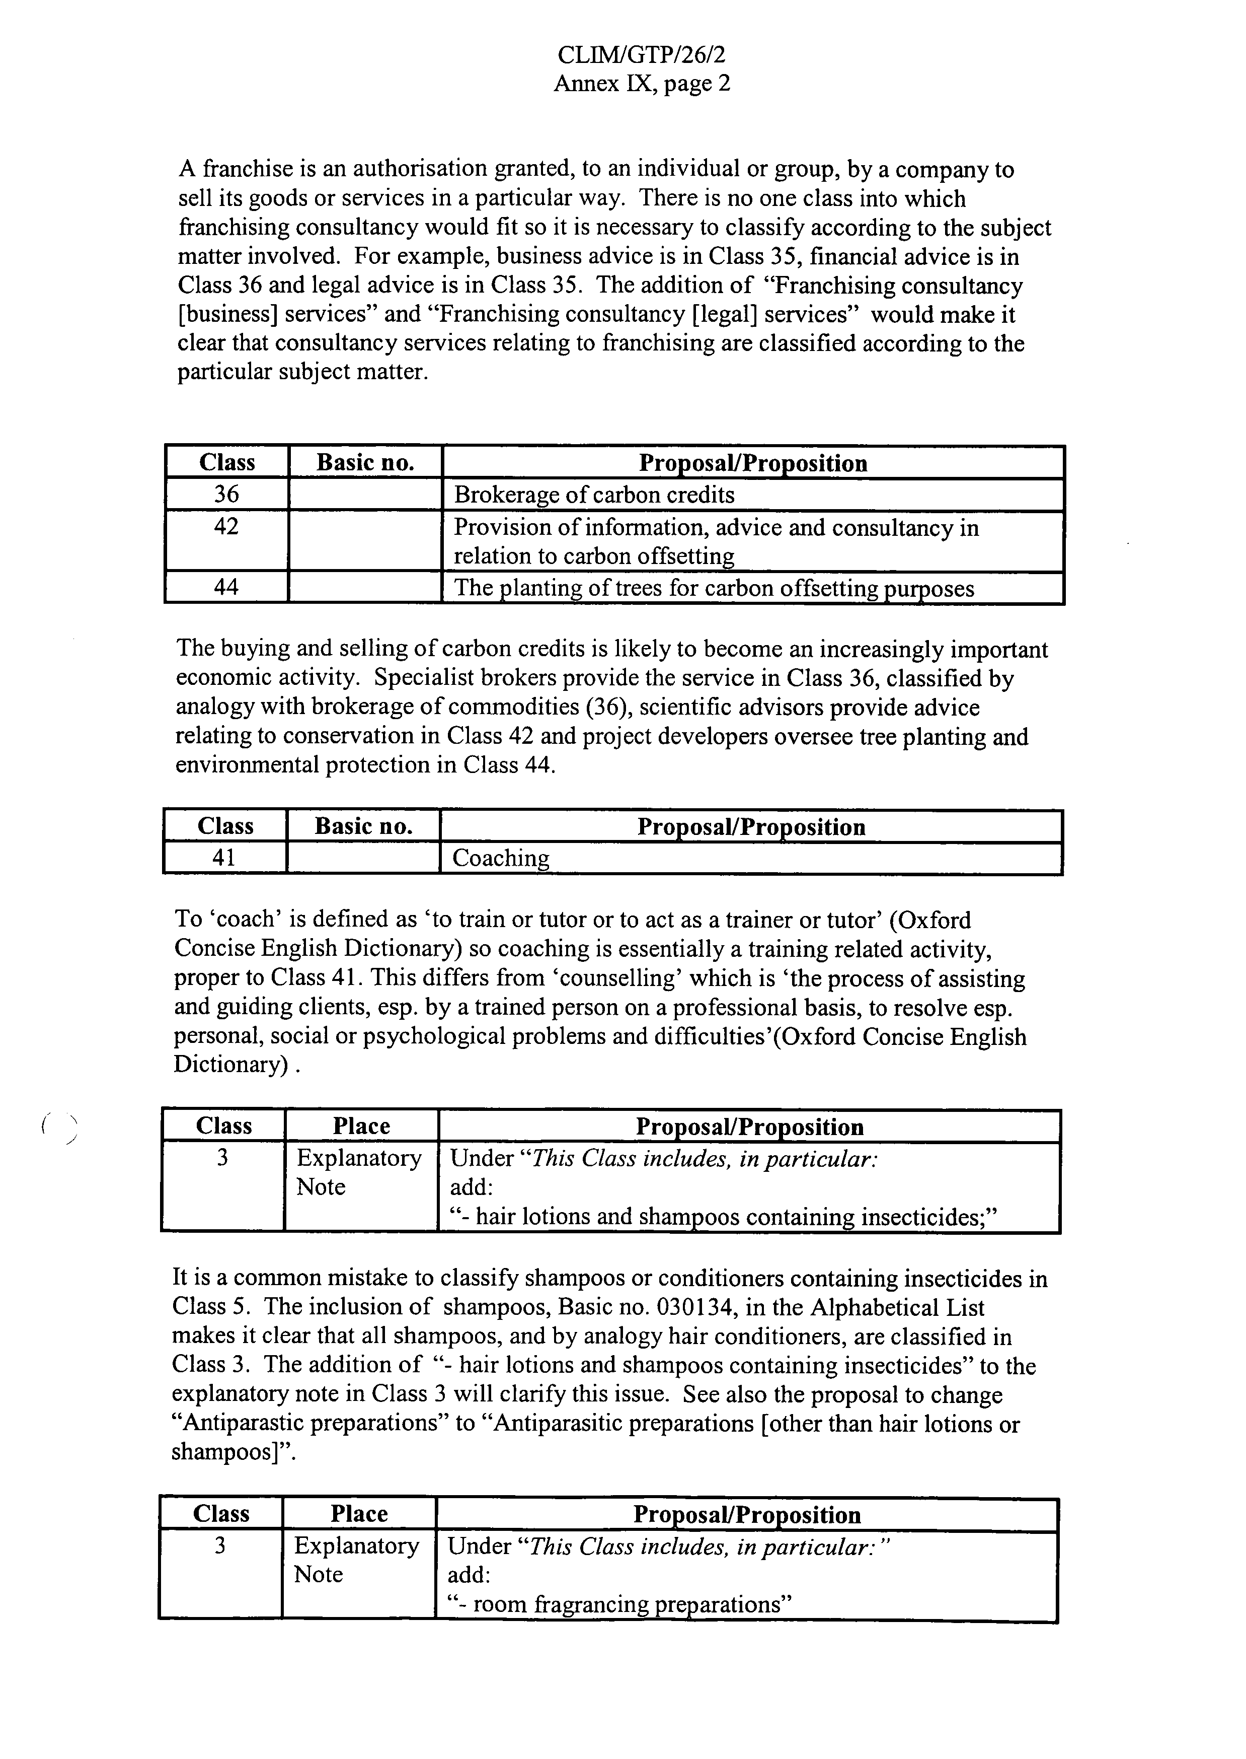
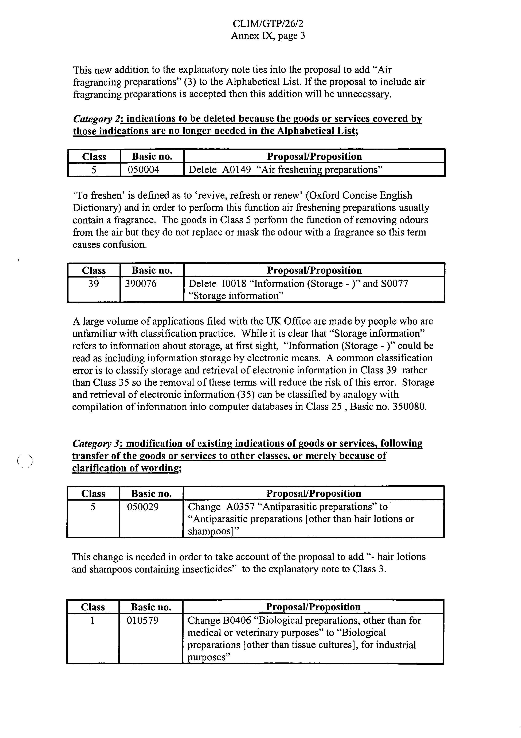

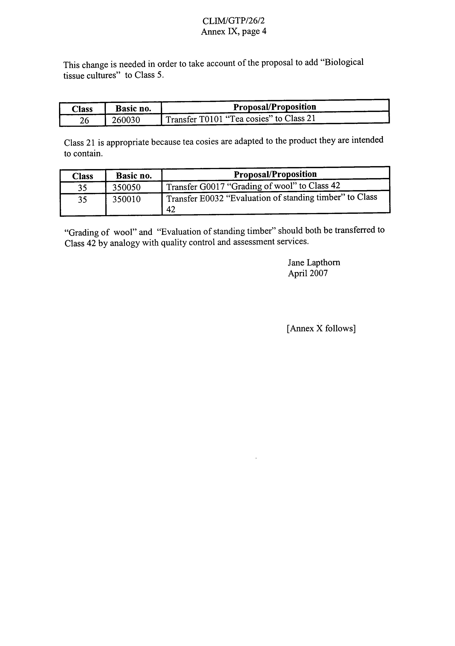
ANNEX X

PROPOSAL SUBMITTED BY THE UNITED STATES OF AMERICA

I – Additions

Class | Description | Reason
3 | Deodorants for pets
3 | Douching preparations for personal sanitary or deodorant purposes
4 | Ethanol [fuel] | New type of fuel.
4 | Oil and fats used as a component in further product manufacture
5 | Anti-dandruff preparations
5 | Antimicrobial preparations | Akin to antibacterial preparations.
5 | Dietary and nutritional supplements
5 | Douching preparations for medical purposes
5 | Nutritional supplements
5 | Personal lubricants | Not necessarily a medicated preparation or for medicated purposes, but not a Class 4 item.
5 | Sanitary tampons | Analogous to Sanitary napkins 050234
6 | Ascenders made of metal [mountaineering equipment]
6 | Chimney flues of metal
6 | Key rings of common metal
6 | Piggy banks of metal
6 | Piggy banks of precious metal
6 | Stair-treads [steps] of metal | Stair-treads [steps] not of metal are in the alphabetical list in 19 (1900740)
7 | Gas generators [machines]
7 | Gas-operated blow torches
7 | Steam generators [machines]
8 | Fish tapes | Hand tool used by electricians to route wiring through walls
8 | Flatware [tableware] | Knives, forks and spoon
9 | Crash dummies
9 | Electric blow torches
9 | Fabric steamers | Performs same function as flat irons (090569)
9 | Gaming machines for gambling | These are calibrated gambling machines and should be in 9.
9 | Garment steamers | Performs same function as flat irons (090569)
9 | Hourglasses [time measuring apparatus]
9 | Laboratory centrifuges
9 | Ophthalmic lenses
9 | Printed circuit boards
9 | Slot machines | These are calibrated and should be in 9
10 | Douche bags
10 | Love dolls | Anatomically accurate human figures or human parts used for sexual activity
10 | Massage tables
10 | Microdermabrasion apparatus
10 | Surgical scrub suits | Based on 100200, "clothing especially for operating rooms"
11 | Bread-making machines
11 | Machines for the separation and purification of water | Based on 110135 Purification installations for sewage - proposed language can be confused with separators and other cleaning machines in 7
11 | Yogurt-making machines
13 | Ammunition belts
13 | Ammunition cartridge belts
13 | Torpedos
14 | Beads for making jewelry | Pieces of jewelry
16 | Bulletin boards
16 | Document holders
16 | Paint trays
16 | Paper party hats | These are for amusement or decorative purposes, not for use as clothing
16 | Passport cases | Based on 160340 passport holders - these are essentially the same item but are sometimes classified in Class 18
17 | Electrical ceramic insulators
17 | Vapor barriers in the form of sheeting
18 | Credit card cases
18 | Gym bags
19 | Chimney flues not of metal
19 | Plaster figurines
19 | Pulse meters
20 | Blinds (Indoor window -) | Cross reference of 200272
20 | Futons
20 | Indoor window shades
20 | Key rings of plastic
20 | Planters
20 | Shades (Indoor window -)
20 | Trays, not of metal, for commercial purposes
20 | Wall-mounted diaper changing platforms | In the nature of a changing table, but usually of plastic and mounted to the wall in a public facility, such as a restroom.
20 | Window blinds of textile [interior]
20 | Window boxes
20 | Window shades [interior]
21 | Mop wringers
21 | Non-woven cloths for cleaning
21 | Waste paper baskets
22 | Bobbins for retaining embroidery floss or wool [not parts of machines]
24 | Baby changing mats
25 | Laboratory coats | To distinguish from 090691 "clothing especially made for laboratories;" lab coats are merely apparel and not protective
25 | Motorcyclist's clothing | Based on 250002, Motorists' clothing is in 25 and such goods are mistakenly put in Class 9 as "clothing for protection against accidents"
25 | Skorts | Combination garment of a skirt and shorts
26 | Beads for handicraft work | Adornments
28 | Air mattresses for recreational purposes
28 | Arcade video game machines
28 | Engines for toy model vehicles | Could also be in 7
28 | Floats for bathing and swimming for recreational purposes
28 | Foosball tables | Table-top football/soccer games, not a piece of furniture.
28 | Gaming chips [or poker chips] | Article for use in gaming, not encoded, used with playing cards as a substitute for money.
28 | Remote controls for toy model vehicles | Could also be in 9
28 | Ropes for rock climbing [sports articles] | Could also be in 22
28 | Swimming flutter boards
28 | Swimming kick boards
28 | Tickets for playing lottery games
28 | Water wings for recreational purposes
29 | Fish mousses
29 | Non-alcohlic egg nog | Made of milk or cream, eggs and sugar
29 | Potato flour
29 | Vegetable mousses
30 | Cake frosting
30 | Cake icing
30 | Candy apples
30 | Chocolate mousses
30 | Chocolate-coated nuts
30 | Dessert mousses
30 | Fruit coulis
30 | Marinades
31 | Top soil
32 | Smoothies
35 | Data processing services
35 | Leasing of photocopy machines
35 | Leasing of vending machines
35 | Tax assessment
35 | Tax consultation
36 | Telecommunication airtime brokerage services
37 | Carpentry services
37 | Janitorial services | Includes cleaning, maintenance and minor repairs, all of which are in Class 37.
37 | Joinery services
37 | Leasing of bulldozers
37 | Leasing of construction equipment
37 | Leasing of cranes [construction equipment]
37 | Leasing of excavators
37 | Leasing of road sweeping machines
38 | Leasing of facsimile apparatus
38 | Leasing of message sending apparatus
38 | Leasing of telecommunication equipment
38 | Leasing of telephones
39 | Car leasing
39 | Coach rental
39 | Leasing of diving bells
39 | Leasing of diving suits
39 | Leasing of freezers
39 | Leasing of horses
39 | Leasing of motor racing cars
39 | Leasing of parking places
39 | Leasing of refrigerators
39 | Leasing of storage containers
39 | Leasing of vehicle roof racks
39 | Leasing of warehouses
39 | Rental of freezers
40 | Bottling services | The activity of commercial filling of bottles for others - Class 37 is also a possibility as is Class 39 based on 39022 packaging of goods
40 | Desk-top publishing services [printing]
40 | Leasing of generators
40 | Leasing of space heating apparatus
40 | Material sterilization services
40 | Sanitization services
41 | Charitable services, namely, providing educational services to needy people
41 | Leasing of audio equipment
41 | Leasing of cine-films
41 | Leasing of lighting apparatus for theatrical sets or television studios
41 | Leasing of motion pictures
41 | Leasing of movie projectors and accessories
41 | Leasing of radio and television sets
41 | Leasing of show scenery
41 | Leasing of skin diving equipment
41 | Leasing of sound recordings
41 | Leasing of sports equipment, except vehicles
41 | Leasing of stadium facilities
41 | Leasing of stage scenery
41 | Leasing of tennis courts
41 | Leasing of video cameras
41 | Leasing of video cassette recorders
41 | Leasing of videotapes
41 | Leasing or camcorders
41 | Providing online greeting cards | Could also be in 45 if viewed as a social activity
42 | Civil engineering services
42 | Duplication of audio and video tapes | Based on 420197 duplication of computer programs
42 | Leasing of computer software
42 | Leasing of computers
42 | Leasing of web servers
43 | Charitable services, namely, providing food to needy people
43 | Charitable services, namely, providing shelter to needy people
43 | Leasing of chairs, tables, table linen, glassware
43 | Leasing of cooking stoves
43 | Leasing of meeting rooms
43 | Leasing of temporary accommodation
43 | Leasing of tents
43 | Leasing of transportable buildings*
43 | Rental of cooking stoves
44 | Charitable services, namely, providing medical services to needy people
44 | Leasing of sanitation facilities
45 | Alternative dispute resolution services
45 | Charitable services, namely, providing clothing to needy people
45 | Charitable services, namely, providing furniture to needy people
45 | Handwriting analysis
45 | Leasing of fire alarms
45 | Leasing of fire extinguishers
45 | Licensing of photographs | The underlying reproduction rights of a photograph are intellectual property rights; Class 45 is the current class for such services.
45 | Mediation services
45 | On-line personal ads for the purposes of dating and social introduction | Not an advertising service, but a dating/introduction service.
45 | Rental of safes
20 - explanatory note | Includes in particular: Containers not of metal for storage or transport | Should be in specific inclusion in Class 20 section - class heading is vague as justification for including goods in the alphabetical list in 20

II – Deletions

Basic # | Class | Description | Reason
110093 | 11 | Chimney flues | These are ducts and should be classified as construction materials in 6 and 19 as chimney shafts are

III – Transfers

Basic # | From Cl | To Cl | Description | Reason
070084 | 7 | 11 | Drying machines | Should be in 11 with other drying apparatus - what is rationale for these goods in 11
070084 | 7 | 11 | Spin driers | Should be in 11 with other drying apparatus - what is rationale for these goods in 11
410096 | 41 | 40 | Digital imaging services | This is more of a transfer service that transforms a physical object into an electronic image than it is a photography activity.
420198 | 42 | 40 | Conversion of data or documents from physical to electronic media | Service is similar to digital imaging - appears to be inconsistent with entry in Class 42 for Data conversion of computer programs and data [not physical conversion]
030168 | 3 | 5 | Alum stones [antiseptic] | Antiseptics are in Class 5
280044 | 28 | 10 | Rehabilitation apparatus (Body —) | Rehabilitation is a medically-related activity so apparatus should be in 10. Cross reference for Body rehabilitation apparatus should be added.
200118 | 20 | 13 | Gun racks | These are specially adapted to hold guns only
260029 | 26 | 23 | Threads of metal for embroiders
170027 | 17 | 9 | Asbestos soles | Analogous to "shoes for protection against accidents, irradiation and fire." Also, asbestos screens for firemen were transferred from 17 to 9 in the 9th edition
80168 | 8 | 3 | Nail files | Analogous with emery (030094)
130004 | 13 | 4 | Tinder | Analogous with firelighters (040007)
200221 | 20 | 10 | Identification bracelets, not of metal, for hospital purposes | These should be in 10 with other medical treatment items; they identify important information about patient that affects treatment (e.g. blood type, allergies, etc.)
060051 | 6 | 10 | Identification bracelets, of metal, for hospitals | These should be in 10 with other medical treatment items; they identify important information about patient that affects treatment (e.g. blood type, allergies, etc.)
200028 | 20 | 21 | Drinking straws | These are household utensils for drinking
200021 | 20 | 28 | Fishing baskets | Used in the sport or pasttime of fishing for holding fish - called fishing creels in US

IV – Modifications

Basic # | Class | Current description | Proposed description | Reason
140162 | 14 | Key rings [trinkets or fobs] | Metal fobs for key rings [trinkets] in 6; plastic fobs for key rings [trinkets] in 20 | This is not a jewelry item - many of these fobs are for purely decorative purposes and are made of various materials
110174 | 11 | Ionization apparatus for the treatment of air | Ionization appratus for the treatment of air or water
090311 | 9 | Ionization apparatus not for the treatment of air | Ionization apparatus not for the treatment of air or water
210285 | 21 | Figurines [statuettes] of porcelain, terra-cotta or glass | Figurines [statuettes] of porcelain, ceramic, earthenware or glass | Terra-cotta is classified in Class 19 so figurines made of that substance should be in 19 also; earthenware and ceramic is classified in Class 21 so figurines made of those substances should be in Class 21 also
210217 | 21 | Statues of porcelain, terra-cotta or glass | Statues of porcelain, earthenware, ceramic or glass | Terra-cotta is classified in Class 19 so statues made of that substance should be in 19 also; earthenware and ceramic is classified in Class 21 so statues made of those substances should be in Class 21 also
210285 | 21 | Statuettes of porcelain, terra-cotta or glass | Statuettes of porcelain, earthenware, ceramic or glass | Terra-cotta is classified in Class 19 so statuettes made of that substance should be in 19 also; earthenware and ceramic is classified in Class 21 so statuettes made of those substances should be in Class 21 also
190224 | 19 | Figurines [statuettes] of stone, concrete or marble | Figurines [statuettes] of stone, concrete, terra-cotta or marble | Terra-cotta is classified in Class 19 so figurines made of that substance should be in 19 also
190170 | 19 | Statues of stone, concrete or marble | Statues of stone, concrete, terra-cotta or marble | Terra-cotta is classified in Class 19 so statues made of that substance should be in 19 also
190224 | 19 | Statuettes of stone, concrete or marble | Statuettes of stone, concrete, terra-cotta or marble | Terra-cotta is classified in Class 19 so statuettes made of that substance should be in 19 also
160321 | 16 | Babies' diapers of paper and cellulose, disposable | Babies' and toddlers' diapers of paper and cellulose, disposable | Applicants have been getting rejections for these goods when used for toddlers
160322 | 16 | Babies' napkin-pants [diaper-pants] of paper and cellulose, disposable | Babies' and toddlers' napkin-pants [diaper-pants] of paper and cellulose, disposable | Applicants have been getting rejections for these goods when used for toddlers
160181 | 16 | Babies' napkins of paper and cellulose, disposable | Babies' and toddlers' napkins of paper and cellulose, disposable | Applicants have been getting rejections for these goods when used for toddlers
160322 | 16 | Diaper-pants (Babies' —) of paper and cellulose, disposable | Diaper-pants (Babies' and toddlers' —) of paper and cellulose, disposable | Applicants have been getting rejections for these goods when used for toddlers
110269 | 11 | Solar collectors [heating] | Solar thermal collectors [heating]
General Remarks | Services (b) | Rental services are in principle classified in the same classes as the services provided by means of the rented objects (e.g., Rental of telephones, cover by Class 38). | Rental and leasing services are in principle classified in the same classes as the services provided by means of the rented objects (e.g., Rental or leasing of telephones, covered by Class 38). | Rental and leasing activities are basically the same - it is allowing a third party to use goods of another for a fee. Leasing is not limited to being a real estate or financial service.
140162 | 14 | Key rings [trinkets or fobs] | Key rings [trinkets or fobs] of precious metal | These items are not jewelry and are often made of compositions other than precious metal
090265 | 9 | Water wings | Water wings for life saving purposes | Water wings are also flotation devices used for recreation purposes
090265 | 9 | Floats for bathing and swimming | Floats for bathing and swimming for life saving purposes | Floats are also flotation devices used for recreation purposes
200242 | 20 | Poles, not of metal | Poles, not of metal, not for building purposes | Confusion with posts, not of metal (190206)

[End of Annex X and of document]

