E
WIPO/LIC/MCT/04/INF.1
ORIGINAL: English
DATE: April 2004
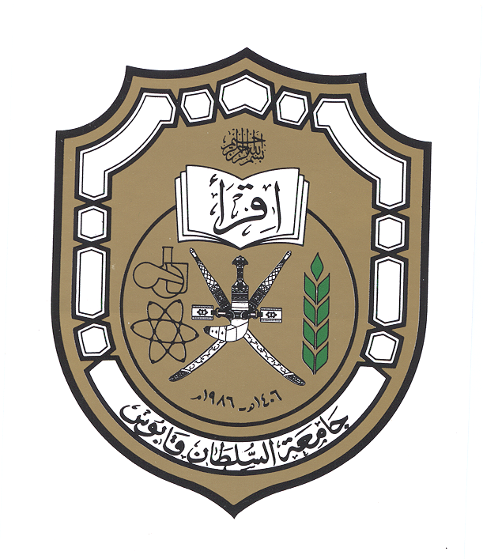  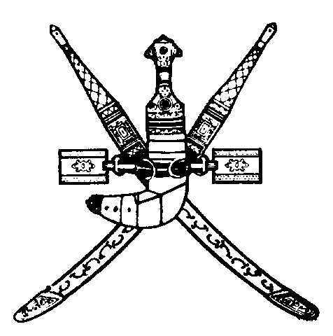 |  | 
SULTANATE OF OMAN | SULTAN QABOOS UNIVERSITY | WORLD INTELLECTUAL  PROPERTY ORGANIZATION
wipo national WORKSHOP on Licensing
and transfer of technology
organized by
the World Intellectual Property Organization (WIPO)
in cooperation with
the Ministry of Commerce and Industry
and
the Sultan Qaboos University (SQU)
Muscat, April 21, 2004
PROGRAM
prepared by the International Bureau of WIPO

Wednesday, April 21, 2004

8.00 – 8.15 OPENING CEREMONY

Welcome addresses by:

Representative of the Sultan Qaboos University (SQU), Sultanate of Oman

Representative of the Director General of the World Intellectual Property Organization (WIPO), Geneva, Switzerland

8.15 – 9.00 Intellectual Property: a Vehicle for Technology Transfer and Licensing

Speakers: Mr. Vladimir Yossifov, Director, Division for Infrastructure Services and Innovation Promotion, WIPO

9.00 – 9.45 Main Elements of Technology License Agreements

Speaker: Mr. Prabuddha Ganguli, Advisor, Vision-IPR, Mumbai, India

9.45 – 10.15 Coffee Break

10.15 – 11.00 Confidentiality Agreements and the Protection of Inventions and Trade Secrets

Speaker: Mr. Vladimir Yossifov

11.00 - 11.45 Commercial and Financial Features in License Agreements

Speaker: Mr. Prabuddha Ganguli

11.45 – 12.30 License Agreements from the Point of View of the Licensee and the Licensor

Speaker: Mr. Vladimir Yossifov

12.30 – 13.00 Coffee Break

13.00 – 13.45 Negotiating a License or Transfer of Technology Agreement

Speaker: Mr. Prabuddha Ganguli

13.45 – 14.30 Licensing Opportunities for SQU and its Employees

Speaker: Dr. Zaki Muscati, Director of Innovation Affairs, SQU

14.30 – 14.45 Closing Ceremony

[End of document]

