E
WIPO-LAS/IP/JOURN/CAI/05/1a
ORIGINAL: English
DATE: May 10, 2005
 | 
LEAGUE OF ARAB STATES | WORLD INTELLECTUAL  PROPERTY ORGANIZATION
wipo/las national SEMINAR ON INTELLECTUAL PROPERTY FOR JOURNALISTS AND MEMBERS OF THE MEDIA
organized by
the World Intellectual Property Organization (WIPO)
in cooperation with
the League of Arab States (LAS)
Cairo, May 23 and 24, 2005
Challenges and Opportunities for a
Competitive Software Industry in Egypt
prepared by Dr. Sherif Kassas, Deputy Director,
Center for Academic Computing, The American University, Cairo

1. Introduction

Information Technology is seen as an area with profound impact on development. This is mainly due to two main reasons. First, due to the impact of information technology on work and business process. It is widely accepted that the proper use and deployment of IT has positive effects on productivity and efficiency. Furthermore, the use of IT, and especially communications technologies and computer networks, can create opportunities that were not otherwise possible. For example, recent studies of Internet usage show that engineering design teams are collaborating globally, using Internet technologies, to shorten products’ time to market [1]. This form of remote collaboration was not cost effective to implement just a few years ago.

The second reason that IT has a profound impact on development is the size and nature of the IT market. Studies of the global IT market indicate that the market size will grow at an 11% compound annual growth rate until the year 2000. Furthermore, this growth rate is not evenly distributed across the world. For example, it is expected that growth rates will reach 16% in the Middle East and Africa.

The size of the global IT market reached $1.3 trillion in 1997 and will, according to those predictions, reach $2 trillion by the year 2000[2].

The remainder of this paper examines the challenges and opportunities presented by the IT market to the Arab world. It examines them at the regional and well as international level. Finally, the paper offers a number of suggestions and recommendations for meeting those challenges.

2. Challenges And Opportunities In The Arab Region

2.1 Market Growth

As mentioned above, the IT markets in the Middle East and Africa will grow at 16%. The spending for IT products and services will grow from $17.8 billion in 1997 to $34.9 billion in 2002. Furthermore, the spending for information services and software alone will grow at 18%, from $4.8 billion in 1997 to $11 billion in 2002[3]. Hence, considering market growth alone, there are excellent prospects and opportunities for a well-positioned Arab software industry.

2.2 The Need For Arabic-Language Software

The Arab-speaking world spans from Morocco to the Arabian Sea and contains more than 250 million citizens. Furthermore, the Arabic language represents an important second language for more than 1.25 billion Muslims around the world. Indeed, a number of companies (most notably, Al-Alamiah Electronics [4]) have realized that there is a software niche formed by the need for Arabic-language software. Such companies have invested significant resources in basic research and development to solve many problems related to Arabic software.

This niche has also attracted many companies worldwide to invest in developing software for the Arabic-speaking world. For example, the IBM branch in Cairo setup a scientific research center dedicated to solving Arabic-related problems such as Optical Character Recognition, Speech recognition, and other related problems specific to the Arabic language. Companies, such as Microsoft and Alice technologies, have committed to developing Arabic-enabled software, such as office and productivity applications (word processors and the likes), as well as Internet tools with Arabic support.

2.3 Intellectual Property Rights

The protection of intellectual property rights is perhaps the most critical factor for the future growth of the Information Infrastructure and the software industry both globally and in the Arab world [5]. There is clearly a strong need for effectively enforced laws for the protection of intellectual property in general and software in particular. Reports suggest that software piracy in the Middle East and Africa is amongst the world’s highest. The estimated revenue losses during 1996 are estimated at $511 million.
Arab governments, realizing the importance of the protection of intellectual property rights, have continued to take steps to improve the protection of intellectual property rights. Among the main motivations for this is the desire to attract additional foreign investment, especially in IT. Most notably, the UAE has been named the most active the Gulf region in enforcing intellectual property laws by the Business Software Alliance [6].

3. Challenges and Opportunities in the International Software Market
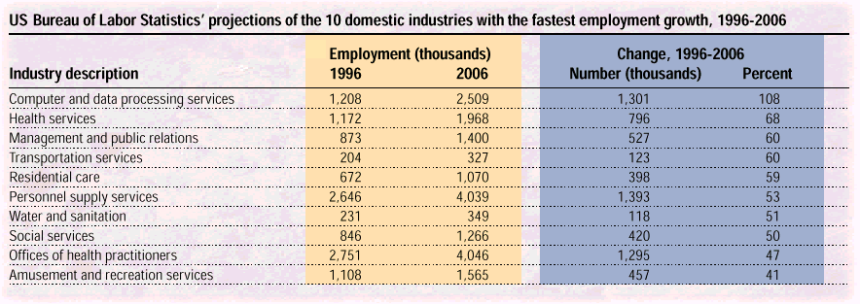
Figure 1: Employment growth in the USA [7]

This section examines the main challenges and opportunity that are present in the global software market. Here we examine three main points that we believe are key to understanding the future and potential of the global software market. Namely: the so-called talent shortage, the software maintenance problem, and the effect of Internet on software development.

3.1 The Talent Shortage

In February 1997, the Information Technology Association of America (ITAA) announced a study that estimated 190,000 open IT positions in the U.S., not including non-profit and public sector jobs. The ITAA reported that its current survey showed 340,000 unfilled positions. Richard Daley, USA Secretary of Commerce, raised the USA government’s October 1997 estimate of a 1.1 million person shortfall in the IT workforce to 1.3 million over the next 10 years [8].

This is just one symptom of the worldwide shortage of IT professionals. Studies suggest that this shortage is global and it will persist for some time to come, mainly due to the continuing growth and demand for the IT sector (see figure 1).
This clearly indicates that there is a void to fill, and a clear opportunity for the development of an Arab software industry with relatively low investment risk.

3.2 The Software Maintenance Challenge

Software Maintenance is defined as the modification of software product after delivery, to correct faults, to improve performance or other attributes, or to adapt the product to a modified environment. It is evident that Software Maintenance will play a substantial role in the near future of the software industry. It is expected that at least 70% of the annual corporate expenditure for software will be spent on maintenance. Maintenance costs grow at 10% a year, at the same rate as the size of system growth.
Hence, coupled with the IT talent shortage, this relatively unglamorous field of software engineering represents an important opportunity for the software services export industry.

3.3 The Internet
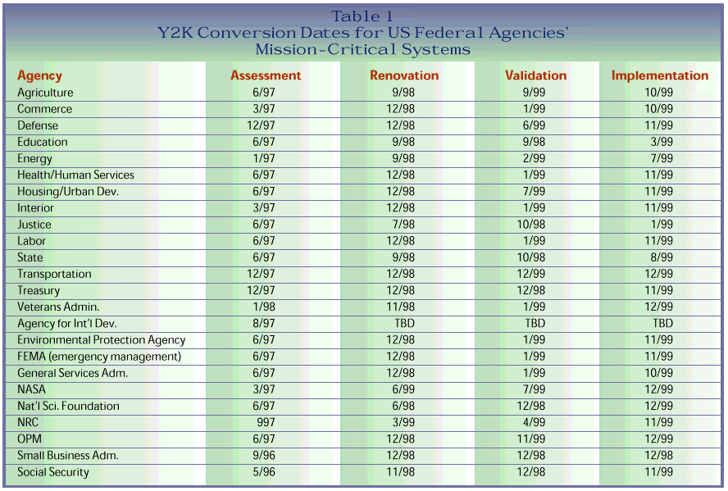
Figure 2: Conversion dates for some mission critical systems in the USA [12].

The Internet represents and great opportunity and challenge in two main ways: as a communications medium and as a development platform.

3.3.1 The Internet As A Communication Tool

The Internet is an effective and relatively low-cost communications medium. Thus it enables effective communications, exchange of information, and collaboration. Users have been making use of Internet tools, such as electronic mail, the World Wide Web, and chat systems, to communicate, collaborate, and access information for many years. The popularity of those systems has prompted organizations to use those tools as effective replacements for traditional business communication tools. For example, Engineering teams collaborating on projects over the Internet have become a reality in 1997[1].

For the Arab software industry the Internet represents an excellent opportunity for product and service export. Arab region based software houses can easily market their software worldwide and take advantage the worldwide shortage of software skills.

3.3.2 The Internet As A Development Platform

The popularity of the internet and the success of its associated tools, such as web browsers and email programs, has prompted organizations to use Internet technologies as the basis for their own internal IT needs. Hence, instead of developing proprietary, and expensive, client/sever applications, organizations started assembling systems using existing and standardized Internet building blocks.

This trend has signaled a significant paradigm shift from traditional development models and methodologies, to the network-centric model of Internet based computing. The paradigm shift has caused the creation of a new approach to software development together with a new set of tools and technologies. This accordingly has created new development opportunities and has rendered obsolete much of the established traditional know how. Thus, enabling new comers to the software development industry to be more competitive.

4. The way froward

Despite some success, the Arab software industry is not utilizing the full potential of the presented opportunities. For example, Egypt, which is considered one of the largest software producers in the Arab world, has a total of $300 million in hi-tech industry production, of which approximately $20 million are exports. Another important fact about the IT market in the Arab world is that there is little value added as most of the companies take the form of agencies of international software vendors [10].

There are a number of main considerations that need to be taken into account in order to promote the software industry in the Arab region. The items outlined here are based on [11].

4.1 Education

Education is perhaps the most crucial factor for the effective development of a software industry. After all, if the Arab world is to provide some of the answers to the worldwide shortage of software skills, those skills must be developed within the region.
There are some efforts heading in this direction in the region. For example, in Egypt the government and the Social fund for development are training up to 500 new software developers per year [10]. More such efforts are needed to effectively expand the supply of skilled developers. Arab governments can further help this process by further promoting higher education, and funding important basic research projects.

4.2 Interfacing with the external world and attracting investment

The software industry must be viewed as a global industry with most of the demand coming from the USA and other developed nations. For example, in 1996 India’s software exports to the USA, Japan and Europe were approximately $750 million. Hence, it is essential to realize that wide spread competence in those countries’ languages (especially English) is important for effective communications with multinational development teams.

4.3 Effective business environment

There is a clear need for an effective business environment that would provide adequate capital to invest in finding markets for software and to invest in software research.

4.4 Effective domestic software market

This is an important factor in establishing a software industry because an effective domestic market will encourage external investment and local developers. This is indeed the case in the Arab world. Mainly because of the size and the particular needs of the Arabic IT marketplace. Companies such as Microsoft, IBM, and Oracle have already invested in the region.

4.5 Telecommunications and Internet infrastructure

As discussed earlier, the Internet is the future export vehicle and development platform for the software industry. Thus, for the Arab region to participate in the software market, we must establish and maintain effective telecommunications and Internet infrastructure. This is another area where government investment and cooperation among the Arab countries can have a positive effect.

4.6 Forming consortia for software developers

Developers in the Arab world need to organize and collaborate to share the cost of expensive basic research, to setup common facilities and to cooperate in mark exploration, when appropriate. There are number of such alliances being formed and established in region, for example, the Egyptian IT association and the Internet society.

4.7 Intellectual property and piracy

As mentioned earlier Intellectual property protection and effective anti piracy laws and enforcement mechanisms are essential. They are essential for both the growth of the domestic market, and for attracting investments to the regional IT industry. This is another area where government intervention and support is essential.

References
- Larry Lange, The Internet: Technology Analysis and Forecast, IEEE Spectrum, January 1998.
- Global Information Technology Market, February 1997, http://www.killen.com/press/pr970221.html.
- Middle East and Africa Information Technology Spending, October 1997, http://www.killen.com/press/pr971023.html.
- Al-Alamiah Electronics: Corporate History, http://www.sakhrsoft.com/lcorpinf/ehist.htm.
- Intellectual Property Rights and The Lehman Report, http://www.bsa.org/policy/lehman.html.
- Bill Cavender, IT Developments Bode Well for Arab World, http://www.awo.net/newspubs/tradelin/980213a.asp
- Lee Garber, Employment in 1998: Focus on Y2K and the Internet, IEEE Computer, January 1998.
- Avron Barr and Shirley Tessler, Strategies for Survival, SCIP Software Industry Study, http://www-scip.stanford.edu/scip/avsgt/strategies0198.pdf.
- Capers Jones, 1998—a year of resource conflict and personnel shortage, IEEE Spectrum, January 19998.
- Egypt’s Technology Society, http://www.arabia.com/EL-WEKALAH/May/others/oth1.html.
- Shirley Tessler and Avron Barr, Software R&D Strategies of Developing Countries, Stanford Computer Industry Project, http://www-scip.stanford.edu/scip/.
- Ed Yourdon, A Tale of Two Futures, IEEE Software, January 1998.

[End of document]

