E
WIPO/IPR/MCT/04/INF.1
ORIGINAL: English
DATE: March 2004
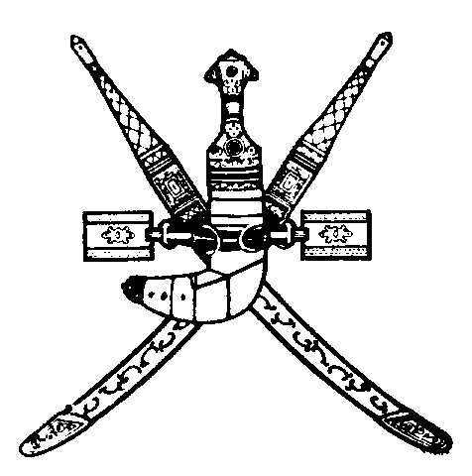 | 
SULTANATE OF OMAN | WORLD INTELLECTUAL  PROPERTY ORGANIZATION
wipo Sub-regional meeting on the Enforcement
of Intellectual Property Rights FOR PROSECUTORS OF THE GULF COOPERATION COUNCIL (GCC) COUNTRIES
organized by
the World Intellectual Property Organization (WIPO)
in cooperation with
the Ministry of Commerce and Industry
and
the Public Prosecution
Muscat, April 24 and 25, 2004
PROGRAM
prepared by the International Bureau of WIPO

Saturday, April 24, 2004

8.30 – 9.00 OPENING CEREMONY

Welcome addresses by:

Representative of the Government of the Sultanate of Oman

Representative of the Director General of the World Intellectual Property Organization (WIPO), Geneva, Switzerland

9.00 – 9.15 Coffee Break

9.15 – 10.15 The International Framework for the Enforcement of Intellectual Property Rights and the World Trade Organization (WTO) Dispute Settlement Mechanism

Speaker: Mr. Hassan Badrawi, Counsellor, Legislative Department, Ministry of Justice, Cairo

10.15 – 10.45 The Effective Enforcement of Intellectual Property Rights and its Contribution to Economic Development

Speaker: Mr. Sherif Saadallah, Executive Director, Economic Development Bureau for Arab Countries, WIPO

10.45 – 11.30 Special Requirements Relating to Border Measures: Border Enforcement Procedures

Speaker: General Ahmed Mohammad Al Fouly, Senior Consultant, International Federation of the Phonographic Industry (IFPI) and former Chief of the Anti-Piracy and Copyright Police Department, Ministry of Interior, Cairo

11.30 – 12.00 Coffee Break

12.00 - 13.00 Difficulties in the Enforcement of Intellectual Property Rights and Possible Solutions

Speakers: Judge Massimo Scuffi, Milan Court of Appeal, Milan, Italy

Mr. Hassan Badrawi

13.00 – 13.45 Couterfeiting and Piracy: Economic Crimes

Speaker: Mr. Nasser Ali Khasawneh, Regional Counsel for Middle East and North Africa, Business Software Alliance (BSA), Dubai

13.45 – 14.45 The Role of the Judiciary and Public Prosecution in the Enforcement of Intellectual Property Rights

Speakers: Judge Massimo Scuffi

Mr. Hassan Badrawi

Sunday, April 25, 2004

8.30 – 9.15 The Role of the Police and Customs Authorities in the Effective Enforcement of Intellectual Property Rights and the Fight Against Counterfeiting and Piracy

Speaker: General Ahmed Mohammad Al Fouly

9.15 – 10.00 The Role of the Private Sector in the Enforcement of Intellectual Property Rights

Speaker: Mr. Nasser Ali Khasawneh

10.00 – 10.45 European Experiences in the Administration of Intellectual Property Enforcement Procedures

Speaker: Judge Massimo Scuffi

10.45 – 11.15 Coffee Break

11.15 – 12.00 WIPO’s Dispute Settlement Services

Speaker: Ms. Ola Zahran, Counsellor, Economic Development Bureau for Arab Countries, WIPO

12.00 – 13.15 Policy Considerations and Practical Measures for the Effective Enforcement of Intellectual Property Rights: Role of the Public and the Private Sector

Panel Discussion: All speakers

13.15 – 13.30 Closing Ceremony

[End of document]

