E
WIPO/IP/SA/04/INF.1
ORIGINAL: English
DATE: January 2004
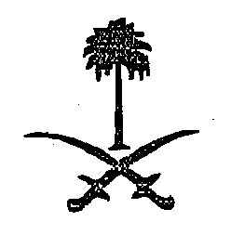 | 
KINGDOM OF SAUDI ARABIA | WORLD INTELLECTUAL  PROPERTY ORGANIZATION
wipo national WORKSHOPS ON THE PARIS CONVENTION FOR THE PROTECTION OF INDUSTRIAL PROPERTY AND THE BERNE CONVENTION FOR THE PROTECTION OF LITERARY AND ARTISTIC WORKS
organized by
the World Intellectual Property Organization (WIPO)
in cooperation with
the Government of the Kingdom of Saudi Arabia

Riyadh, March 29, 2004
Dammam, March 30, 2004
Jeddah, March 31, 2004
PROGRAM
prepared by the International Bureau of WIPO

8.00 - 8.30 OPENING CEREMONY

Welcome addresses by:

Representative of the Government of the Kingdom of
Saudi Arabia

Representative of the Director General of the World Intellectual Property Organization (WIPO), Geneva, Switzerland

8.30 - 10.30 The Obligations of the Government of the Kingdom of Saudi Arabia
under the Berne Convention for the Protection of Literary and
Artistic Works

Speakers: Mr. Nuno Pires De Carvalho, Head, Economic Development Sector, Cooperation for Development (Intellectual Property Law) Department, WIPO, Geneva

Mr. Mahmud Muntasser, Counsellor, Econmic Development Bureau for Arab Countries, WIPO, Geneva

10.30 - 11.00 Coffee Break

11.00 - 15.00 The Obligations of the Government of the Kingdom of Saudi Arabia
under the Paris Convention for the Protection of Industrial Property

Speakers: Mr. Nuno Pires de Carvalho
Mr. Mahmud Muntasser

15.00 - 15.15 Closing Ceremony

[End of document]

