E
WIPO/IP/MCT/07/INF/2
ORIGINAL: English
DATE: March 2007
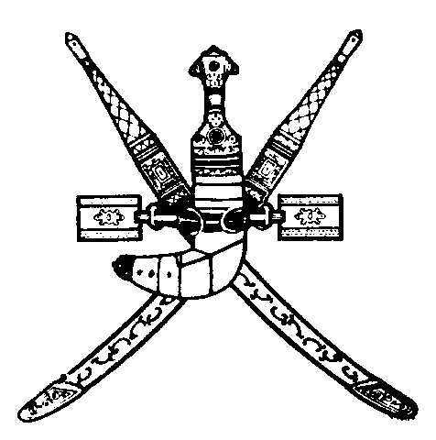 | 
SULTANATE OF OMAN | WORLD INTELLECTUAL  PROPERTY ORGANIZATION
wipo sub-regional seminar on industrial property and access to pharmaceutical products – addressing the concerns of developing countries
organized by
the World Intellectual Property Organization (WIPO)
in cooperation with
the Ministry of Commerce and Industry
and
the Ministry of Health
Muscat, April 2 to 4, 2007
List of participants
prepared by the International Bureau of WIPO

I. PARTICIPANTS

BAHRAIN

Mr. Nawaf AL MAJED, General Engineer, National Patent Office, Ministry of Industry and Commerce, Manama

Ms. Sawsan Moh’d Abbass MURAD, Assistant Director, Pharmacy and Drug Control, Ministry of Health, Manama

EGYPT

Ms. Mona FARAG, Head of Technical Examination, Egyptian Patent Office,
Academy of Scientific Research and Technology (ASRT), Cairo

Ms. Rehab ALI, Executive Pharmacist, Registration Department, Drug Policies and Planning Centre, Ministry of Health, Cairo

JORDAN

Ms. Laila JARRAR, Director, Drug Directorate, Jordan Food and Drug Administration, Ministry of Health, Amman

Ms. Zain ALAWAMLEH, Legal Researcher, Ministry of Industry and Trade, Amman

Mr. Wael ARMOUTI, Legal Advisor, Jordan Food and Drug Administration,
Ministry of Health, Amman

KUWAIT

Ms. Hessa Mostafa AL-OUMI, Electrical Engineer, Trademarks and Patent Department, Ministry of Commerce and Industry, Kuwait

Mr. Rashed Mattar ALOWEHAN, Trademarks and Patent Department, Ministry of Commerce and Industry, Kuwait

LEBANON

Mr. Wissam EL-AMIL, Research Officer in Intellectual Property Rights, Ministry of Economy and Trade, Beirut

MOROCCO

Ms. Narjiss HACHINI, Executive, Commercial and Industrial Property Office (OMPIC), Casablanca
QATAR

Mr. Khalid Al-Hajri, Patent Office, Ministry of Economy and Commerce, Doha

Mr. Abdelrazzak bin Abdallah Al-Kawari, Director, Patent Office, Ministry of Economy and Commerce, Doha

SAUDI ARABIA

Mr. Khaled AL-AKEEL, Director General for Patents, King Abdulaziz City for Science and Technology (KACST), Riyadh

Mr. Munis Mohammed AL-RWAILY, Scientific Researcher in Industrial Property, Abdulaziz City for Science and Technology (KACST), Riyadh

PATENT OFFICE OF THE COOPERATION COUNCIL FOR THE ARAB STATES OF THE GULF (GCCPO)

Mr. Majed AL RUFAYYIG, Patent Examiner (Pharmaceutical Applications), GCCPO, Riyadh

II. LOCAL AND FOREIGN SPEAKERS

Ms. Asiya Ibrahim Juma AL-KINDI, Pharmacist and Head, Drugs Section , Directorate of Specifications and Supplies, Muscat

Dr. Batool Jaffer SULEIMAN, Director, Rational Drug Use, Ministry of Health, Muscat

Ms. Hanan SBOUL, Secretary General, Jordanian Assosciation of Manufacturers of Pharmaceuticals and Medical Appliances (JAPM), Amman

Dr. Jaber bin Marhoun Flaifil AL-WAHAIBY, Expert on Intellectual Property Matters, Muscat

III. WORLD INTELLECTUAL PROPERTY ORGANIZATION (WIPO)

Mrs. Nahla HAIDAR, Director, Technical Assistance and Capacity Building Bureau for Arab Countries

Mr. Nuno PIRES DE CARVALHO, Acting Director-Advisor, Division for Public Policy and Development, Office of Strategic Use of Intellectual Property for Development (OSUIPD)

Mr. Mahmud MUNTASSER, Counsellor, Technical Assistance and Capacity Building Bureau for Arab Countries

[End of document]

