E
WIPO/IP/DIPL/CAI/04/6c
ORIGINAL: English
DATE: November 2004
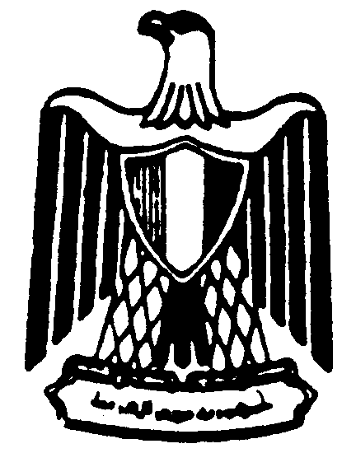 | 
MINISTRY OF FOREIGN AFFAIRS  ARAB REPUBLIC OF EGYPT | WORLD INTELLECTUAL  PROPERTY ORGANIZATION
wipo national training Workshop
ON INTELLECTUAL PROPERTY for diplomats
organized by
the World Intellectual Property Organization (WIPO)
and
the Institute for Diplomatic Studies
Cairo, December 13 to 16, 2004
The OSS Paradigm shift
Document prepared by Dr. Sherif El Kassas, Deputy Director, Center for Academic Computing, The American University, Cairo

[End of document]

