E
WIPO/IP/CAI/04/INF.1
ORIGINAL: English
DATE: August 2004
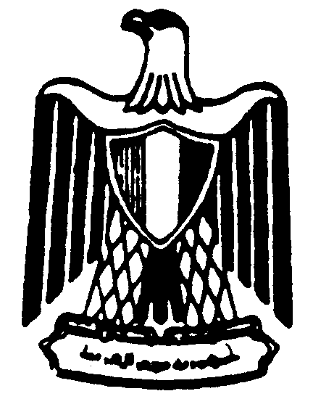 | 
ARAB REPUBLIC OF EGYPT | WORLD INTELLECTUAL  PROPERTY ORGANIZATION
wipo INTRODUCTORY Workshop
ON INTELLECTUAL PROPERTY
organized by
the World Intellectual Property Organization (WIPO)
in cooperation with
the Ministry of Foreign Trade and Industry
Cairo, October 10, 2004
PROGRAM
prepared by the International Bureau of WIPO

9.00 – 9.30 OPENING CEREMONY

Welcome addresses by:

Representative of the Ministry of Foreign Trade and Industry of the Arab Republic of Egypt

Representative of the Director General of the World Intellectual Property Organization (WIPO), Geneva

09.30 – 10.15 Introduction to Industrial Property Rights

Speaker: Mr. Karim El-Helaly, Head, Intellectual Property
Department, Zaki Hashem Law Firm, Cairo

10.15 – 11.00 Introduction to Copyright and Related Rights

Speaker: Dr. Hassan Gemei, Professor of Private Law, Faculty of
Law, Cairo University

11.00 – 11.30 Coffee Break

11.30 – 12.30 Overview of the Intellectual Property System in Egypt

(i) Framework for the Protection of Copyright and Related Rights

Speaker: Dr. Hassan Gemei

(ii) Framework for the Protection of Industrial Property Rights

Speaker: Mr. Karim El-Helaly

12.30 – 14.00 Global Protection Systems

(i) The Functioning of the Patent Cooperation Treaty (PCT) System

Speakers: Mr. Mahmud Muntasser, Counsellor, Economic Cooperation Development for Arab Countries,
WIPO, Geneva

Ms. Samia Sobhy Mohamed, Manager, PCT Department, Egyptian Patent Office, Cairo

(ii) The Benefits of the Madrid and Hague Systems

Speakers: Mr. Mahmud Muntasser

Representative from the Egyptian Trademarks Office

14.00 – 14.15 Closing Ceremony

[End of document]

