WIPO-IDB/IP/RYD/07/Smart-Turbine
ORIGINAL: English
DATE: May 2007
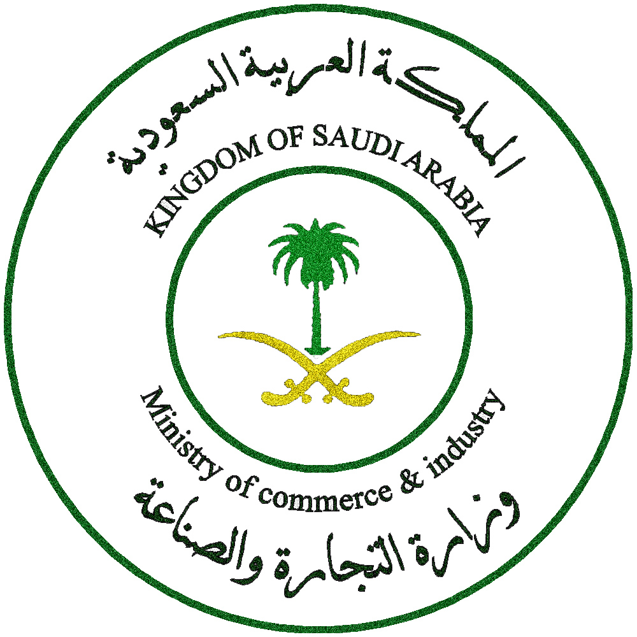 |  | 
ISLAMIC DEVELOPMENT BANK | MINISTRY OF COMMERCE  AND INDUSTRY | WORLD INTELLECTUAL  PROPERTY ORGANIZATION
wipo/IDB REGIONAL SEMINAR FOR ARAB COUNTRIES ON INTELLECTUAL PROPERTY AND TRANSFER OF TECHNOLOGY
organized by
the World Intellectual Property Organization (WIPO)
and
the Islamic Development Bank (IDB)
in cooperation with
the Ministry of Commerce and Industry
of the Kingdom of Saudi Arabia

Riyadh, June 4 to 6, 2007
The strory about smart turbine
prepared by the International Bureau of WIPO

The Story about Smart Turbine
Renewable Energy: Wind and Solar

Dr. Farhana Ahmed was sitting in her laboratory early one morning, drinking strong black tea on the lab table where she and her students had worked late the previous night. She was glancing at the newspaper absent mindedly, and thinking with great satisfaction about recent results in her research work at the Institute for Advanced Energy Research (IAER) at Al Watania University.

Though she was only half concentrating on the newspaper, her eye came upon a headline: “Energy deals set to get hotter in 2006”. The article reported that: “The world’s top energy companies are sitting on $75 million in cash, and will be looking for more exploration, as well as more international and more high risk projects”.

Dr. Farhana was not normally an excitable person and generally maintained a scholarly demeanor. But this morning, she jumped up from her chair and accidentally knocked over her tea onto the keyboard of her portable computer. Luckily none of her students were there to witness this display of careless excitement. Why, she wondered aloud, is there so much money for these so-called deals, when there is so little money to support good science?

She was the director of the IAER, a publicly funded research institute at the University. A petroleum engineer with a PhD in chemistry, she loved her work. For the last ten years, working with a select and dedicated group of graduate students and research assistants, she had been deeply involved in research on thin film technologies for energy collection and storage. She was fascinated by these thin films, ultra fine layers of silicon and other materials, that were essentially invisible but were powerful agents for collecting and storing solar energy.

Her dream was to develop an ideal thin film technology that could be applied to multiple uses wherever solar energy collection was needed. Her favorite application was for wind turbines to harvest energy from the sun during wind production or when winds were still. In her lab, she tried numerous materials, but each seemed to have a critical disadvantage. Using traditional silicon, or a-Si film, did not work well because of degradation problems when the film prototype was actually exposed to air and wind. Other films such as cadmium telluride (CdTe) had very high laboratory efficiency, but less than optimal because of manufacturing and disposal problems related to the toxicity of cadmium.

The doctor’s experiments, even though they were still theoretical and inconclusive, had begun attract a great deal of attention for the IAER. Dr. Farhana was invited, and accepted to speak on New Materials and Thin Films at international conferences in Bahrain, Denmark, Canada, and Ireland. In 2002, she received a prize for the most innovative research in new energy technologies from a research center in Spain and was invited to deliver a keynote address where her presentation was given simultaneous interpretation and published in a prestigious European journal. She was invited to spend six months in Madrid to collaborate with researchers there on a well- funded and exciting wind power project, but she declined to accept this invitation for personal reasons. (Her husband and teenaged children did not want to move from home for six months).

Dr. Farhana was happy with her work at IAER. She had a group of superb graduate students, and the number of bright young students interested in working in this new field was growing every year. Her colleagues in the faculty of the University were encouraging of her work.

One professor in particular, Dr. Mahir Abdullah, a physicist from the Applied Physics Laboratory, was eager to collaborate on Dr. Farhana`s dream: An integrated system including a hybrid stacked thin film and a wind turbine for use as a decentralized energy system in small buildings and residences. By December of 2005, the two professors had a prototype of the system, they called the “Smart Turbine”. The beauty of the Smart Turbine was that it could function as a highly efficient wind energy collector, due to Dr. Mahir’s superb turbine design, and it also used a new durable photovoltaic thin film developed by Dr. Farhana to collect solar energy. Both elements of the system were integrated using software elements to measure flow and to increase synergy between the wind and solar elements. Whenever the wind died down, the solar collection intensified. Whenever the sky was cloudy, the wind system became dominant. The prototype of the Smart Turbine was a success, and although there were still some elements that could be improved, the system worked!

When Dr. Farhana read the article in the newspaper about energy deals, as she was cleaning up the tea that she had spilled, she began to think about how to commercialize the Smart Turbine and her new thin film technology. She called up her colleague, Dr. Mahir and asked him to go with her to meet the director of the University technology management office (TMO), a lawyer named Mr. Alladin Nasser.

Attorney Nasser met with Drs. Farhana and Mahir. The first thing he did was help them to fill in “invention disclosure forms”, describing the research results they had that seemed new and useful. He also explained and gave them a copy of the Al Watania University Intellectual Property Policy, which provided that all rights in inventions developed by faculty, staff and students using University and Institute facilities, belonged to the University. The policy also provided for sharing of any future financial benefit from intellectual property, giving a 30% of net revenues share to professors, 30% to the laboratory or institute concerned, 30% to a graduate scholarship fund and 10% to the University to offset administrative costs. The policy also contained a conflict of interest rule designed to ensure that professors would devote their energies to teaching and research rather than commercial ventures or consulting. Professors were not permitted to form spin off companies to exploit their research results, unless they took a leave of absence or resigned.

Attorney Nasser reminded the two professors of the terms of their employment contracts which provided that intellectual property in research would be owned by the University, and that private consulting by professors with commercial interests would be limited to 10 hours per week.

The professors were on their way out of the Technology Management office, when Dr. Farhana remembered that she had to ask Mr. Nasser a question: was there any problem in her delivering a scientific paper about Smart Turbine at an important meeting in Madrid to take place in two months? Mr. Nasser said he would just get the patents filed in time, but that neither they nor their students should under any circumstances make any public statements about Smart Turbine before the patent applications were filed.

Dr. Farhana thought that Mr. Nasser was a bit officious and annoying, but then she was impressed by how quickly he acted. Within 5 weeks, he arranged for a patent agent to draft and file 3 detailed patent applications for Smart Turbine (including claims covering the turbine apparatus, the new thin film, and the system integrating the two technologies). The patent applications were filed with the national office of intellectual property, as well as with the World Intellectual Property Organization (WIPO) Patent Cooperation Treaty (PCT) office. Funds for filing these applications were available from the national government special fund for technology promotion. Dr. Mahir was listed as the inventor for the turbine apparatus, Dr. Farhana as the inventor of the thin film, and both professors were listed as inventors of the system, with Dr. Farhana’s name first, which pleased her very much.

Still, after the filing of the patent applications, nothing happened. Dr. Farhana had thought that there would somehow be a rush of buyers interested in the technology. New to the world of IP, she did not know that patent applications are maintained as confidential by IP offices for at least one year after filing, and that IP protection and marketing are separate challenges. Mr. Nasser patiently explained this to her, but she began to have more concerns. The prototype experiments were promising, and she was full of new ideas for new applications and uses for the thin film (rural housing, marine vessels, city street lamps, and so on), but neither the professors not the University were prepared for commercialization. How would she ever get her project off the ground?

She delivered her paper in Madrid before a packed audience, describing the functioning of the Smart Turbine and her new thin film, the performance, and energy savings. After the presentation, a small crowd formed around her asking questions and offering business cards. She was so delighted, and spent the next several days in informal meetings discussing and learning from other scientists about their work, that she did not think about technology commercialization, but only about the intellectual excitement of her fast changing field of work. There was even an article in El Pais, the leading Spanish newspaper, about the advance of new energy technologies, citing Al Watania University’s IAER as a beacon of technology innovation. Dr. Farhana was so proud.

Upon her return from Spain, Dr. Farhana spent a few days on vacation with her family and then returned to the lab, inspired and refreshed. There were three letters on her desk waiting for her. The first was from a Spanish company, as she noted from the stamps and the return address. To her shock and horror, upon opening it, she saw the following words:

“Dear Dr. Farhana:
This law firm represents Energo….”

It was a demand letter, demanding that the University, the IAER, and Drs. Farhana and Mahir cease and desist from any further making, using or selling of the “patented technology”, etc. belonging to Energo, a Spanish/Danish joint venture. The letter enclosed what was called a “claims chart” which purported to show each claim of the Energo patent that was infringed by Smart Turbine. But—it was ridiculous—the claims had nothing to do with Smart Turbine and involved an ordinary compound silicon thin film and an entirely different turbine design, with no integration of the two systems! The letter ended by expressing confidence that an amicable business resolution could be reached upon negotiation, especially in light of Energo’s well-developed European distribution channels, and the advanced wind technology capabilities of the joint venture partners, but Dr. Farhana was so angry that she did not bother to read this sentence.

Dr. Farhana tore open the second letter, hoping it was some kind of apology by the Spanish-Danish joint venture company for its mistake. Instead, the second letter was from Professor Iglesias, the scientist who had invited her to the Madrid conference, stating that he had recently accepted a new and challenging position as Research Contracts Coordinator at Euroconsor, a large European energy consortium on renewable energy. Would she be interested in a very attractive research services contract whereby the IAER would be handsomely funded to perform selected research projects to support Euroconsor’s important new global energy initiatives?

Dr. Farhana dropped the second letter to the floor, and opened the third letter. It was from a petroleum products company in the region, Al Khaleej Petroleum—she had heard of this company before, who hadn’t? Al Khaleej was a big company with a large capital surplus due to high energy prices, and its management was known for its business acumen. The letter was from the Chief Technology Officer, Dr. Muhammad Darusman, who said he had seen her impressive presentation on Smart Turbine at the Madrid conference and had followed her work over the years. He invited her to a meeting at the Al Khaleej corporate headquarters to discuss possibilities for collaboration to commercially exploit Smart Turbine. He said that his company lawyer, Mr. Abdul Hadi Nabil would be there, so the University should invite its legal counsel as well. He attached a document to the letter that was called a “Market Study for Smart Turbines”; it analyzed the existing and potential markets, segmented by region and technology applications, for massive urban grid systems, as well as small decentralized and mobile systems.

Dr. Farhana was in turmoil. What would she do? She called Dr. Mahir, who came over to her office to read the letters right away. He called Mr. Nasser, who invited them both to meet him in the IAER conference room.

They discussed the University’s choices and the risks associated with each choice. There was a possible settlement with Energo, which, despite first appearances, could possibly result in an amicable business relationship involving joint development and scientific collaboration. There was the choice of working with Professor Iglesias and Euroconsor in a research services arrangement, but Professor Farhana was reluctant once Mr. Nasser explained that research service agreements often but not always provide that any IP resulting from the work belong to the party funding the research. Then, finally, there was Al Khaleej which had cash to spend and had made a serious invitation to negotiation, but was not known to be strong in renewable energy technology

One month later, the two professors, and Mr. Nasser have agreed to meet and negotiate with Al Khaleej. Representing Al Khaleej are Mr. Darusman and Mr. Nabil. Both sides have brought marketing and technical staff to assist them. Both sides have signed non-disclosure agreements prohibiting disclosure or improper use of confidential information.

You are there. What deal can you negotiate?

[End of story]

