WIPO-IDB/IP/RYD/07/INF/1
ORIGINAL: English
DATE: May 2007
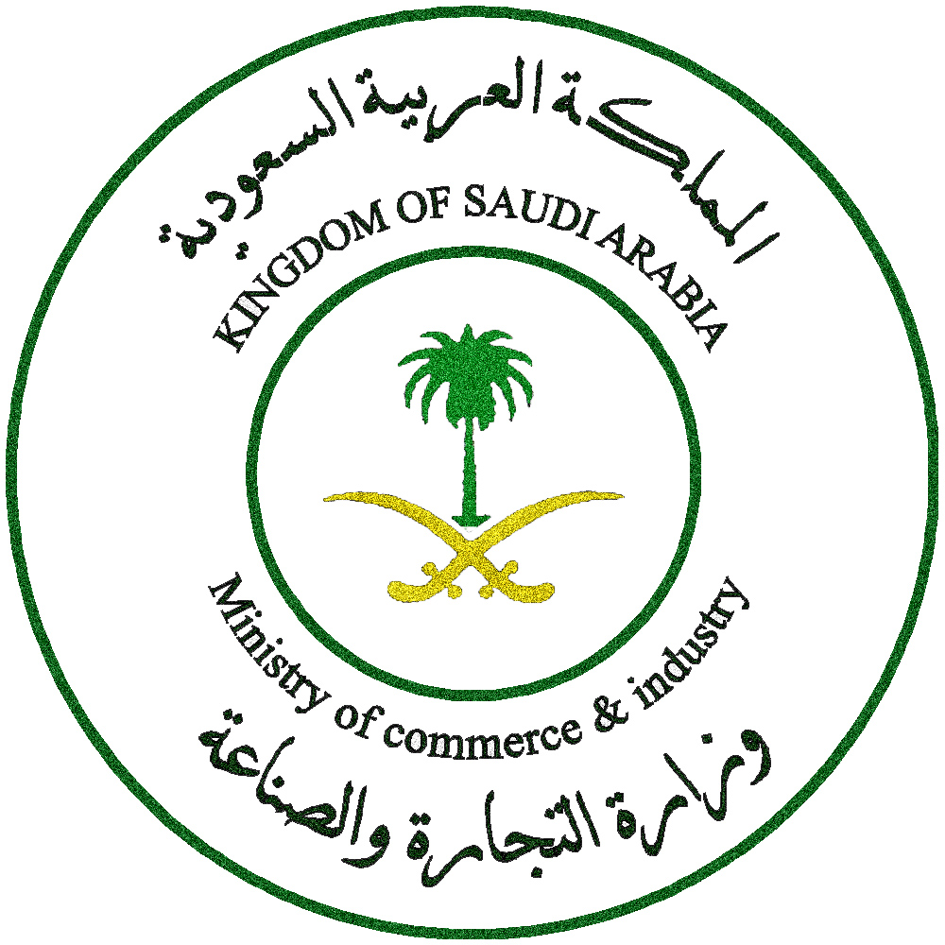 |  | 
ISLAMIC DEVELOPMENT BANK | MINISTRY OF COMMERCE  AND INDUSTRY | WORLD INTELLECTUAL  PROPERTY ORGANIZATION
wipo/IDB REGIONAL SEMINAR FOR ARAB COUNTRIES ON INTELLECTUAL PROPERTY AND TRANSFER OF TECHNOLOGY
organized by
the World Intellectual Property Organization (WIPO)
and
the Islamic Development Bank (IDB)
in cooperation with
the Ministry of Commerce and Industry
of the Kingdom of Saudi Arabia

Riyadh, June 4 to 6, 2007
program
prepared by the International Bureau of WIPO
Monday, June 4, 2007

8.00 – 8.30 Registration

8.30 – 9.00 OPENING CEREMONY

Welcome addresses by:

The representative of the President of the Islamic Development Bank (IDB), Jeddah

The representative of the Ministry for Commerce and Industry of the Kingdom of Saudi Arabia, Riyadh

The representative of the Director General of the World Intellectual Property Organization (WIPO), Geneva

9.00 – 10.00 Intellectual Property and Universities: From Research to Development to Commercialization

Speaker: Mrs. Nahla Haidar, Director, Technical Assistance
and Capacity Building Bureau for Arab Counties, WIPO

10.00 – 11.00 Intellectual Property and Technology Transfer in Universities and Research and Development Institutions: Why it Works and How it Works

Speaker: Mr. Jon Sandelin, Office of Technology Licensing, Stanford
University, Stanford, California, United States of America (USA)

11.00 – 11.30 Coffee Break

11.30 – 13.15 Funding and Knowledge Led Growth: The Role of Banks, Venture Capital and Government Funders in Research, Development and Commercialization

Speakers: Mr. Mohamed Shariff, Director, Innovation and
Commercialization Centre, Universiti Putra Malaysia

Mr. Bowman Heiden, Deputy Director, Center for IP Studies,
Chalmers University of Technology, Göteborg, Sweden

13.15 – 13.45 Discussions

13.45 – 14.00 Introduction to the Role Play

Tuesday, June 5, 2007

8.30 – 9.30 Scientific Research and Technology Management: An Imperative for the Arab World

Speaker: Mr. Samer Refai, Secretary General, Arab School for Science and Technology, Damascus

9.30 – 10.30 Research in Renewable Energy: A Critical Investment for the Region

Speaker: Mr. Ali Al-Karaghouli, Consultant, United Nations Environmental Program for West Asia (UNEP/ROWA), Manama

10.30 – 11.00 Coffee Break

11.00 – 12.30 Overview of Key Terms in a Technology Licensing Agreement

Speaker: Mrs. Cynthia Cannady, Director, Office of Strategic Use
of Intellectual Property for Development Intellectual Property
and New Technologies Division, WIPO

12.30 – 13.00 Discussions

13.00 – 14.00 Lunch Break

14.00 – 17.00 Licensing Exercise (Role-Play)

Participants break into teams to prepare for a negotiation between an hypothetical research institution and an hypothetical company.

Moderator: Mrs. Fatima Daboussi, Deputy Director, Technical Assistance
and Capacity Building Bureau for Arab Countries, WIPO

Coaches: Mrs. Cannady
Mr. Sandelin
Mr. Heiden

Wednesday, June 6, 2007

8.30 – 12.00 Licensing Exercise (Role-Play) (Cont’d)

University teams meet with Company teams to negotiate a technology licensing agreement.

Moderator: Mrs. Fatima Daboussi

Coaches: Mrs. Cannady
Mr. Sandelin
Mr. Heiden

12.00 – 13.15 Plenary Session to Review Team Results

13.15 – 14.00 CLOSING CEREMONY

[End of document]

