E
WIPO/CR/KRT/05/5b
ORIGINAL: English
DATE: January 2005
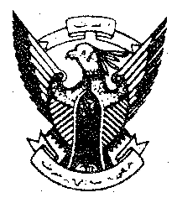 | 
REPUBLIC OF THE SUDAN | WORLD INTELLECTUAL  PROPERTY ORGANIZATION
WIPO National Seminar on Copyright, Related Rights, and collective management
organized by
the World Intellectual Property Organization (WIPO)
in cooperation with the Ministry of Culture

Khartoum, February 28 to March 2, 2005
Fighting Copyright Piracy
prepared by Mr. Henry Olsson, Judge at the Court of Appeal,
and Special Government Adviser, Ministry of Justice, Stockholm

[End of document]

