E
WIPO-LAS/IP/MCT/03/INF.1
ORIGINAL: English
DATE: September 2003
 | 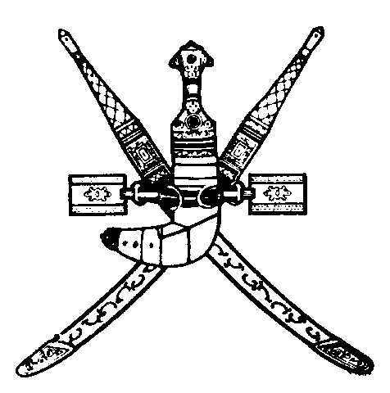 | 
LEAGUE OF ARAB STATES | SULTANATE OF OMAN | WORLD INTELLECTUAL  PROPERTY ORGANIZATION
WIPO/LAS ARAB REGIONAL COORDINATION MEETING FOR
HEADS OF INDUSTRIAL PROPERTY AND COPYRIGHT OFFICES
organized by
the World Intellectual Property Organization (WIPO)
and
the League of Arab States (LAS)
in cooperation with
the Ministry of Commerce and Industry
Muscat, September 15 to 17, 2003
PROGRAM
prepared by the International Bureau of WIPO

Monday, September 15, 2003

8.30 - 9.00 Opening Ceremony

Welcome addresses by:

the Representative of the Sultanate of Oman

the Representative of the World Intellectual Property Organization (WIPO), Geneva

the Representative of the League of Arab States (LAS)

9.00 - 9.30 Coffee Break

9.30 - 10.00 Report on WIPO’s Cooperation for Development Program
on Intellectual Property for the Arab Countries

Speaker: Mr. Sherif Saadallah, Director, Cooperation for Development Bureau for Arab Countries, WIPO

10.00 – 10.30 Report on the Activities of the Intellectual Property Unit of the League of Arab States (LAS)

Speaker: Mrs. Maha Bakheet, Official, Intellectual Property Unit, LAS, Cairo

10.30 – 11.00 WIPO’s Work on Recent Intellectual Property Issues Associated with the Multilateral Trade Agenda

Speaker: Ms. Ola Zahran, Counsellor, Cooperation for Development Bureau for Arab Countries, WIPO

11.00 - 11.45 Recent Multilateral Negotiations on Intellectual Property Issues in International Fora

Speaker: Mr. Nuno Pires de Carvalho, Head, Industrial Property Law Section, Cooperation for Development (Intellectual Property Law) Department, WIPO

11.45 - 12.15 Coffee Break

12.15 – 13.00 Report on the Work of the WIPO Standing Committee on Copyright and Related Rights

Speaker: Mr. Dimiter Gantchev, Consultant, Copyright and Related Rights Sector, WIPO

13.00 – 13.45 Report on the Work of the Standing Committees in the Field of Industrial Property

Speaker: Mr. Nuno Pires de Carvalho

13.45 - 14.15 Report on the Installation and Functioning of the Common Software for Arab Industrial Property Offices and Results of the WIPO Regional Technical Workshop on the Automation System for Arab Industrial Property Offices

Speaker: Mr. Hisham Al-Fayed, Information Technology Consultant, WIPO, Cairo

Tuesday, September 16, 2003

8.30 – 9.00 Lessons Learned from Intellectual Property Disputes

Speaker: Mr. Nuno Pires de Carvalho

9.00 – 9.45 The Importance of Cultural Industries and Economic Growth

Speaker: Mr. Dimiter Gantchev

9.45 – 10.00 Initiative for the Development of a Software for Arab Collective Management Societies

Speaker: Mr. Hisham Fayed

10.00 – 10.30 Coffee Break

10.30 – 11.00 Status of Treaty Adherence and Overview of Activities Implemented in Arab Countries during the 2002/2003 Biennium

Speaker: Ms. Ola Zahran

11.00 Presentation of Country Reports on the Situation of Intellectual Property in Arab Countries: Update by Intellectual Property Offices on Recent Developments

- Legal Framework of Intellectual Property in the Arab Countries and its Application

- Enforcement Efforts

- Intellectual Property Administration: General Organization, Management and Procedural Operations

- Use of Information Technologies: Automation of Operations

- Training of Human Resources

Presentation of National Reports of the following Countries:

11.00 - 11.15 Algeria

11.15 – 11.30 Bahrain

11.30 - 11.45 Djibouti

11.45 - 12.00 Egypt

12.00 - 12.15 Jordan

12.15 – 12.45 Coffee Break

Presentation of National Reports of the following Countries: (continued)

12.45 - 13.00 Kuwait

13.00 - 13.15 Lebanon

13.15 - 13.30 Libyan Arab Jamahiriya

13.30 - 13.45 Mauritania

13.45 – 14.00 Morocco

Wednesday, September 17, 2003

Presentation of National Reports of the following Countries:

8.30 - 8.45 Oman

8.45 - 9.00 Palestinian National Authority (PNA)

9.00 - 9.15 Qatar

9.15 - 9.30 Saudi Arabia

9.30 – 10.00 Coffee Break

10.00 - 10.15 Sudan

10.15 – 10.30 Syrian Arab Republic

10.30 - 10.45 Tunisia

10.45 - 11.00 United Arab Emirates

11.00 - 11.15 Yemen

11.15 - 11.45 Coffee Break

11.45 - 14.00 General Orientation of Future Needs of Arab Countries in the Field of Intellectual Property

General Discussion on the Following Items:

(a) Automation of Intellectual Property Offices

(b) Human Resource Development

(c) Cooperation with Education Institutions

(d) Collective Management of Copyright and Related Rights

(e) Legislative Infrastructure

(f) Other Issues

14.00 - 14.15 Closing Ceremony

[End of document]

