E
WIPO/TM/BEY/03/INF.1
ORIGINAL: English
DATE: February 2003
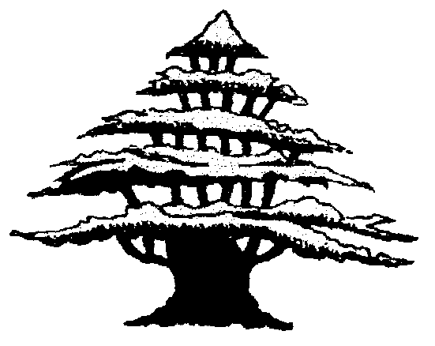 | 
REPUBLIC OF LEBANON | WORLD INTELLECTUAL  PROPERTY ORGANIZATION
wipo NATIONAL SEMINAR ON the PROTECTION OF TRADEMARKS AND GEOGRAPHICAL INDICATIONS
organized by
the World Intellectual Property Organization (WIPO)
in cooperation with
the Ministry of Economy and Trade
Beirut, March 17 to 19, 2003
PROGRAM
prepared by the International Bureau of WIPO

Monday, March 17, 2003

9.30 – 10.00 OPENING CEREMONY

Welcome addresses by:

His Excellency Mr. Bassel Fleihan, Minister for Economy and Trade, Republic of Lebanon

Mr. Sherif Saadallah, Director, Cooperation for Development Bureau for Arab Countries, World Intellectual Property Organization (WIPO), Geneva

10.00 – 10.30 International Framework for the Protection of Trademarks and Geographical Indications

Speaker: Mr. Bojan Pretnar, Deputy Director, Concept
Development Unit, Trademarks, Industrial Designs and
Geographical Indications Department, WIPO

10.30 – 11.00 Protecting Trademarks in Lebanon: The National Legal Framework and Applicable Procedures

Speaker: Mrs. Salwa Rahhal Faour, Director, Intellectual Property Protection Office, Ministry of Economy and Trade, Beirut

11.00 – 11.30 Coffee Break

11.30 – 12.15 Use of Trademarks and Geographical Indications in Commerce

Speakers: Mr. Bojan Pretnar

Mr. Frédéric Brand, Officer in charge of the Registry, AOC-IGP, Federal Office for Agriculture, Berne, Switzerland

12.15 – 13.00 How to Manage an International Trademark Portfolio: Choosing,
Protecting, Monitoring and Enforcing Trademarks and Domain Names

Speaker: Dr. Gerd F. Kunze, Consultant, Chexbres, Switzerland

Tuesday, March 18, 2003

9.00 – 10.00 Protecting your Trademark Abroad: The Madrid System for the
International Registration of Marks

(i) The Madrid Agreement Concerning the International Registration of Marks and the Protocol Relating to the Madrid Agreement

Speaker: Ms. Ola Zahran, Counsellor, Cooperation for
Development Bureau for Arab Countries, WIPO

(ii) Advantages for Industry in Using the Madrid System

Speaker: Dr. Gerd F. Kunze

10.00 – 10.45 Licensing and Franchising: Making the Most of a Mark

Speaker: Dr. Gerd F. Kunze

10.45 – 11.30 Developing, Using, Protecting and Enforcing Trademarks: The Point
of View of Lebanon

Speakers: Dr. Ghaleb Mahmassany, Attorney at Law, and President, Intellectual Property Committee, International Chamber of Commerce (Lebanon National Committee), Beirut

Mr. Iyad Baajour, Attorney at Law, and Intellectual Property Consultant, Ministry of Economy and Trade, Beirut

11.30 – 12.00 Coffee Break

12.00 – 12.45 Cases of Trademark Infringement

Speaker: Dr. Gerd F. Kunze

Dr. Nassib Elias, Judge, Ministry of Justice, Beirut

Tuesday, March 18, 2003 (cont’d)

12.45 - 13.30 Geographical Indications, Appellations of Origin, Indications of Source: Introduction to and the Applicable International Legal Framework
Speaker: Mr. Bojan Pretnar

Wednesday, March 19, 2003

9.00 – 9.30 The Protection of Geographical Indications in Lebanon

Speaker : Rudolph Elkareh, Expert in the Field of Geographical Indications, Paris

9.30 – 10.15 Geographical Indications and Trademarks: Harmony of Conflict

Speakers: Mr. Frédéric Brand

Mrs. Susana Pérez Ferreras, Administrator, Industrial
Property Unit, European Commission, Brussels

10.15 – 11.00 Protection of Geographical Indications: The European Union Experience

Speaker: Mrs. Susana Pérez Ferreras

11.00 – 11.45 Use of Geographical Indications in a Collective Marketing Strategy

Speaker: Mr. Frédéric Brand

11.45 – 12.15 Coffee Break

12.15 – 13.00 Geographical Indications: Definitions, Quality Control, Enforcement at Home and Abroad

Speaker: Mrs. Susana Pérez Ferreras

Wednesday, March 19, 2003 (cont’d)

13.00 – 13.45 Panel on National Geographical Indications: Case Study from
Lebanon

Speakers: Representatives of the Local Industries (Companies of Sannine, Ksara, Jdeita and Shtoura)

[End of document]

