E
WIPO/IPR/MCT/03/INF.1
ORIGINAL: English
DATE: November 10, 2003
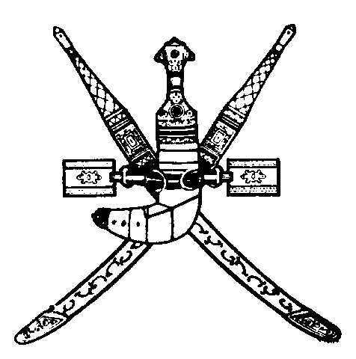 | 
SULTANATE OF OMAN | WORLD INTELLECTUAL  PROPERTY ORGANIZATION
wipo national seminar on ENFORCEMENT OF intellectual property RIGHTS for GENERAL PROSECUTORS
organized by
the World Intellectual Property Organization (WIPO)
in cooperation with
the Ministry of Commerce and Industry
Muscat, December 1 and 2, 2003
PROGRAM
prepared by the International Bureau of WIPO

Monday, December 1, 2003

8.30 – 8.45 OPENING CEREMONY

Welcome addresses by:

Representative of the Government of the Sultanate of Oman

Representative of the Director General of the World Intellectual Property Organization (WIPO), Geneva, Switzerland

8.45 – 9.00 Coffee Break

9.00 – 9.45 International Protection Standards in the Field of Industrial Property

Speaker: Mr. Nuno Pires de Carvalho, Head, Industrial Property Law Section, Cooperation for Development (Intellectual Property Law) Department, WIPO

9.45 – 10.30 International Protection Standards in the Field of Copyright and Related Rights

Speaker: Dr. Uma Suthersanen, Senior Lecturer and Senior Fellow, Queen Mary Intellectual Property Research Institute, University of London, London

10.30 – 11.15 Enforcement of Intellectual Property Rights under the Agreement on Trade-Related Aspects of Intellectual Property Rights (TRIPS Agreement)

Speaker: Mr. Nuno Pires de Carvalho

11.15 – 11.30 Coffee Break

11.30 – 12.00 Enforcement under the Omani Intellectual Property Laws

Speaker: Local speaker

12.00 – 12.45 Ways and Means of Identifying Pirated and Counterfeited Goods

Speaker: General Ahmed Mohammad Al Fouly, Senior Consultant, International Federation of the Phonographic Industry (IFPI) and former Chief of the Anti-Piracy and Copyright Police Department, Ministry of Interior, Cairo

12.45 – 14.00 Effective Enforcement Actions: Running a Secure and Effective Raid and Preparing a Case for the Prosecutor

Speaker: General Ahmed Mohammad Al Fouly

Tuesday, December 2, 2003

9.00 – 9.45 Economic Importance of Intellectual Property Rights

Speaker: Mr. Sherif Saadallah, Director, Cooperation for Development Bureau for Arab Countries, WIPO

9.45 – 10.30 Infringement of Copyright and Related Rights: Selected Case Studies

Speaker: Dr. Uma Suthersanen

10.30 – 11.15 Infringement of Industrial Property Rights: Selected Case Studies

Speaker: Mr. Nuno Pires de Carvalho

11.15 – 11.45 Coffee Break

11.45 – 12.30 Alternative Dispute Settlement Procedures

Speaker: Ms. Ola Zahran, Counsellor, Cooperation for Development Bureau for Arab Countries, WIPO

12.30 – 13.15 The Role of Intellectual Property Prosecution in Ensuring Justice and Fair Competition

Speaker: Mr. Nuno Pires de Carvalho

13.15 – 13.30 Closing Ceremony

[End of document]

