E
WIPO/IPTK/MCT/02/INF.12
ORIGINAL: English
DATE: November 2001
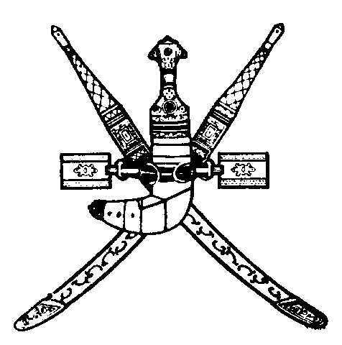 | 
SULTANATE OF OMAN | WORLD INTELLECTUAL  PROPERTY ORGANIZATION
UNDER THE PATRONAGE OF
HIS HIGHNESS SAYyiD FAISAL BIN ALI AL SAID
wipo international forum on “intellectual property
and traditional knowledge: our identity, our future”
organized by
the World Intellectual Property Organization (WIPO)
in cooperation with
the Government of the Sultanate of Oman
Muscat, January 21 and 22, 2002
PRELIMINARY REPORT ON “national experiences with THE LEGAL PROTECTION OF EXPRESSIONS OF FOLKLORE” PREPARED FOR
THE SECOND SESSION OF THE INTERGOVERNMENTAL COMMITTEE ON INTELLECTUAL PROPERTY AND GENETIC RESOURCES, TRADITIONAL KNOWLEDGE AND FOLKLORE
Document prepared by the International Bureau of WIPO

