 | 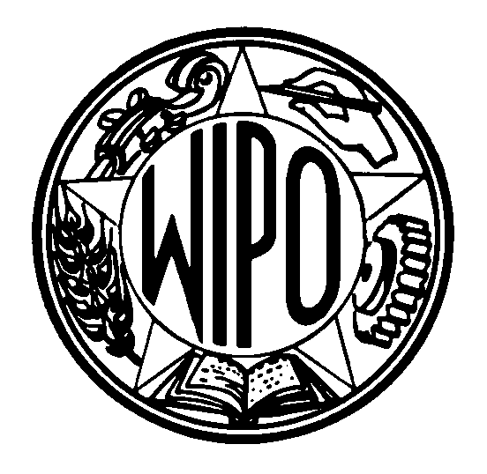 | Information Notice No. 08/2003
WORLD INTELLECTUAL PROPERTY ORGANIZATION
34, chemin des Colombettes, P.O. Box 18, CH-1211 Geneva 20 (Switzerland)
‡ (41-22) 338 91 11 – Facsimile (International Trademark Registrations Section): (41-22) 740 14 29
e-mail: intreg.mail@wipo.int – Internet: http://www.wipo.int

MADRID AGREEMENT AND PROTOCOL CONCERNING THE
INTERNATIONAL REGISTRATION OF MARKS

Change of name of the Federal Republic of Yugoslavia to Serbia and Montenegro

1 The International Bureau has been informed that the name of the Federal Republic of Yugoslavia has been changed to Serbia and Montenegro.

2 As a consequence, the name of “Serbia and Montenegro,” instead of the Federal Republic of Yugoslavia, is now used in all documents, publications and communications from the International Bureau, including international application and subsequent designation forms (forms MM1, MM2, MM3 and MM4). In respect of these documents, publications and communications, the code “YU” used for designating this country remains however unchanged.

March 13, 2003

