 | 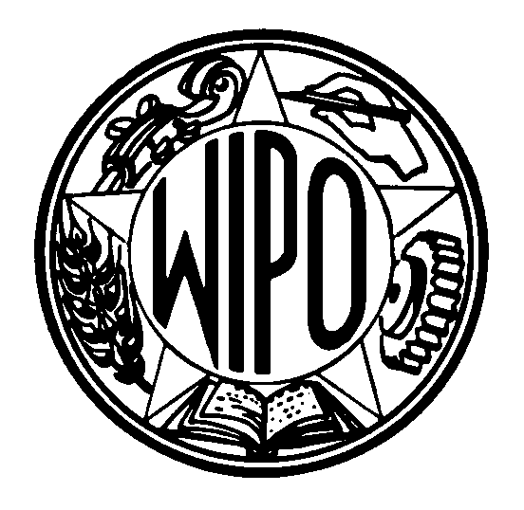 | Information Notice No. 05/2003
WORLD INTELLECTUAL PROPERTY ORGANIZATION
34, chemin des Colombettes, P.O. Box 18, CH-1211 Geneva 20 (Switzerland)
‡ (41-22) 338 91 11 – Facsimile (International Trademark Registrations Section): (41-22) 740 14 29
e-mail: intreg.mail@wipo.int – Internet: http://www.wipo.int

MADRID PROTOCOL CONCERNING THE INTERNATIONAL REGISTRATION OF MARKS

Declaration Made Under Rule 20bis(6)(b): Republic of Korea

1 In a notification addressed to the Director General of the World Intellectual Property Organization (WIPO), the Republic of Korea has made the declaration provided for by Rule 20bis(6)(b) of the Common Regulations under the Madrid Agreement and Protocol, in accordance with which the recording of licences in the International Register has no effect in that country.

2 Consequently, a licence relating to an international registration of mark which has been granted with respect to the Republic of Korea shall, in order to have effect in that country, be recorded in the national Register of the Office of the Republic of Korea. The formalities required for such recording must be completed directly with the Office of the Republic of Korea and according to the conditions laid down by the legislation of that country.

3 This declaration will enter into force on April 10, 2003.

February 4, 2003

