 | 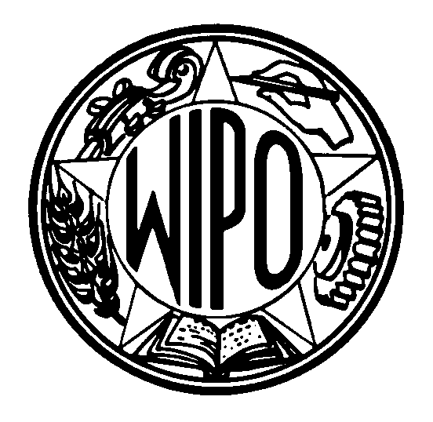 | Information Notice No. 15/2001
WORLD INTELLECTUAL PROPERTY ORGANIZATION
34, chemin des Colombettes, P.O. Box 18, CH-1211 Geneva 20 (Switzerland)
‡ (41-22) 338 91 11 – Facsimile (International Trademark Registry): (41-22) 740 14 29
e-mail: intreg.mail@wipo.int – Internet: http://www.wipo.int

PROTOCOL RELATING TO THE MADRID AGREEMENT CONCERNING
THE INTERNATIONAL REGISTRATION OF MARKS

Accession by the Republic of Zambia

1 On August 15, 2001, the Government of the Republic of Zambia deposited with the Director General of the World Intellectual Property Organization (WIPO) its instrument of accession to the Protocol Relating to the Madrid Agreement Concerning the International Registration of Marks. The Madrid Protocol will enter into force with respect to the Republic of Zambia on November 15, 2001.

2 Accession to the Madrid Protocol by the Republic of Zambia brings the number of Contracting Parties of the Protocol to 54 (namely, Antigua and Barbuda, Armenia, Australia, Austria, Belgium, Bhutan, Bulgaria, China, Cuba, Czech Republic, Democratic People’s Republic of Korea, Denmark, Estonia, Finland, France, Georgia, Germany, Greece, Hungary, Iceland, Ireland, Italy, Japan, Kenya, Latvia, Lesotho, Liechtenstein, Lithuania, Luxembourg, Monaco, Mongolia, Morocco, Mozambique, Netherlands, Norway, Poland, Portugal, Republic of Moldova, Romania, Russian Federation, Sierra Leone, Singapore, Slovakia, Slovenia, Spain, Swaziland, Sweden, Switzerland, Turkey, Turkmenistan, Ukraine, United Kingdom, Yugoslavia and Zambia) and the membership of the Madrid Union to 70.

3 A list of the members of the Madrid Union, with information on the dates on which they became bound by the Madrid Agreement or the Protocol, as well as on declarations made under the two treaties, is available under the heading “List of Members” on the page entitled “Madrid System for the International Registration of Marks” on WIPO’s website, at the following address: www.wipo.int.

August 31, 2001

