 | 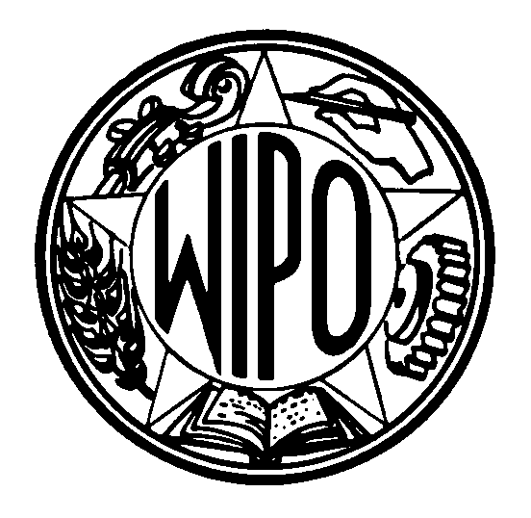 | Information Notice No. 10/2001
WORLD INTELLECTUAL PROPERTY ORGANIZATION
34, chemin des Colombettes, P.O. Box 18, CH-1211 Geneva 20 (Switzerland)
‡ (41-22) 338 91 11 – Facsimile (International Trademark Registry): (41-22) 740 14 29
e-mail: intreg.mail@wipo.int – Internet: http://www.wipo.int

PROTOCOL RELATING TO THE MADRID AGREEMENT CONCERNING
THE INTERNATIONAL REGISTRATION OF MARKS

Accession by the Republic of Bulgaria

1 On July 2, 2001, the Government of the Republic of Bulgaria deposited with the Director General of the World Intellectual Property Organization (WIPO) its instrument of accession to the Protocol Relating to the Madrid Agreement Concerning the International Registration of Marks. The Madrid Protocol will enter into force with respect to the Republic of Bulgaria on October 2, 2001.

2 The said instrument of accession was accompanied by the following declarations:

− the declaration that, pursuant to Article 5(2)(b) of the said Protocol, the time limit of one year to exercise the right to notify a refusal of protection referred to in Article 5(2)(a) thereof is replaced by 18 months;

− the declaration that, in accordance with Article 8(7)(a) of the Madrid Protocol, the Government of the Republic of Bulgaria wants to receive, in connection with each international registration in which the Republic of Bulgaria is mentioned under Article 3ter of the said Protocol, and in connection with the renewal of any such international registration, instead of a share in the revenue produced by the supplementary and complementary fees, an individual fee.

3 The amounts in Swiss francs of the said individual fees will be published as soon as they have been established in accordance with Rule 35(2)(b) of the Common Regulations under the Madrid Agreement and Protocol.

4 Accession to the Madrid Protocol by the Republic of Bulgaria brings the number of Contracting Parties of the Protocol to 52, namely, Antigua and Barbuda, Armenia, Australia, Austria, Belgium, Bhutan, Bulgaria, China, Cuba, Czech Republic, Democratic People’s Republic of Korea, Denmark, Estonia, Finland, France, Georgia, Germany, Greece, Hungary, Iceland, Italy, Japan, Kenya, Latvia, Lesotho, Liechtenstein, Lithuania, Luxembourg, Monaco, Mongolia, Morocco, Mozambique, Netherlands, Norway, Poland, Portugal, Republic of Moldova, Romania, Russian Federation, Sierra Leone, Singapore, Slovakia, Slovenia, Spain, Swaziland, Sweden, Switzerland, Turkey, Turkmenistan, Ukraine, United Kingdom and Yugoslavia.

5 A list of the members of the Madrid Union and information on the dates on which these States became party to the Madrid Agreement or the Protocol, as well as on declarations made under these two treaties, are available under the heading “List of Members” on the International Marks page on WIPO’s website, at the following address: www.wipo.int.

July 10, 2001

