 | 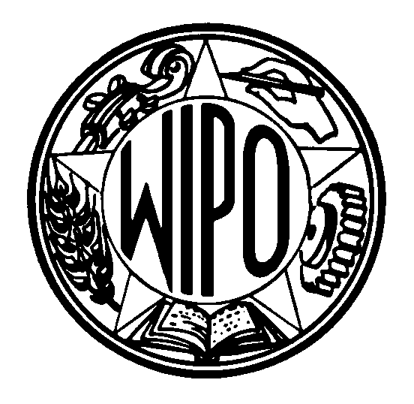 | Information Notice No. 15/2000
WORLD INTELLECTUAL PROPERTY ORGANIZATION
34, chemin des Colombettes, P.O. Box 18, CH-1211 Geneva 20 (Switzerland)
‡ (41-22) 338 91 11 – Facsimile (International Trademark Registry): (41-22) 740 14 29
e-mail: intreg.mail@wipo.int – Internet: http://www.wipo.int

MADRID AGREEMENT CONCERNING THE INTERNATIONAL
REGISTRATION OF MARKS AND PROTOCOL RELATING
TO THAT AGREEMENT

Information Concerning Macau

The Director General of the World Intellectual Property Organization (WIPO) has received a Note dated July 7, 2000, from the Permanent Mission of the People’s Republic of China to the United Nations Office in Geneva and other International Organizations in Switzerland according to which, until further notice from the Chinese Government, the Madrid Agreement Concerning the International Registration of Marks and the Protocol Relating to that Agreement, to which the People's Republic of China is party, are not applicable to the Macau Special Administrative Region of China.

July 28, 2000

