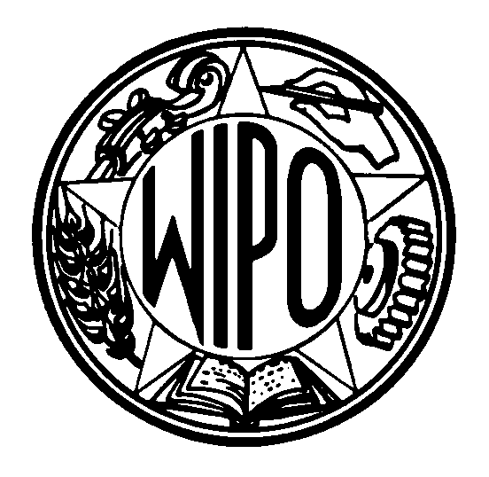
WORLD INTELLECTUAL PROPERTY ORGANIZATION
34, chemin des Colombettes, P.O. Box 18, CH-1211 Geneva 20 (Switzerland)
‡ (41-22) 338 91 11 – Facsimile (International Trademark Registry): (41-22) 740 14 29
e-mail: intreg.mail@wipo.int – Internet: http://www.wipo.int

PROTOCOL RELATING TO THE MADRID AGREEMENT CONCERNING THE INTERNATIONAL REGISTRATION OF MARKS

Accession by the Republic of Latvia

1 On October 5, 1999, the Republic of Latvia deposited with the Director General of the World Intellectual Property Organization (WIPO) its instrument of accession to the Protocol Relating to the Madrid Agreement Concerning the International Registration of Marks. The Madrid Protocol will enter into force, with respect to Latvia, on January 5, 2000.

2 Accession by Latvia to the Madrid Protocol brings the number of the Contracting Parties of the Protocol to 41, namely, Austria, Belgium, China, Cuba, Czech Republic, Democratic People’s Republic of Korea, Denmark, Estonia, Finland, France, Georgia, Germany, Hungary, Iceland, Kenya, Latvia, Lesotho, Liechtenstein, Lithuania, Luxembourg, Monaco, Morocco, Mozambique, Netherlands, Norway, Poland, Portugal, Republic of Moldova, Romania, Russian Federation, Sierra Leone, Slovakia, Slovenia, Spain, Swaziland, Sweden, Switzerland, Turkey, Turkmenistan, United Kingdom and Yugoslavia.

October 28, 1999

