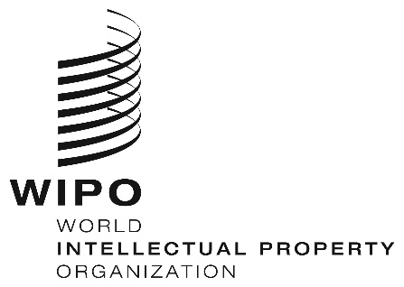
INFORMATION NOTICE NO. 4/2023
Hague Agreement Concerning the International Registration of Industrial Designs
Level of the standard designation fee concerning international applications: Namibia
- On January 13, 2023, the Director General of the World Intellectual Property Organization (WIPO) received from the Business and Intellectual Property Authority (BIPA) of Namibia, a declaration for the application of level three of the standard designation fee, under Rule 12(1)(c)(i) of the Common Regulations Under the 1999 Act and the 1960 Act of the Hague Agreement.
- The application of level three of the standard designation fee will take effect in respect of Namibia on April 13, 2023.
February 28, 2023

