

INFORMATION NOTICE NO. 10/2011

Hague Agreement Concerning the International Registration of Industrial Designs

Introduction of the new Hague system logo

- On April 26, 2010, the World Intellectual Property Organization (WIPO) unveiled a new logo. The new logo forms the cornerstone of a new visual identity for the Organization, in line with the new directions being taken to keep pace with the rapid evolution of intellectual property in the 21st century.
- The new and former WIPO logos have been communicated to all the member States
of the Paris Union and to the members of the World Trade Organization (WTO), under
Article 6ter of the Paris Convention for the Protection of Industrial Property and Article 3(1)(a) of the Agreement between WIPO and WTO.
- The International Bureau of WIPO is integrating the new logo of the Organization in all contacts with users of The Hague system and the public at large. Accordingly, in the course
of September 2011, the International Bureau of WIPO will gradually introduce the new Hague system logo, which is based on WIPO logo, as reproduced below:
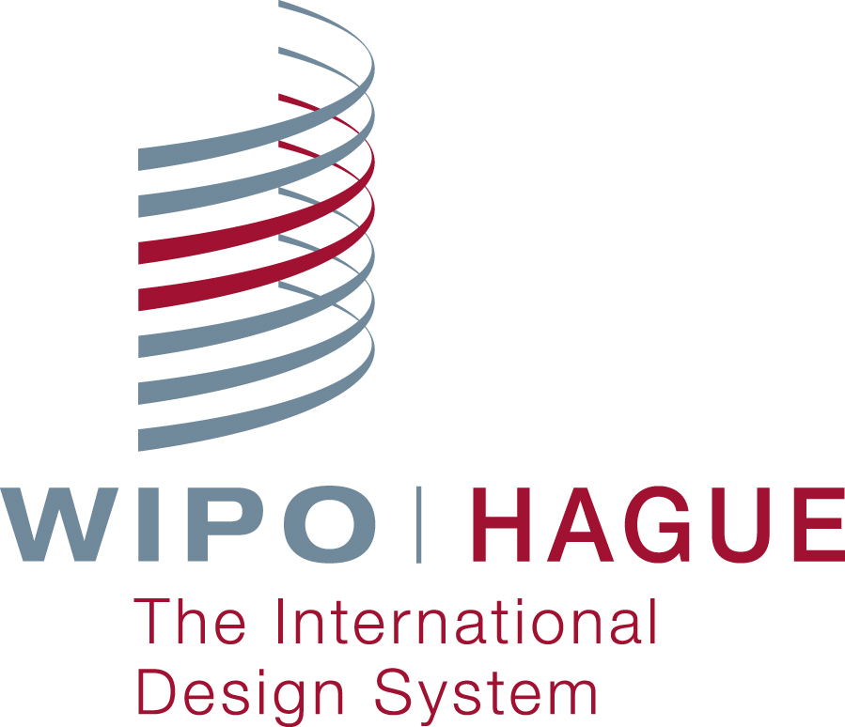

- The new Hague system logo will be incorporated in all printed and electronic publications and in all official documents issued by the International Bureau of WIPO within the framework
of The Hague system.

August 29, 2011

