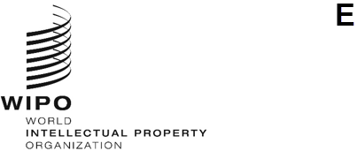

INFORMATION NOTICE No. 15/2023
Geneva Act of the Lisbon Agreement on Appellations of Origin and Geographical Indications
Change in the Name and Address of the Competent Authority: Lao People’s Democratic Republic
- Please note that the name and address of the Lao People’s Democratic Republic Competent Authority for the purposes of the procedures under the Geneva Act of the Lisbon Agreement provided under paragraph 2 of Information Notice No. 1/2021 dated January 12, 2021, have changed.

- The current details of the Competent Authority notified by the Lao People’s Democratic Republic are as follows:
Department of Intellectual Property (DIP)
Ministry of Industry and Commerce
Sidamduan Road, Ban Sidamduan
Chanthabouly District
P.O. Box 4107
Vientiane Capital
Lao People’s Democratic Republic
Telephone: (856) 21 213 470 ext. 154
E-mail: dip.laopdr@gmail.com
Website: https://dip.gov.la

December 7, 2023

